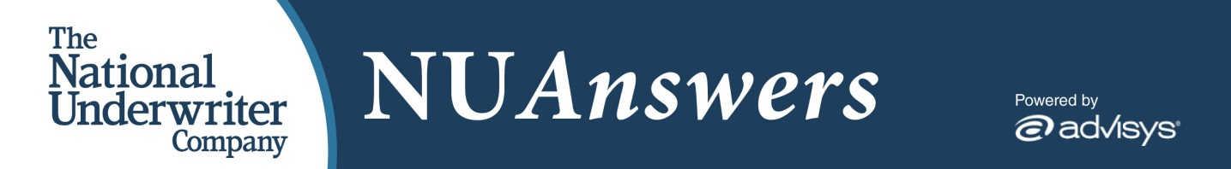
Welcome to NU Answers,
Your subscription to NU Answers has been successfully created. Since you previously reviewed the online service with a trial subscription, please login with your username (email address) and password you created during your trial period. If you have forgotten your password, you may request a password reset on the login screen.
To login, go to http://www.nuanswers.com/
Username:
We hope you enjoy your subscription to NU Answers — the only online resource combining National Underwriter’s expert-authored tax and retirement content with Advisys’s effective and FINRA approved client presentations, enabling you to research topics in advance of client meetings. With NU Answers, you can put together personalized client presentations in minutes.
Please contact us with any questions you may have at any time. If you’d like, we can set up a one-on-one online walk through of the product with a product specialist. Just call us at (800) 543-0874 to schedule a day and time that is convenient for you.
Thank you,
The NU Answers Team
4157 Olympic Blvd., Suite 225
Erlanger, KY 41018
Toll Free: (800) 543-0874
customerservice@nuco.com

