Investment Strategies
The following investment strategies, or styles, are not mutually exclusive. More often than not, the individual investor, or mutual fund manager, will employ one or more strategies, depending upon the investment objectives.
Buy-and-Hold. Buy-and-hold is a fairly passive investment strategy under which the investor takes a long-term view of the market. The investor who employs a buy-and-hold strategy may use fundamental analysis to select strong stocks that offer good value (see page 31), or may simply seek to use indices to own the market in the aggregate. Little attention is paid to any short- or intermediate-term market or economic trends. Once purchased, bonds are typically held to their maturity date, and stocks are held through both bull and bear markets. Given time, the strategy can be very effective, provided the investor is successful in initially selecting fundamentally strong stocks, and/or assuming that economic growth in the aggregate continues to lift the value of the overall market. The advantages of a buy-and-hold strategy include: (1) transaction costs are kept to a minimum; (2) time devoted to portfolio maintenance is comparatively low; and (3) taxation is delayed until the investment is sold. The buy-and-hold strategy is the opposite of market timing.
Market Timing. The strategy of market timing generally focuses on short-term market trends in an attempt to generate quick profits from short-term changes in security prices. With the objective of buying low and selling high, individuals who employ market timing use a variety of indicators and models that they believe will signal a time to either buy or sell. Although widely practiced by professionals and day traders, the long-term track records documenting the validity of any particular system are limited.
In contrast to a buy-and-hold strategy, the disadvantages of market timing include: (1) transaction costs are incurred; (2) much time must be devoted to trading and portfolio maintenance; and (3) taxation is potentially triggered each time a security is sold. Because the largest market gains tend to be concentrated in short time periods, the biggest disadvantage of market timing is that the investor may be out of the market when stocks experience their largest gains.
Tactical Asset Allocation. Tactical asset allocation is a broad term to label strategies where the asset allocation of the investor's portfolio shifts over time, generally in response to market or economic trends or fundamental valuation. Changes tend to be significantly more gradual than the often all-in-all-out transactions of market timing, but represent far more variability than the stable asset allocation of buy-and-hold portfolios that are typically not altered at all unless there is a material change in goals or time horizon.
Investment Strategies
Contrarian Investing. As the term indicates, the contrarian investor sells when others are buying, and buys when others are selling. By going against the crowd, the contrarian hopes to buy low and sell high while the market is doing the opposite. Contrarians recognize that stock prices are driven up when the demand for stocks is greater than supply (i.e., there are more buyers than sellers). Once prices increase, most investors who intended to purchase have already done so and there is no one left to buy (i.e., the demand for stock evaporates). Without buyers, stocks peak and then lose momentum, and this causes a chain reaction of more selling and less buying as a decline emerges. The same phenomenon occurs when the market bottoms, only in reverse. Once a contrarian investor has purchased a stock, he is most likely to patiently follow a buy-and-hold strategy, waiting for the market to reverse itself in order to sell for long-term capital gain. The key characteristic of contrarian investing is that buy and sell transactions are typically done exactly opposite the general trend of the market at the time (thus, the “contrarian” label).
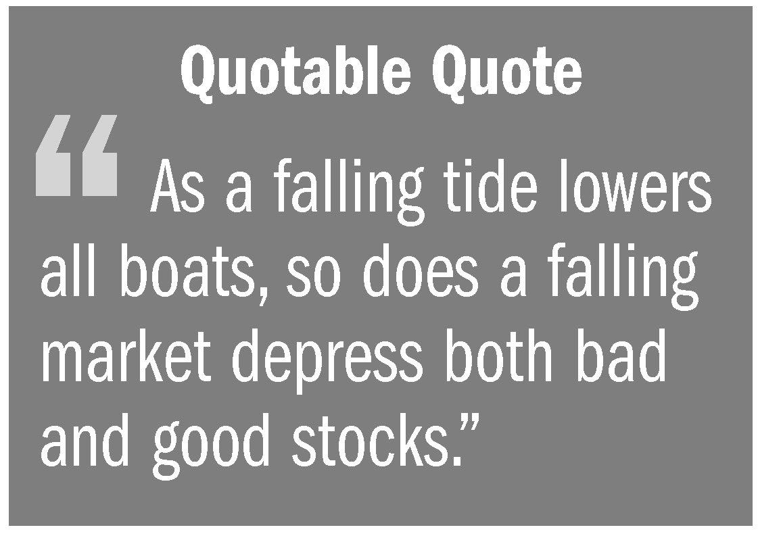
Value Investing. Value investors believe the best indicator of a stock’s value is not necessarily the price in the market on any particular day. Stocks fall in and out of favor with investors and, over the short term, the market frequently overreacts to bad news, thus depressing the prices of both good stocks and bad stocks. Likewise, whole industries fall out of favor with investors, often without regard to their future earnings potential. Value investors look for both stocks and industries that are out of favor in the market, yet represent good potential for earning long-term returns. The value investor looks at factors such as sales, earnings history and outlook, assets, and stockholder equity, and compares them to the stock’s current market price. If the stock is judged to be under-valued, it is purchased. Value can flow from low price-earnings ratios, low price-to-book ratios, and high dividend yields. Value investors look for companies where book value may exceed market value, new companies not yet “discovered” by other investors, and hidden value that other investors have failed to find (e.g., a restructuring that will turn the company around or a new product about to be launched). Value investing involves elements of both the fundamentalist (focusing on the financials), and the contrarian (buying what others are not), both combined with a buy-and-hold strategy (patiently waiting for the stock to rise in price). Although the value investor feels that he can cull out the good from the bad, value investing is not without risk. A failing industry or company with a low price earnings ratio may never recover.
Investment Strategies
Growth Investing. The growth investor employs a strategy of finding and investing in growth stocks of companies within industries that are expected to experience substantial growth. The investor is typically looking for that well managed small to medium size company that is well positioned to generate revenues or earnings greater than the market as a whole. Returns from growth investing are expected to come from increases in stock values, not from dividends paid to stockholders.
Socially Responsible Investing. The concept of socially responsible investing (SRI) has been evolving for many years. Begun by churches that refused to invest in gambling, alcohol, and tobacco stocks, the practice was adapted by social movements to express their protests and concerns by avoiding specific investments (e.g., by not investing in companies with foreign subsidiaries employing child labor). The concept of SRI has expanded to include environmental, community, other societal or corporate governance (ESG) issues. The term “socially responsible investing” continues to be used, but a variety of other terms are also used, including responsible investing, sustainable investing, ESG investing, mission-related investing, or ethical investing. SRI generally involves investing with one’s values by avoiding certain stocks, whereas ESG investing entails seeking out stocks of companies that demonstrate good environmental practices, provide socially responsible products and services, and exercise good corporate governance (openess, honesty, integrity, etc.). For example, ESG investors might seek out companies that have taken steps to minimize their environmental footprint, divest themselves of subsidiaries manufacturing unhealthy products, or improve labor relations. The 2012 Trends Report from the US SIF Foundation found that the total net assets of both mutual funds and alternative investment funds that considered ESG criteria increased significantly with mutual funds doubling from 2010 to $641 billion. Alternative investment funds were $132 billion, a 250 percent increase from the corresponding assets identified at year-end 2009.

Press Release, The Social Investment Forum Foundation: US Sustainable and Responsible Investing (SRI) Assets Up 22 Percent in Two Years, November 14, 2012. This organization is a national membership association dedicated to advancing the concept, practice, and growth of socially and environmentally responsible investing (SRI).

