Disability – The Living Death
No estate or financial plan can be considered complete unless there has been an evaluation of the risks of disability. Planning to live is as important as planning to die, and the risk is greater. For example, for a male age 40, long-term disability is 2.9 times more likely than death.
Before disability, most people are able to acquire savings to the extent income exceeds expenses. However, after disability caused by a sickness or injury, income will fall and expenses will rise.
WITHOUT PLANNING, the expenses of a disability can quickly exhaust the family’s savings and create substantial debt. This is true despite the availability of Social Security after six months of continuous and total disability. For most people these payments will rarely fill the gap created between falling income and increasing expenses. When available, Social Security disability payments to a disabled wage earner with children will be substantially more than those to a disabled wage earner without children. The fact that a disabled wage earner is married – and often responsible for the financial needs of a spouse – does not result in an increase in Social Security payments.
Attempting to reduce expenses by selling personal possessions, a car, or even the family home, is unlikely to eliminate the substantial debt which is created by a long-term disability, which is often referred to as “the living death.”
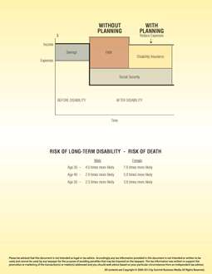
Disability – The Living Death
WITH PLANNING, the cornerstone of any disability plan is disability insurance. Just as life insurance protects a family in case of the insured’s death, disability income insurance protects both the insured and his family in case of the insured’s disability. In addition, before disability strikes, the purchase of a comprehensive major medical expense plan offers one of the most effective ways of paying the major expenses of many disabilities. A waiver of premium rider on existing or new life insurance policies will provide for payment of premiums after a stated period of disability.

