Introduction to Estate Planning

1. Estate Planning

1.1 Estate Planning Explained


1.2 Navigating this Course.
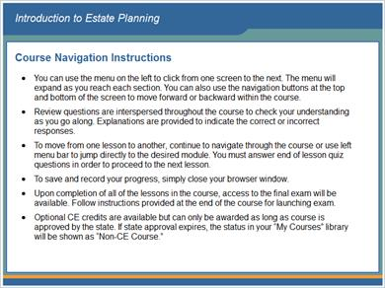

1.3 Support Information
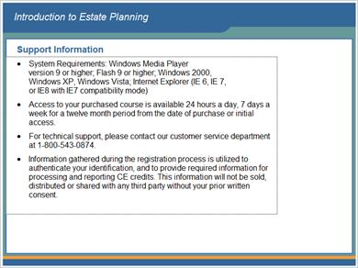

1.4 Lesson 1: Ownership and Transfer of Property


1.5 Lesson 1 Objectives
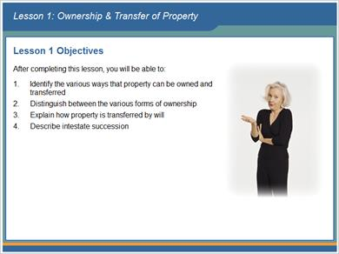

1.6 Introduction
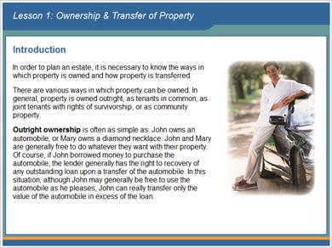

1.7 Property Ownership


1.8 Property Ownership


1.9 Property Ownership
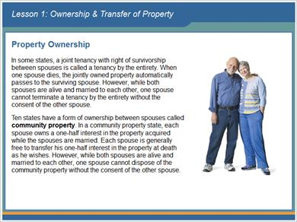

1.10 Property Ownership
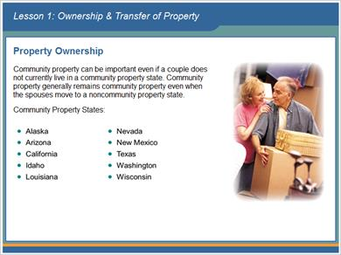

1.11 Property Ownership
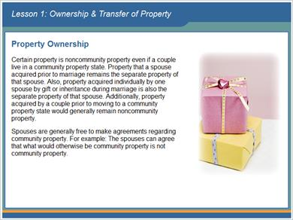

1.12 Property Transfer
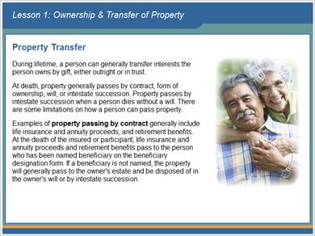

1.13 Property Transfer
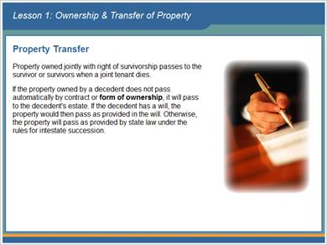

1.14 Property Transfer
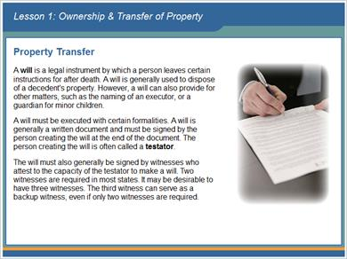

1.15 Property Transfer
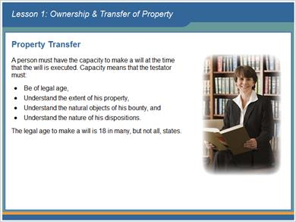

1.16 Property Transfer
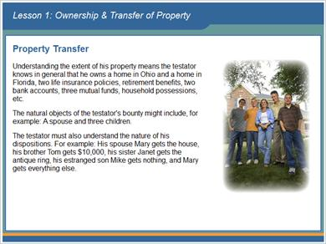

1.17 Legacy
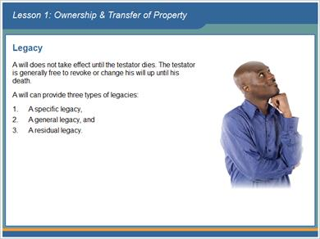

1.18 Legacy


1.19 Legacy
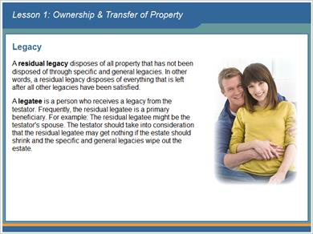

1.20 Legacy
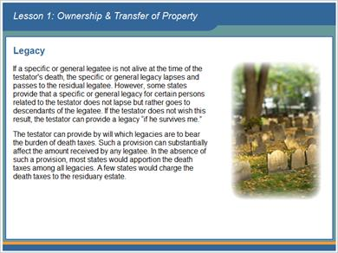

1.21 Periodic Review of Wills
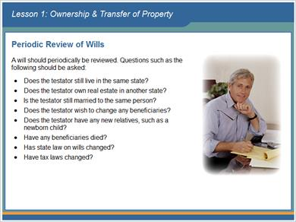

1.22 Limitations of Property Transfer
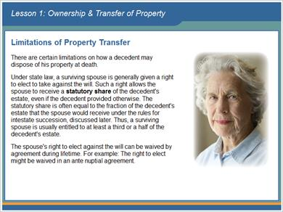

1.23 Limitations of Property Transfer
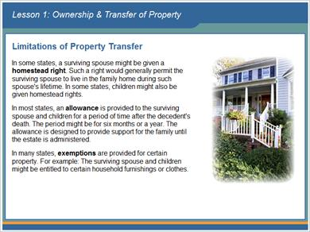

1.24 Limitations of Property Transfer
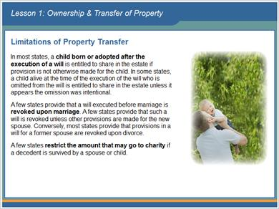

1.25 Intestate Succession
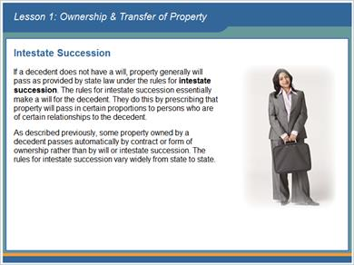

1.26 Intestate Succession
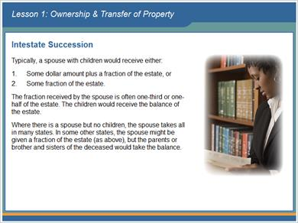

1.27 End of Lesson 1
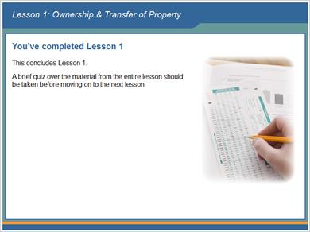

1.28 A remainder interest is the right to receive property after another interest in the property, such as a life estate, terminates.
(True/False, 10 points, 1 attempt permitted)
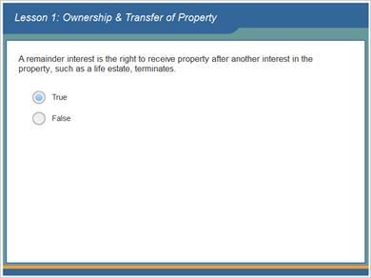
Correct | Choice
X | True
 | False
Feedback when correct:
That's right! The person with the remainder interest receives the property when the person with the life estate dies.
Feedback when incorrect:
Sorry, this is true. The person with the remainder interest receives the property when the person with the life estate dies.

Correct (Slide Layer)
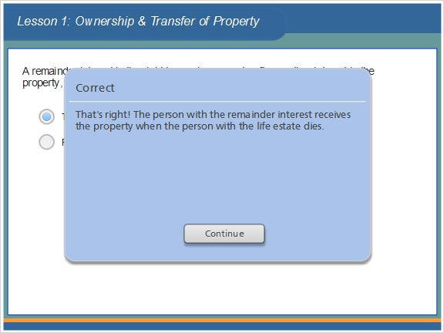

Incorrect (Slide Layer)
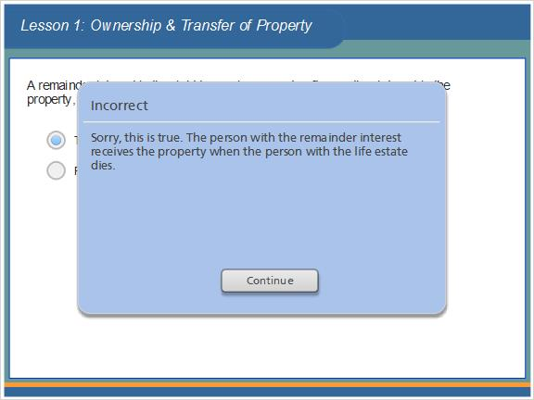

1.29 In some states, a joint tenancy with right of survivorship between a parent and a child is called a tenancy by the entirety.
(True/False, 10 points, 1 attempt permitted)
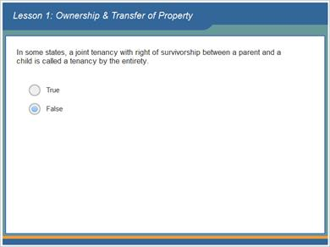
Correct | Choice
 | True
X | False

Feedback when correct:
That's right! A tenancy by the entirety is between spouses.
Feedback when incorrect:
Sorry, this is false. A tenancy by the entirety is between spouses.

Correct (Slide Layer)
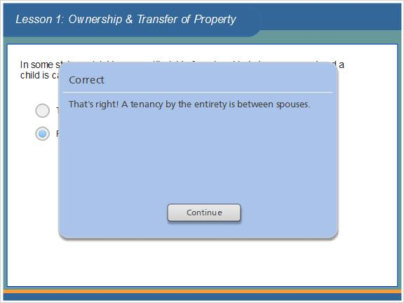

Incorrect (Slide Layer)
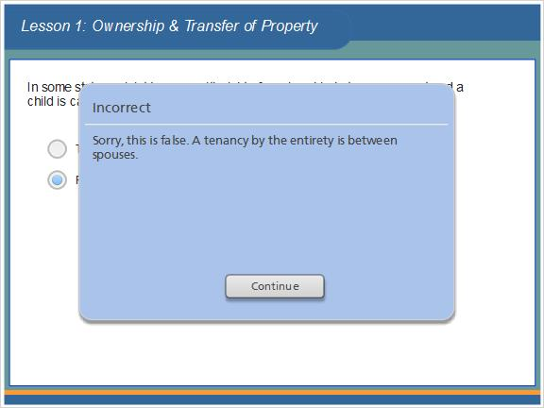

1.30 At death, life insurance proceeds generally pass by contract.
(True/False, 10 points, 1 attempt permitted)
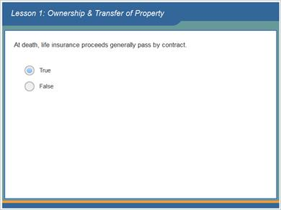
Correct | Choice
X | True
 | False

Feedback when correct:
That's right! Examples of property passing by contract generally include life insurance and annuity proceeds, and retirement benefits.
Feedback when incorrect:
Sorry, this is true. Examples of property passing by contract generally include life insurance and annuity proceeds, and retirement benefits.

Correct (Slide Layer)
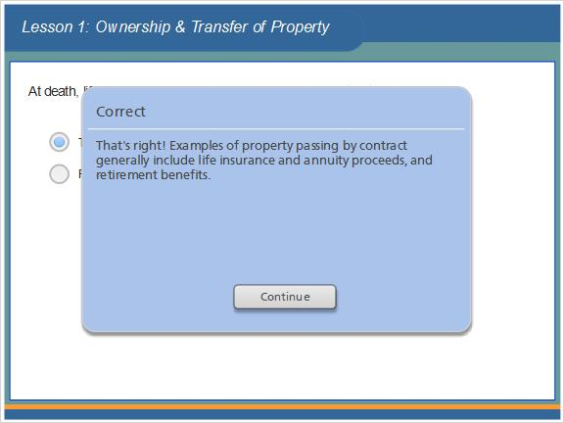

Incorrect (Slide Layer)
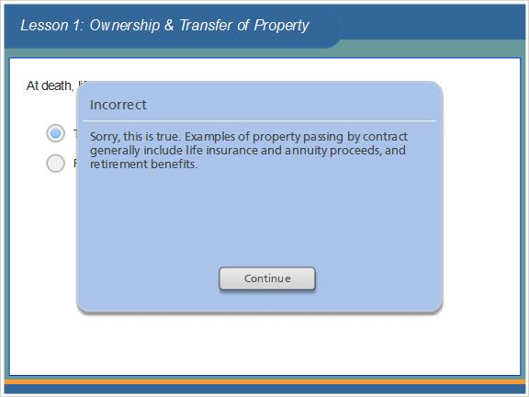

1.31 A residual legacy disposes of all property that has not been disposed of through specific and general legacies.
(True/False, 10 points, 1 attempt permitted)
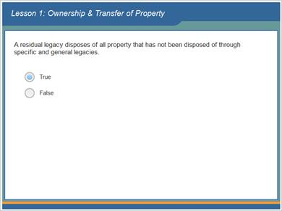
Correct | Choice
X | True
 | False

Feedback when correct:
That's right! A residual legacy disposes of all property that has not been disposed of through specific and general legacies. In other words, a residual legacy disposes of everything that is left after all other legacies have been satisfied.
Feedback when incorrect:
Sorry, this is true. A residual legacy disposes of all property that has not been disposed of through specific and general legacies. In other words, a residual legacy disposes of everything that is left after all other legacies have been satisfied.

Correct (Slide Layer)
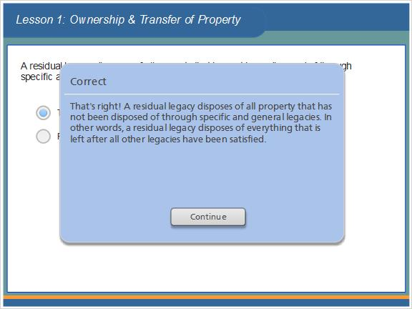

Incorrect (Slide Layer)
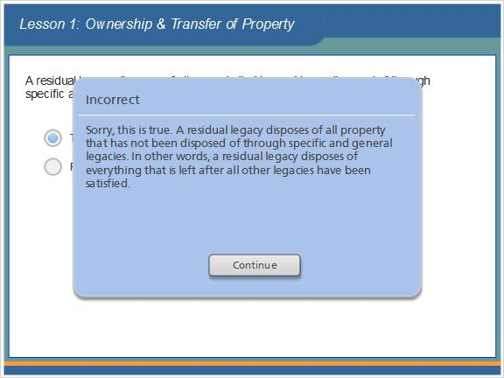

1.32 The burden of death taxes is determined without regard to provisions by the testator in a will.
(True/False, 10 points, 1 attempt permitted)
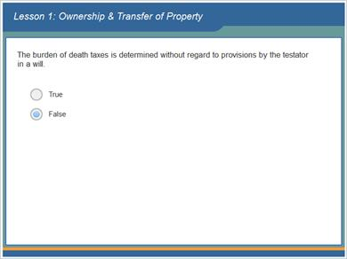
Correct | Choice
 | True
X | False

Feedback when correct:
That's right! The testator can provide by will which legacies are to bear the burden of death taxes.
Feedback when incorrect:
Sorry, this is false. The testator can provide by will which legacies are to bear the burden of death taxes.

Correct (Slide Layer)
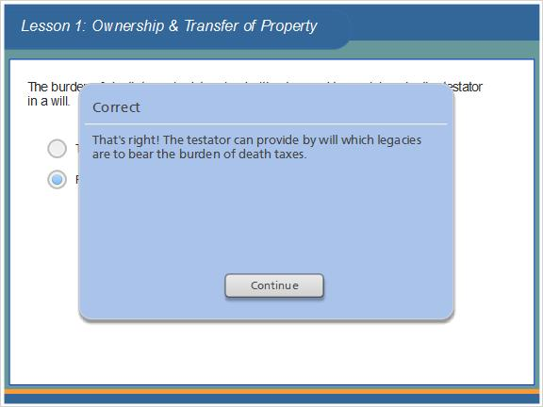

Incorrect (Slide Layer)
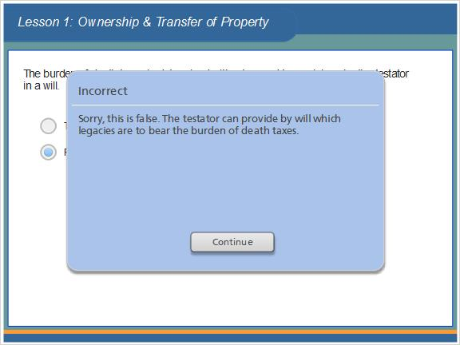

1.33 The rules for intestate succession are the same in all states.
(True/False, 10 points, 1 attempt permitted)
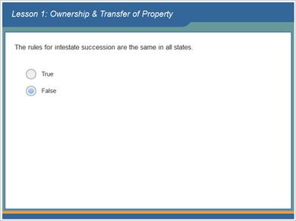
Correct | Choice
 | True
X | False

Feedback when correct:
That's right! The rules for intestate succession vary widely from state to state.
Feedback when incorrect:
Sorry, this is false. The rules for intestate succession vary widely from state to state.

Correct (Slide Layer)
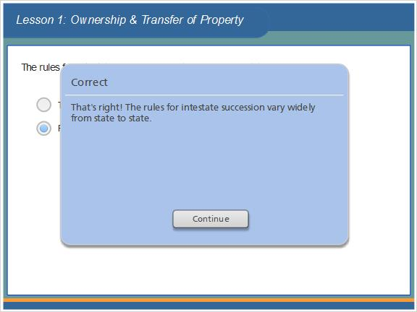

Incorrect (Slide Layer)
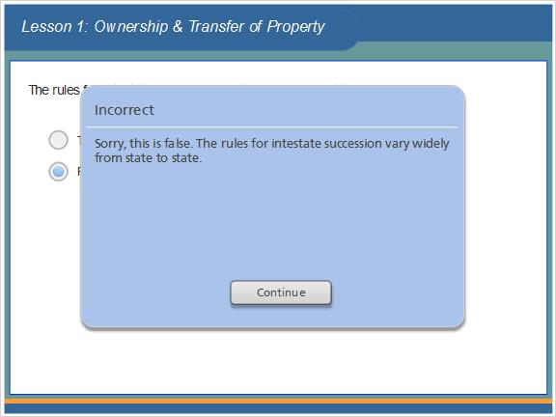

1.34 Results Slide
(Results Slide, 0 points, 1 attempt permitted)
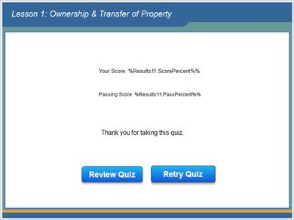

Results for
1.28 A remainder interest is the right to receive property after another interest in the property, such as a life estate, terminates.
1.29 In some states, a joint tenancy with right of survivorship between a parent and a child is called a tenancy by the entirety.
1.30 At death, life insurance proceeds generally pass by contract.
1.31 A residual legacy disposes of all property that has not been disposed of through specific and general legacies.
1.32 The burden of death taxes is determined without regard to provisions by the testator in a will.
1.33 The rules for intestate succession are the same in all states.

Result slide properties
Passing Score | 70%

1.35 Lesson 1 Read More Supplement


1.36 Lesson 2: The Federal Estate Tax


1.37 Lesson 2 Objectives
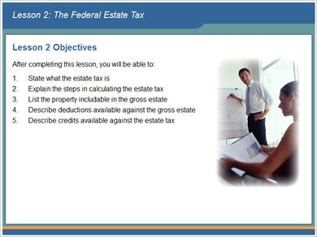

1.38 Introduction
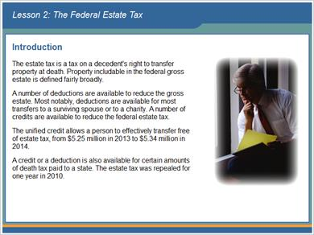

1.39 Introduction
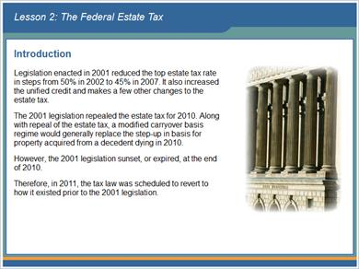

1.40 Introduction
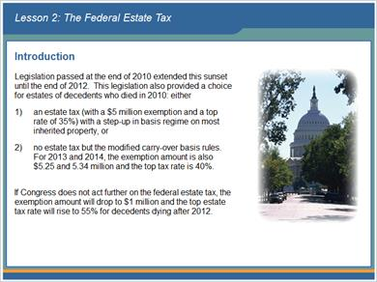

1.41 Property Included in the Federal Gross Estate
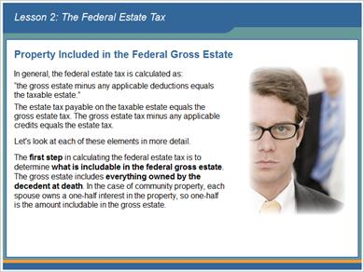

1.42 Property Included in the Federal Gross Estate
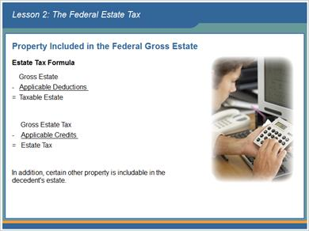

1.43 Property Included in the Federal Gross Estate
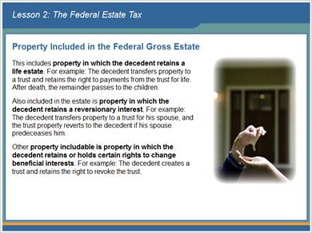

1.44 Property Included in the Federal Gross Estate
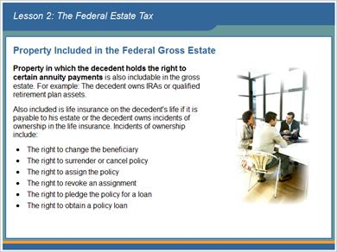

1.45 Property Included in the Federal Gross Estate
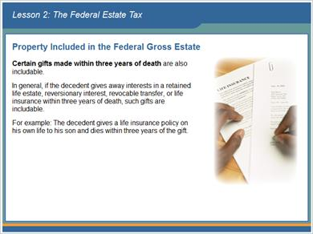

1.46 Property Included in the Federal Gross Estate
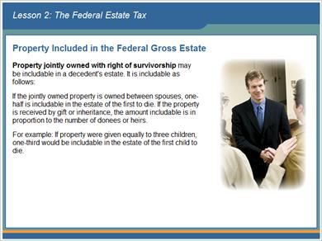

1.47 Property Included in the Federal Gross Estate


1.48 Property Included in the Federal Gross Estate
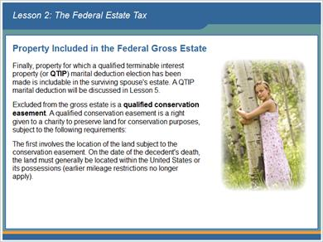

1.49 Property Included in the Federal Gross Estate
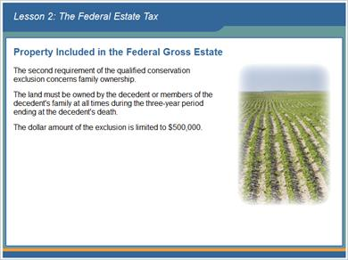

1.50 Deductions from the Gross Estate
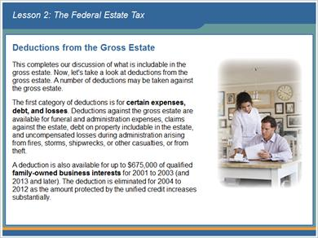

1.51 Deductions from the Gross Estate
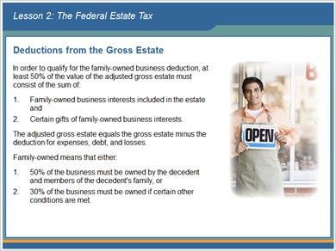

1.52 Deductions from the Gross Estate
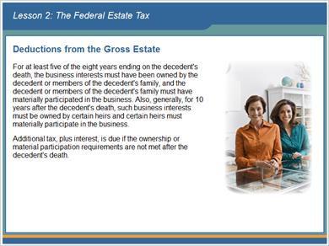

1.53 Deductions from the Gross Estate
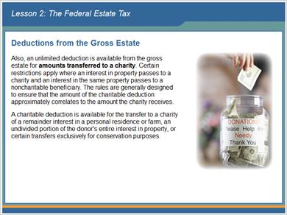

1.54 Deductions from the Gross Estate
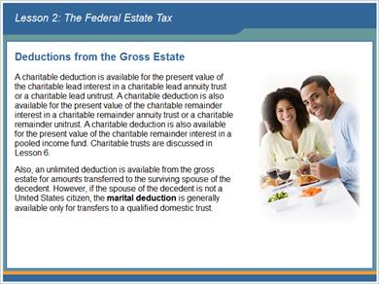

1.55 Deductions from the Gross Estate
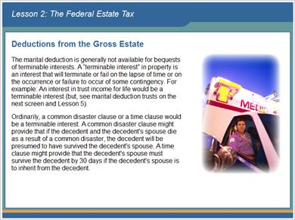

1.56 Deductions from the Gross Estate
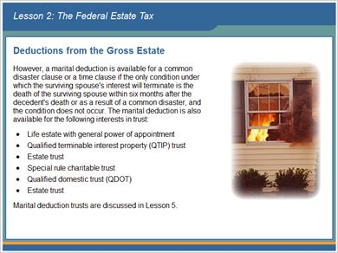

1.57 Estate Tax Calculation
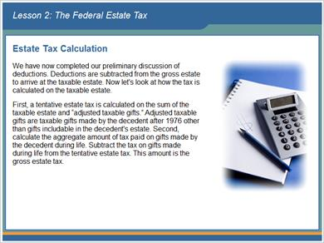

1.58 Estate Tax Calculation
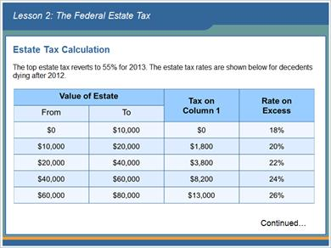

1.59 Estate Tax Calculation
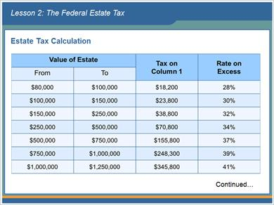

1.60 Estate Tax Calculation
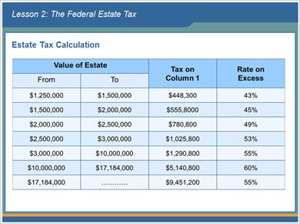

1.61 Estate Tax Credits
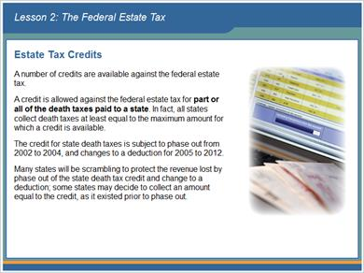

1.62 Estate Tax Credits
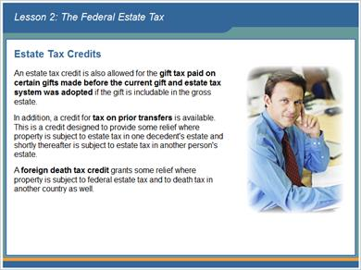

1.63 Estate Tax Credits
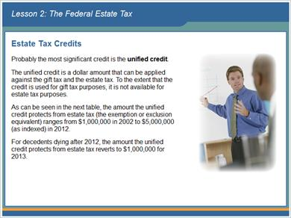

1.64 Estate Tax Credits
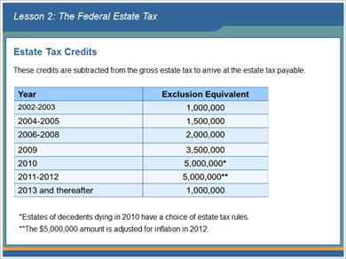

1.65 Estate Tax Credits
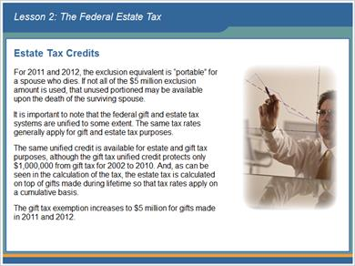

1.66 End of Lesson 2
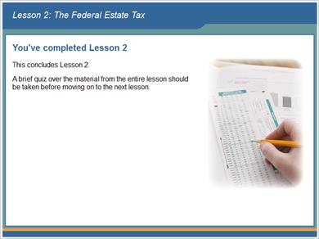

1.67 The estate tax is a tax on the beneficiary's right to receive property.
(True/False, 10 points, 1 attempt permitted)
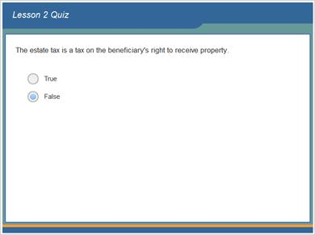
Correct | Choice
 | True
X | False

Feedback when correct:
That's right! The estate tax is a tax on a decedent's right to transfer property at death.
Feedback when incorrect:
Sorry, this is false. The estate tax is a tax on a decedent's right to transfer property at death.

Correct (Slide Layer)
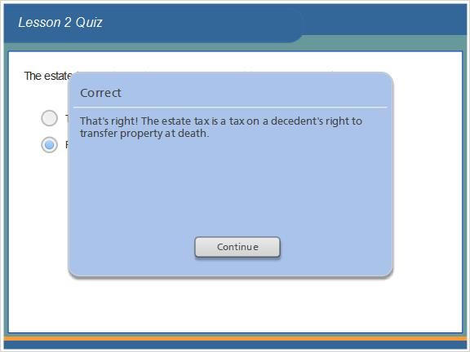

Incorrect (Slide Layer)
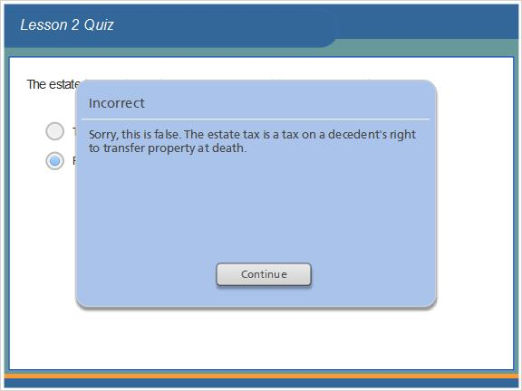

1.68 One half of community property is includable in the gross estate.
(True/False, 10 points, 1 attempt permitted)

Correct | Choice
X | True
 | False

Feedback when correct:
That's right! In the case of community property, each spouse owns a one-half interest in the property, so one-half is the amount includable in the gross estate.
Feedback when incorrect:
Sorry, this is true. In the case of community property, each spouse owns a one-half interest in the property, so one-half is the amount includable in the gross estate.

Correct (Slide Layer)
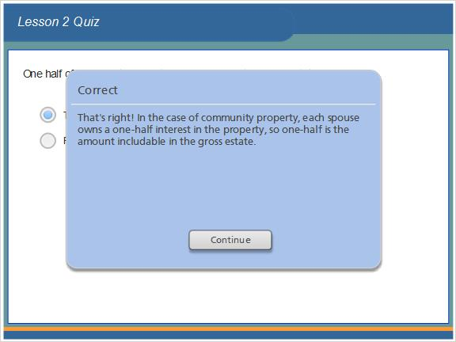

Incorrect (Slide Layer)
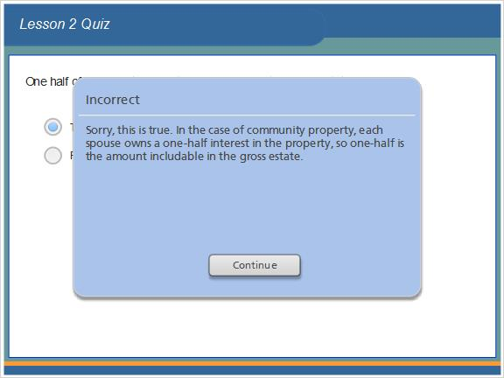

1.69 Certain restrictions apply to the charitable deduction where an interest in property passes to charity and an interest in the same property passes to a noncharitable beneficiary.
(True/False, 10 points, 1 attempt permitted)
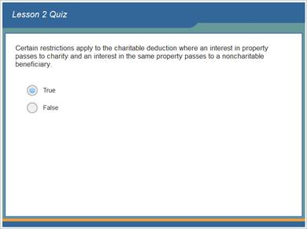
Correct | Choice
X | True
 | False

Feedback when correct:
That's right! Certain restrictions apply where an interest in property passes to a charity and an interest in the same property passes to a noncharitable beneficiary.
Feedback when incorrect:
Sorry, this is true. Certain restrictions apply where an interest in property passes to a charity and an interest in the same property passes to a noncharitable beneficiary.

Correct (Slide Layer)
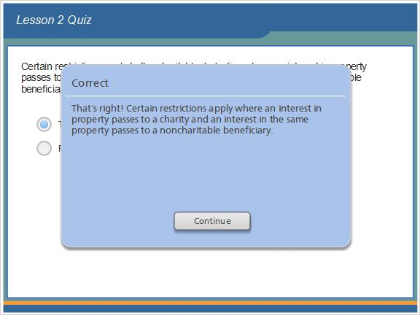

Incorrect (Slide Layer)
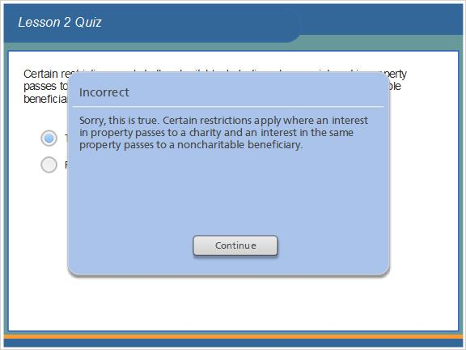

1.70 The marital deduction is limited to 50% of the gross estate.
(True/False, 10 points, 1 attempt permitted)

Correct | Choice
 | True
X | False

Feedback when correct:
That's right! An unlimited deduction is available from the gross estate for amounts transferred to the surviving spouse of the decedent.
Feedback when incorrect:
Sorry, this is false. An unlimited deduction is available from the gross estate for amounts transferred to the surviving spouse of the decedent.

Correct (Slide Layer)
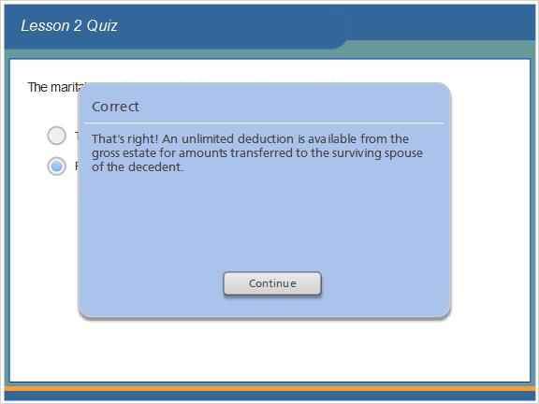

Incorrect (Slide Layer)
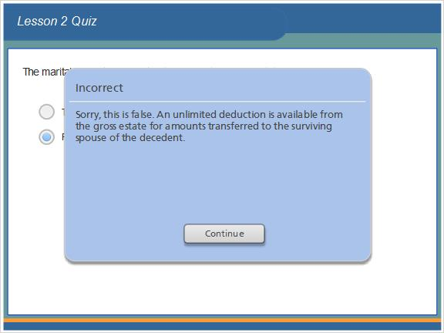

1.71 Estate tax is reduced by credits.
(True/False, 10 points, 1 attempt permitted)
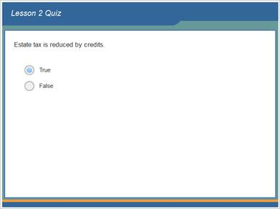
Correct | Choice
X | True
 | False

Feedback when correct:
That's right! A number of credits are available to reduce the federal estate tax.
Feedback when incorrect:
Sorry, this is true. A number of credits are available to reduce the federal estate tax.

Correct (Slide Layer)
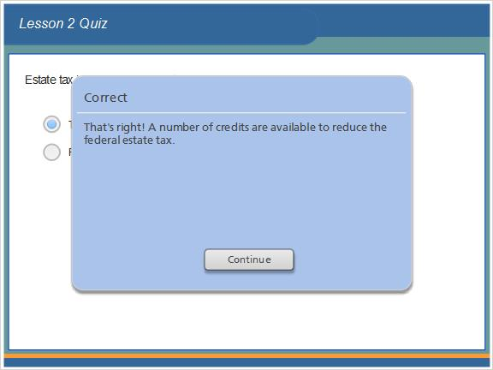

Incorrect (Slide Layer)
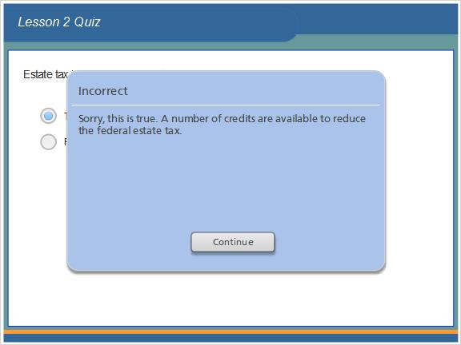

1.72 A credit or a deduction is allowed against the federal estate tax for part or all of the death taxes paid to a state.
(True/False, 10 points, 1 attempt permitted)
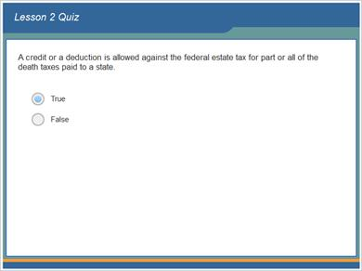
Correct | Choice
X | True
 | False

Feedback when correct:
That's right! A credit or a deduction is allowed against the federal estate tax for part or all of the death taxes paid to a state.
Feedback when incorrect:
Sorry, this is true. A credit or a deduction is allowed against the federal estate tax for part or all of the death taxes paid to a state.

Correct (Slide Layer)
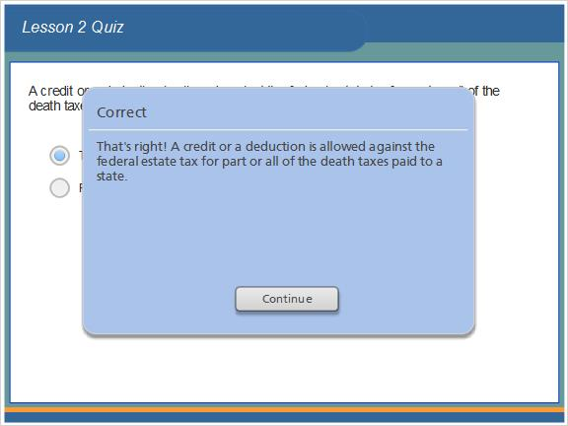

Incorrect (Slide Layer)
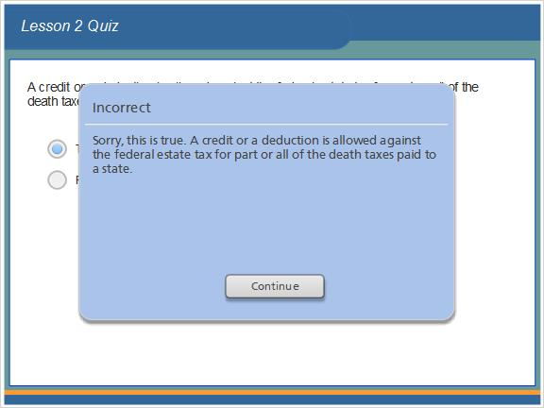

1.73 Results Slide
(Results Slide, 0 points, 1 attempt permitted)
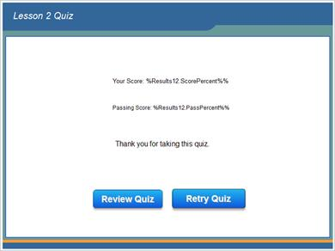

Results for
1.67 The estate tax is a tax on the beneficiary's right to receive property.
1.68 One half of community property is includable in the gross estate.
1.69 Certain restrictions apply to the charitable deduction where an interest in property passes to charity and an interest in the same property passes to a noncharitable beneficiary.
1.70 The marital deduction is limited to 50% of the gross estate.
1.71 Estate tax is reduced by credits.
1.72 A credit or a deduction is allowed against the federal estate tax for part or all of the death taxes paid to a state.

Result slide properties
Passing Score | 70%

1.74 Lesson 2 Read More Supplement
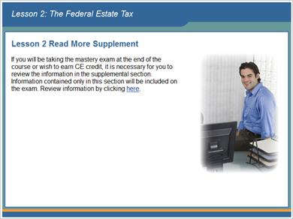

1.75 Lesson 3: The Federal Gift Tax


1.76 Lesson 3 Objectives
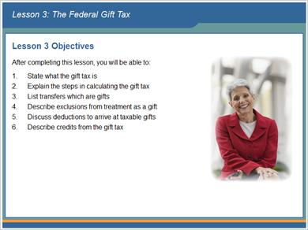

1.77 Introduction
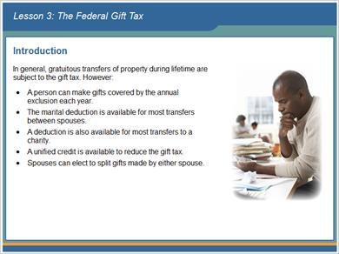

1.78 Introduction
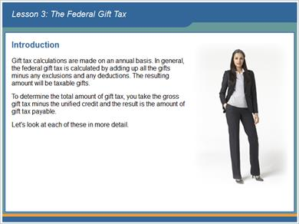

1.79 Gifts
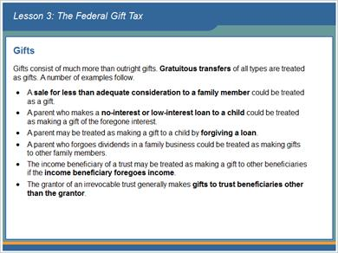

1.80 Gifts
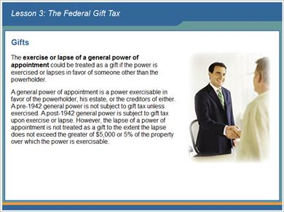

1.81 Gifts
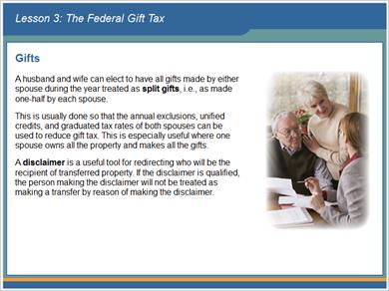

1.82 Gifts
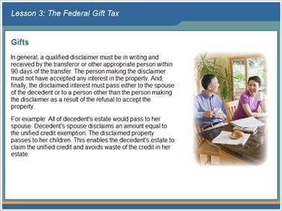

1.83 Exclusions from Gift Treatment
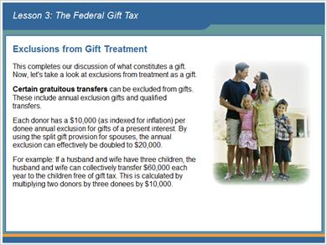

1.84 Exclusions from Gift Treatment
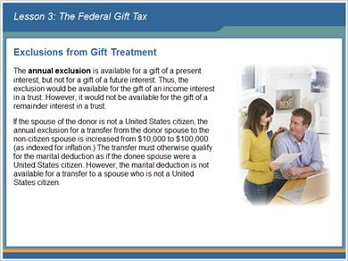

1.85 Exclusions from Gift Treatment
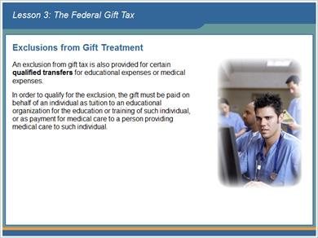

1.86 Deductions
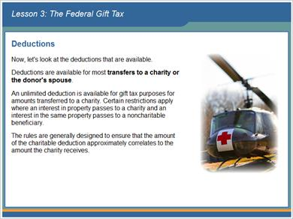

1.87 Deductions
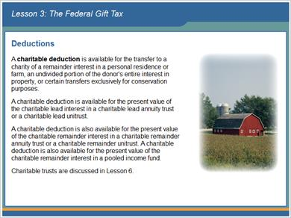

1.88 Deductions
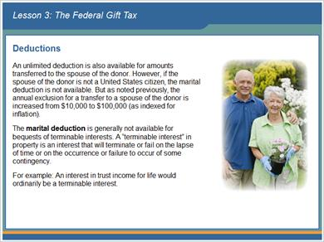

1.89 Deductions
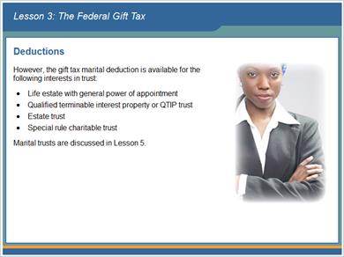

1.90 Tax Calculation
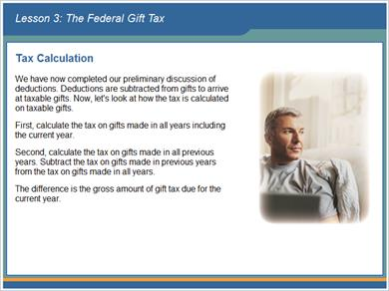

1.91 Tax Calculation
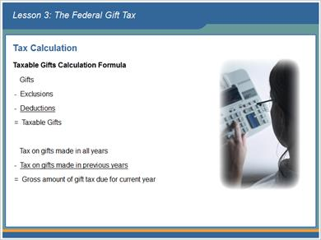

1.92 Tax Calculation
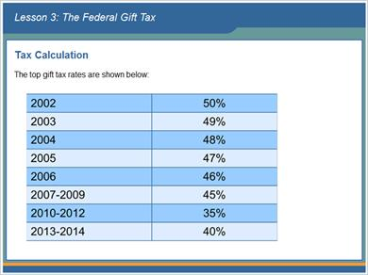

1.93 Tax Calculation
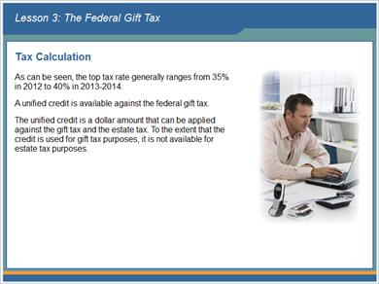

1.94 Tax Calculation
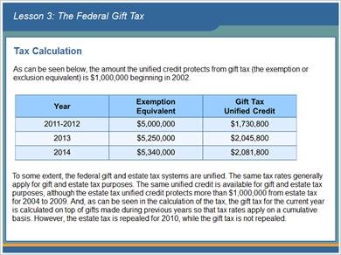

1.95 End of Lesson 3
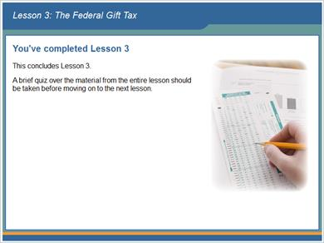

1.96 The unified credit is subtracted from the gross gift tax to arrive at the gift tax payable for the year.
(True/False, 10 points, 1 attempt permitted)
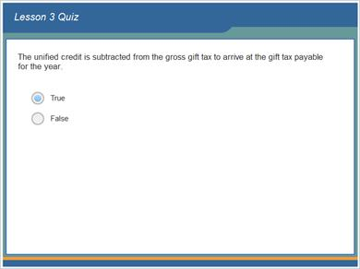
Correct | Choice
X | True
 | False

Feedback when correct:
That's right! To determine the total amount of gift tax, you take the gross gift tax minus the unified credit and the result is the amount of gift tax payable.
Feedback when incorrect:
Sorry, this is true. To determine the total amount of gift tax, you take the gross gift tax minus the unified credit and the result is the amount of gift tax payable.

Correct (Slide Layer)
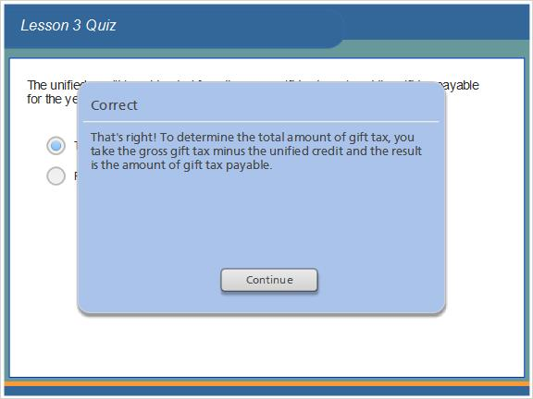

Incorrect (Slide Layer)
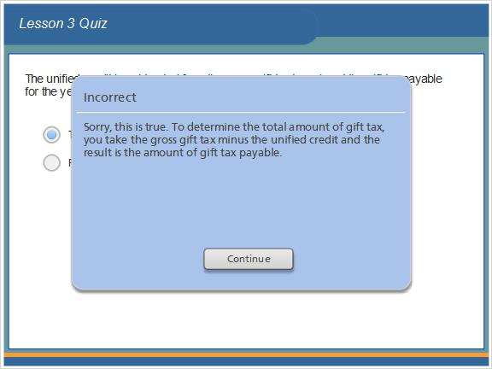

1.97 Gift tax is calculated on a cumulative basis.
(True/False, 10 points, 1 attempt permitted)
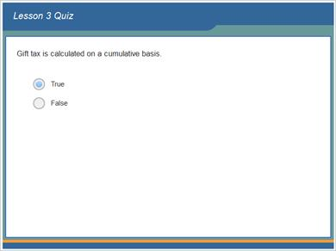
Correct | Choice
X | True
 | False

Feedback when correct:
That's right! The gift tax for the current year is calculated on top of gifts made during previous years so that tax rates apply on a cumulative basis.
Feedback when incorrect:
Sorry, this is true. The gift tax for the current year is calculated on top of gifts made during previous years so that tax rates apply on a cumulative basis.

Correct (Slide Layer)
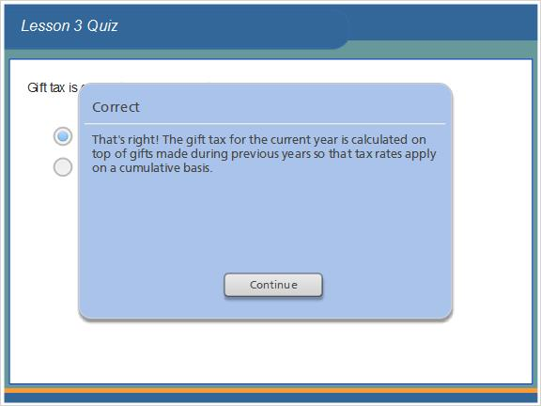

Incorrect (Slide Layer)
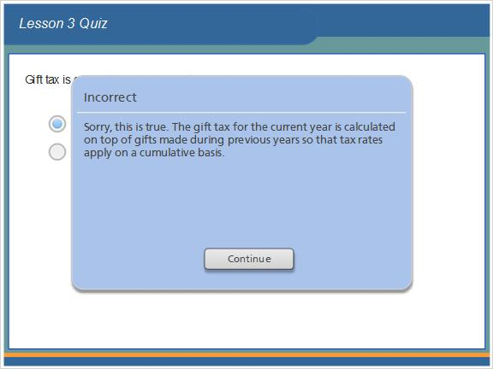

1.98 The top gift tax rate is 28%.
(True/False, 10 points, 1 attempt permitted)
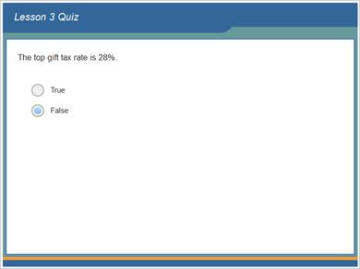
Correct | Choice
 | True
X | False

Feedback when correct:
That's right! The top gift tax rate ranges from 55% in 2011 (and 2013) to 35% in 2010-2012.
Feedback when incorrect:
Sorry, this is false. The top gift tax rate ranges from 55% in 2011 (and 2013) to 35% in 2010-2012.

Correct (Slide Layer)
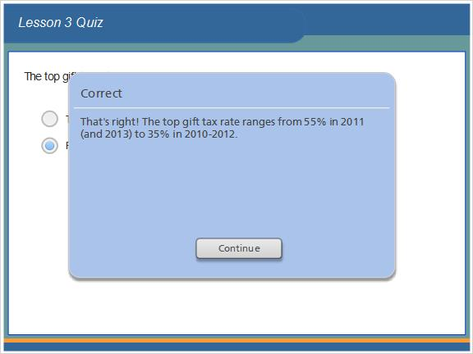

Incorrect (Slide Layer)
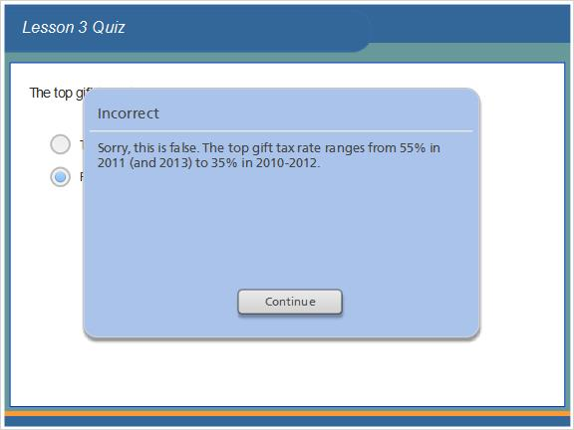

1.99 Qualified transfers include transfers for educational expenses or medical expenses.
(True/False, 10 points, 1 attempt permitted)
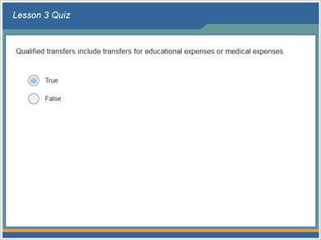
Correct | Choice
X | True
 | False

Feedback when correct:
That's right! An exclusion from gift tax is also provided for certain qualified transfers for educational expenses or medical expenses.
Feedback when incorrect:
Sorry, this is true. An exclusion from gift tax is also provided for certain qualified transfers for educational expenses or medical expenses.

Correct (Slide Layer)
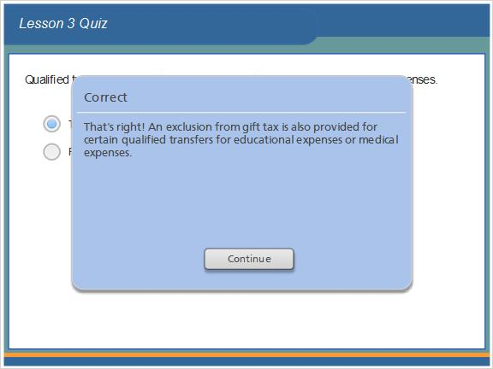

Incorrect (Slide Layer)
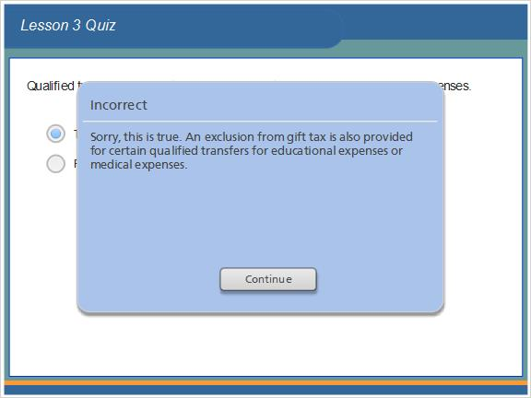

1.100 An unlimited deduction is available for gift tax purposes for amounts transferred to charity.
(True/False, 10 points, 1 attempt permitted)
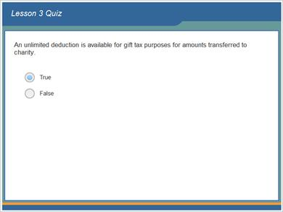
Correct | Choice
X | True
 | False

Feedback when correct:
That's right! An unlimited deduction is available for gift tax purposes for amounts transferred to a charity.
Feedback when incorrect:
Sorry, this is true. An unlimited deduction is available for gift tax purposes for amounts transferred to a charity.

Correct (Slide Layer)
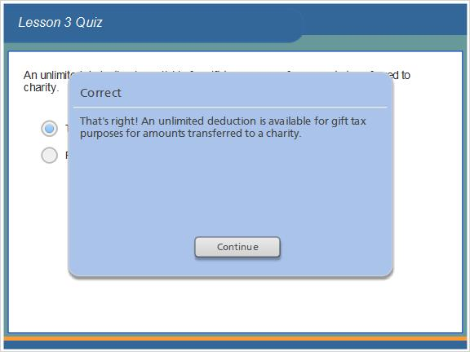

Incorrect (Slide Layer)
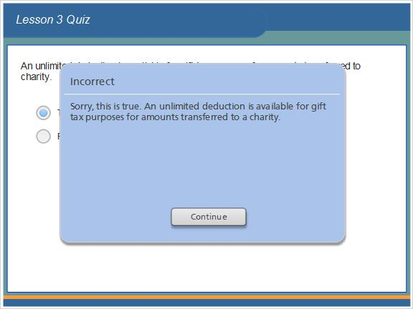

1.101 The marital deduction is generally available only for bequests of terminable interests.
(True/False, 10 points, 1 attempt permitted)
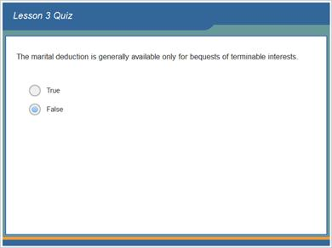
Correct | Choice
 | True
X | False

Feedback when correct:
That's right! The marital deduction is generally not available for bequests of terminable interests.
Feedback when incorrect:
Sorry, this is false. The marital deduction is generally not available for bequests of terminable interests.

Correct (Slide Layer)
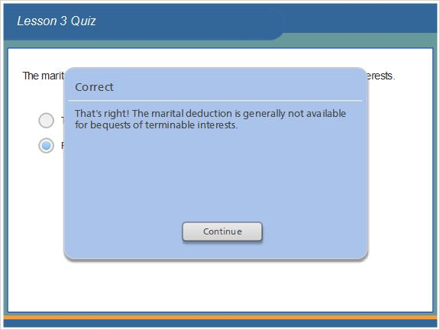

Incorrect (Slide Layer)
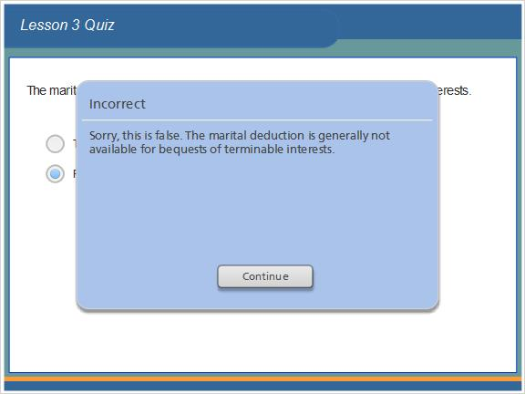

1.102 Results Slide
(Results Slide, 0 points, 1 attempt permitted)
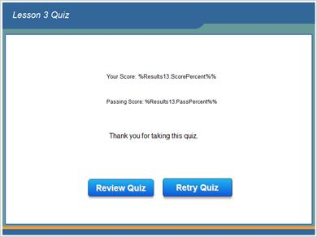

Results for
1.96 The unified credit is subtracted from the gross gift tax to arrive at the gift tax payable for the year.
1.97 Gift tax is calculated on a cumulative basis.
1.98 The top gift tax rate is 28%.
1.99 Qualified transfers include transfers for educational expenses or medical expenses.
1.100 An unlimited deduction is available for gift tax purposes for amounts transferred to charity.
1.101 The marital deduction is generally available only for bequests of terminable interests.

Result slide properties
Passing Score | 70%

1.103 Lesson 3 Read More Supplement
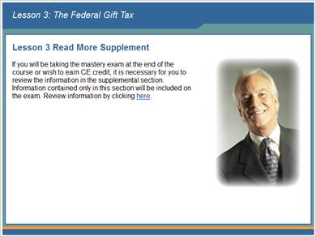

1.104 Lesson 4: Generation-Skipping Transfer Tax


1.105 Lesson 4 Objectives
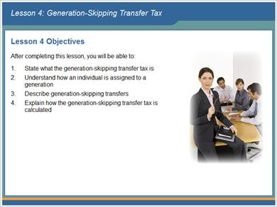

1.106 Introduction
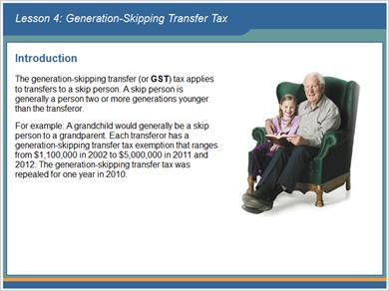

1.107 Introduction
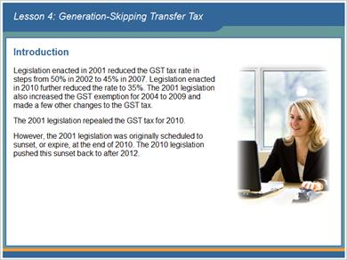

1.108 Assignment to Generations
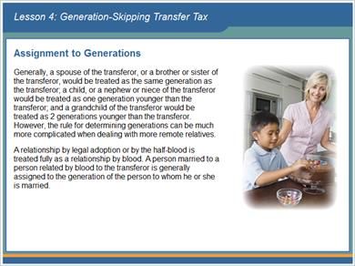

1.109 Pre-Deceased Parent Rule
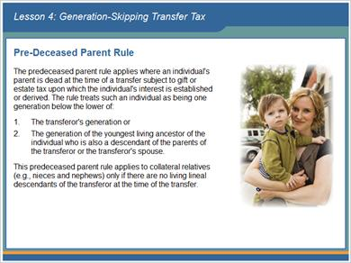

1.110 Pre-Deceased Parent Rule
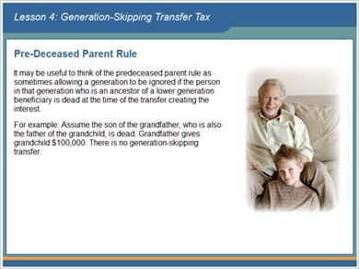

1.111 Assignment on the Basis of Date of Birth
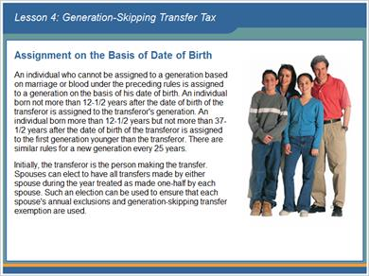

1.112 Multiple-Skip Rule
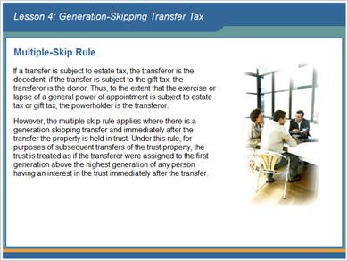

1.113 Multiple-Skip Rule
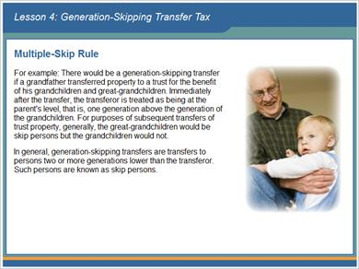

1.114 Exclusions & Exceptions
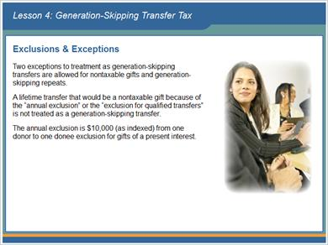

1.115 Exclusions & Exceptions
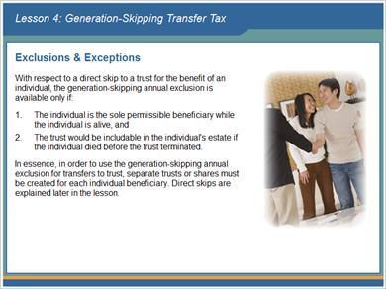

1.116 Exclusions & Exceptions
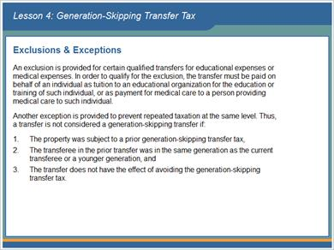

1.117 Transfers
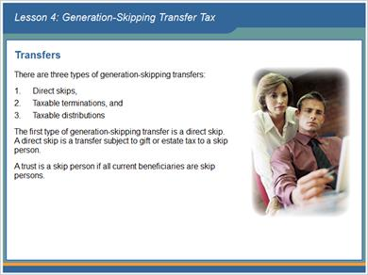

1.118 Transfers
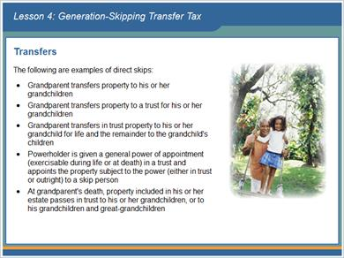

1.119 Transfers
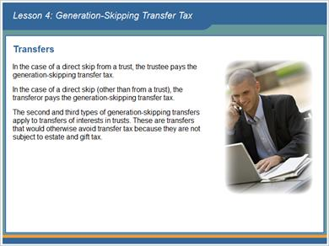

1.120 Transfers
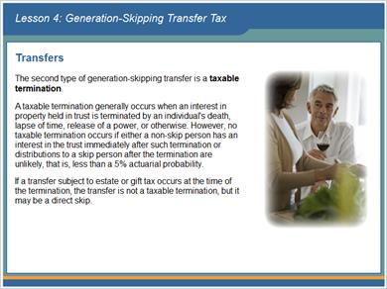

1.121 Transfers
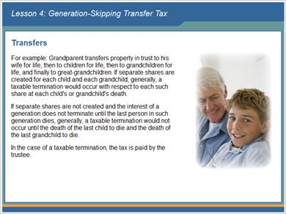

1.122 Transfers
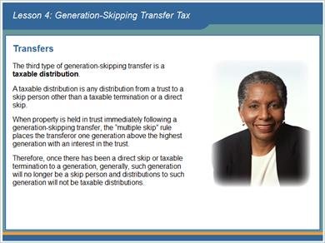

1.123 Transfers
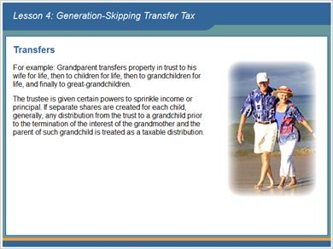

1.124 Transfers
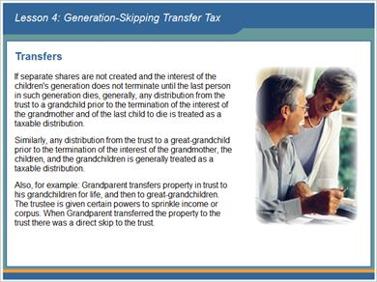

1.125 Transfers
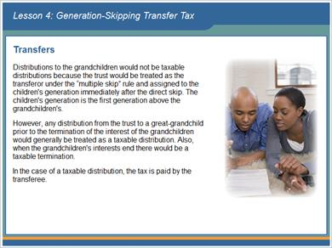

1.126 Calculation of GST Tax
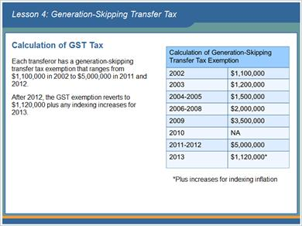

1.127 Calculation of GST Tax
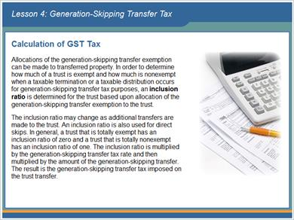

1.128 Calculation of GST Tax
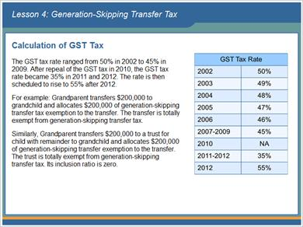

1.129 Calculation of GST Tax
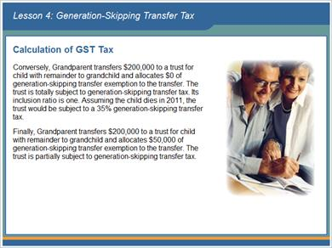

1.130 Calculation of GST Tax
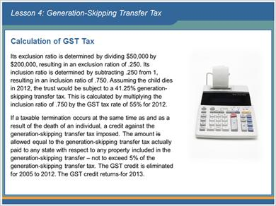

1.131 End of Lesson 4
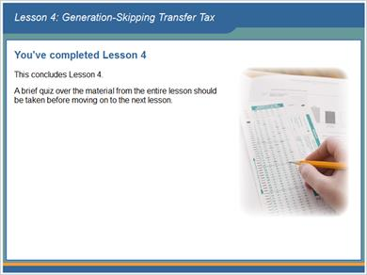

1.132 The generation-skipping transfer tax rate ranges from 50% in 2002 to 35% in 2012.
(True/False, 10 points, 1 attempt permitted)
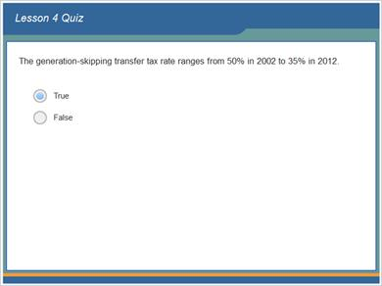
Correct | Choice
X | True
 | False

Feedback when correct:
That's right! The generation-skipping transfer tax rate ranges from 50% in 2002 to 35% in 2012. The GST tax was repealed for 2010, but returned in 2011 and 2012 with a tax rate of 35%. The GST tax rate is scheduled to revert to 55% for 2013.
Feedback when incorrect:
Sorry, this is true. The generation-skipping transfer tax rate ranges from 50% in 2002 to 35% in 2012. The GST tax was repealed for 2010, but returned in 2011 and 2012 with a tax rate of 35%. The GST tax rate is scheduled to revert to 55% for 2013.

Correct (Slide Layer)
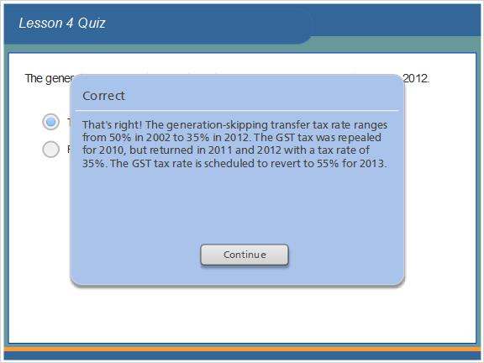

Incorrect (Slide Layer)
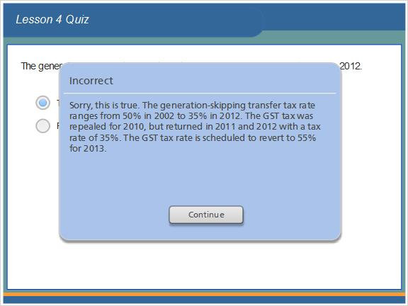

1.133 To the extent that the exercise or lapse of a general power of appointment is subject to estate tax or gift tax, the powerholder is the transferor.
(True/False, 10 points, 1 attempt permitted)
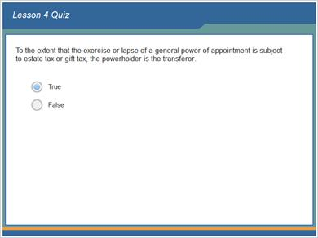
Correct | Choice
X | True
 | False

Feedback when correct:
That's right! If a transfer is subject to estate tax, the transferor is the decedent; if the transfer is subject to the gift tax, the transferor is the donor. Thus, to the extent that the exercise or lapse of a general power of appointment is subject to estate tax or gift tax, the powerholder is the transferor.
Feedback when incorrect:
Sorry, this is true.If a transfer is subject to estate tax, the transferor is the decedent; if the transfer is subject to the gift tax, the transferor is the donor. Thus, to the extent that the exercise or lapse of a general power of appointment is subject to estate tax or gift tax, the powerholder is the transferor.

Correct (Slide Layer)
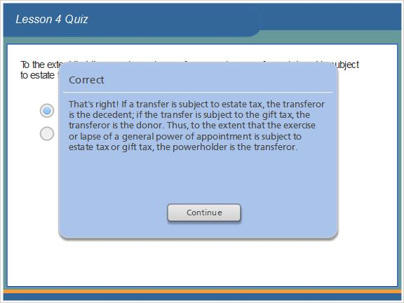

Incorrect (Slide Layer)
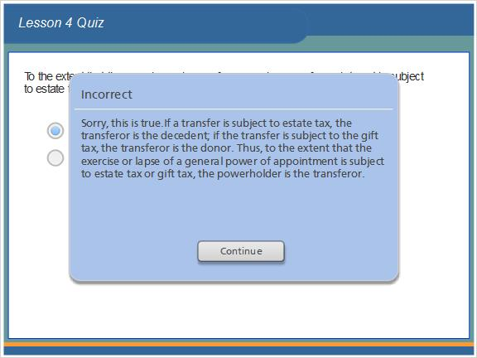

1.134 Lifetime transfers that would be a nontaxable gift because of the "annual exclusion" or the "exclusion for qualified transfers" are nevertheless treated as generation-skipping transfers.
(True/False, 10 points, 1 attempt permitted)
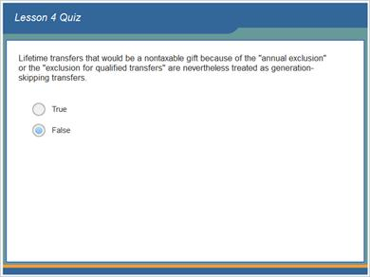
Correct | Choice
 | True
X | False

Feedback when correct:
That's right! Lifetime transfers that would be a nontaxable gift because of the "annual exclusion" or the "exclusion for qualified transfers" are not treated as generation-skipping transfers.
Feedback when incorrect:
Sorry, this is false. Lifetime transfers that would be a nontaxable gift because of the "annual exclusion" or the "exclusion for qualified transfers" are not treated as generation-skipping transfers.

Correct (Slide Layer)
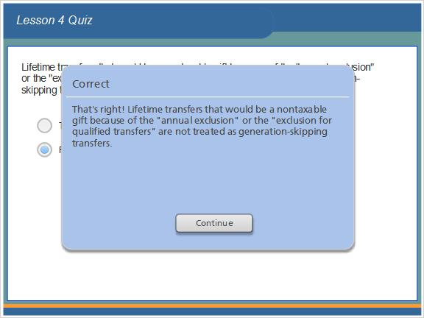

Incorrect (Slide Layer)
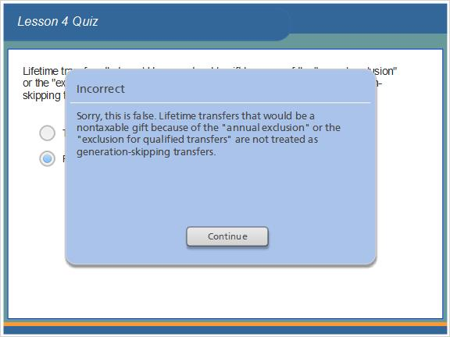

1.135 A direct skip is a transfer subject to gift or estate tax to a skip person.
(True/False, 10 points, 1 attempt permitted)
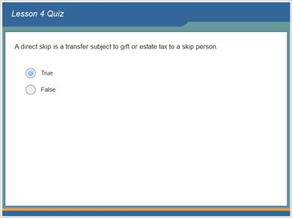
Correct | Choice
X | True
 | False

Feedback when correct:
That's right! A direct skip is a transfer subject to gift or estate tax to a skip person.
Feedback when incorrect:
Sorry, this is true. A direct skip is a transfer subject to gift or estate tax to a skip person.

Correct (Slide Layer)
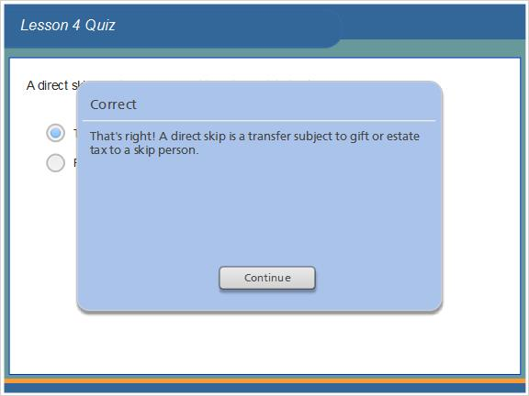

Incorrect (Slide Layer)
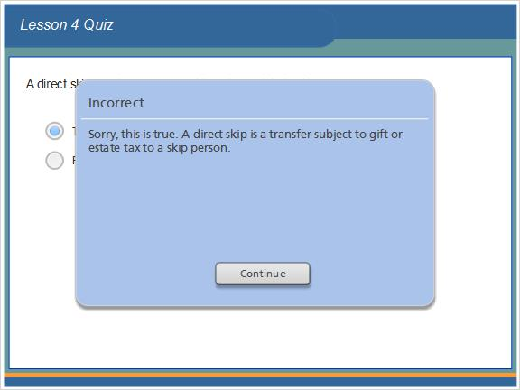

1.136 The generation-skipping transfer exemption is $600,000.
(True/False, 10 points, 1 attempt permitted)
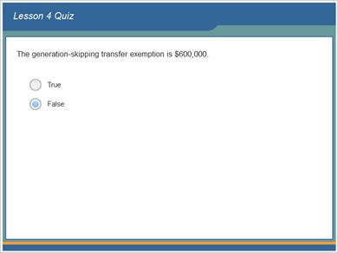
Correct | Choice
 | True
X | False

Feedback when correct:
That's right! The generation-skipping transfer exemption ranges from $1,060,000 (as indexed) in 2001 to $5,000,000 in 2011-2012.
Feedback when incorrect:
Sorry, this is false. The generation-skipping transfer exemption ranges from $1,060,000 (as indexed) in 2001 to $5,000,000 in 2011-2012.

Correct (Slide Layer)
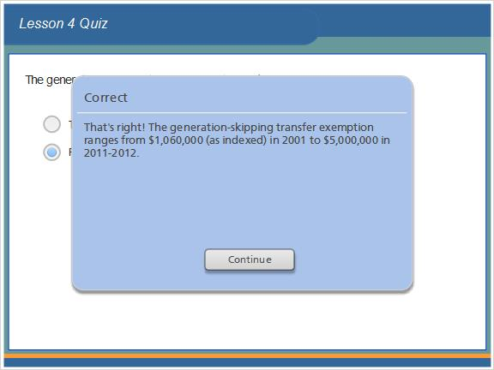

Incorrect (Slide Layer)
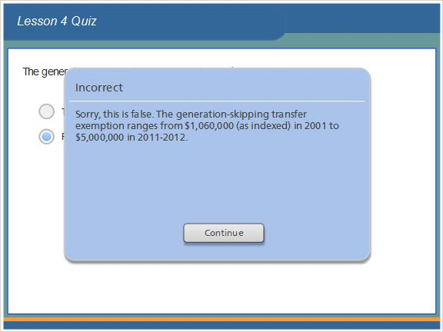

1.137 The inclusion ratio may change as additional transfers are made to the trust.
(True/False, 10 points, 1 attempt permitted)
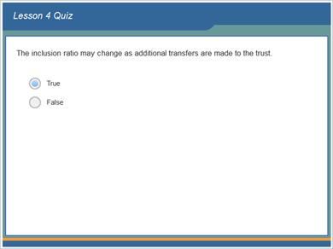
Correct | Choice
X | True
 | False

Feedback when correct:
That's right! The inclusion ratio may change as additional transfers are made to the trust.
Feedback when incorrect:
Sorry, this is true. The inclusion ratio may change as additional transfers are made to the trust.

Correct (Slide Layer)
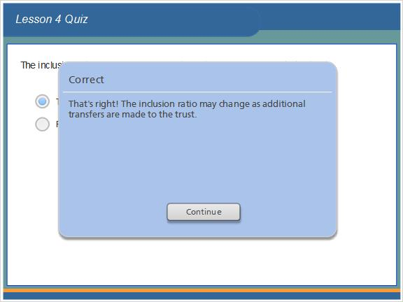

Incorrect (Slide Layer)
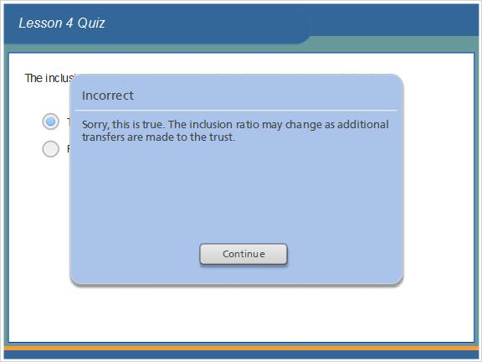

1.138 Results Slide
(Results Slide, 0 points, 1 attempt permitted)
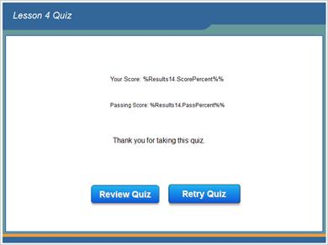

Results for
1.132 The generation-skipping transfer tax rate ranges from 50% in 2002 to 35% in 2012.
1.133 To the extent that the exercise or lapse of a general power of appointment is subject to estate tax or gift tax, the powerholder is the transferor.
1.134 Lifetime transfers that would be a nontaxable gift because of the "annual exclusion" or the "exclusion for qualified transfers" are nevertheless treated as generation-skipping transfers.
1.135 A direct skip is a transfer subject to gift or estate tax to a skip person.
1.136 The generation-skipping transfer exemption is $600,000.
1.137 The inclusion ratio may change as additional transfers are made to the trust.

Result slide properties
Passing Score | 70%

1.139 Lesson 4 Read More Supplement
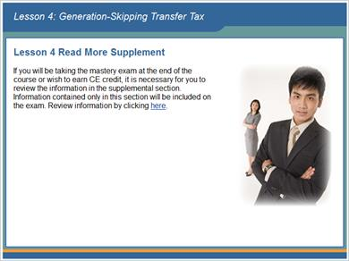

1.140 Lesson 5: Marital Deduction Planning


1.141 Lesson 5 Objectives
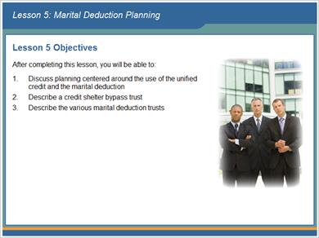

1.142 Introduction
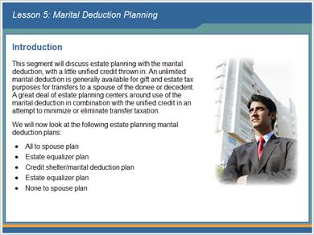

1.143 All to Spouse Plan
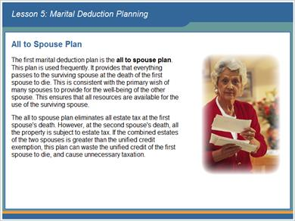

1.144 All to Spouse Plan
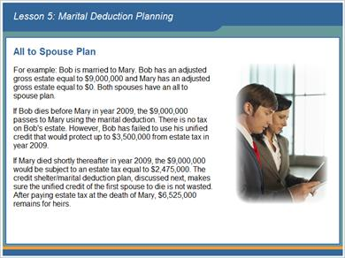

1.145 All to Spouse Plan
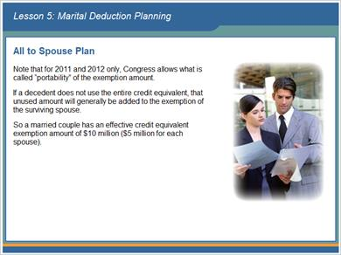

1.146 Credit Shelter/Marital Deduction Plan
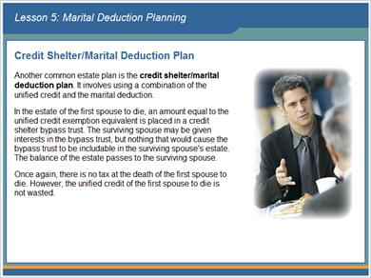

1.147 Credit Shelter/Marital Deduction Plan
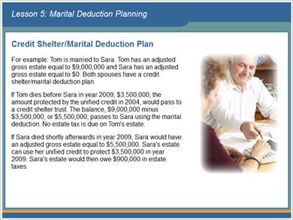

1.148 Credit Shelter/Marital Deduction Plan
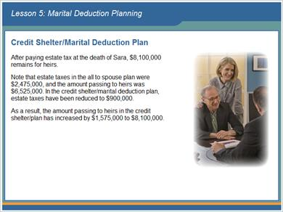

1.149 Credit Shelter/Marital Deduction Plan
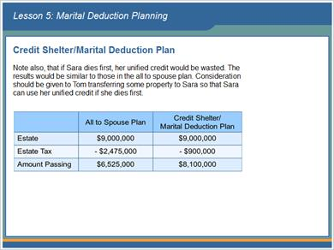

1.150 Credit Shelter/Marital Deduction Plan
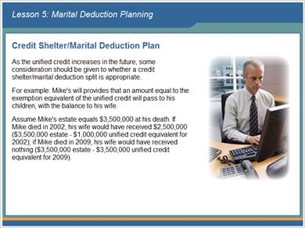

1.151 Credit Shelter/Marital Deduction Plan
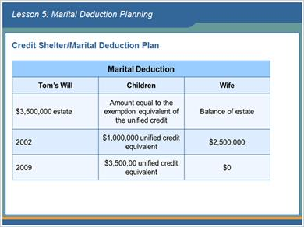

1.152 Estate Equalizer Plan
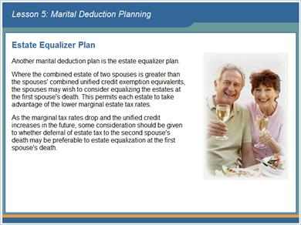

1.153 Estate Equalizer Plan
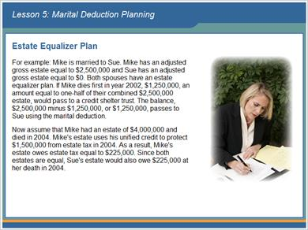

1.154 Estate Equalizer Plan
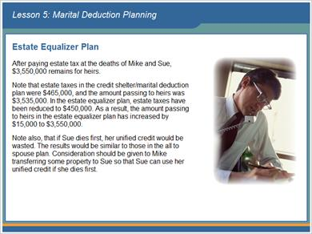

1.155 None to Spouse Plan
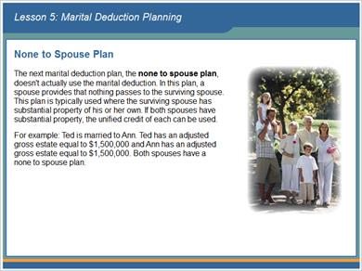

1.156 None to Spouse Plan
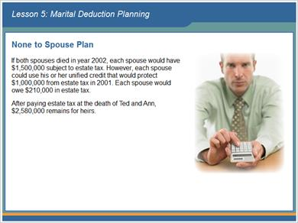

1.157 Reverse QTIP Election
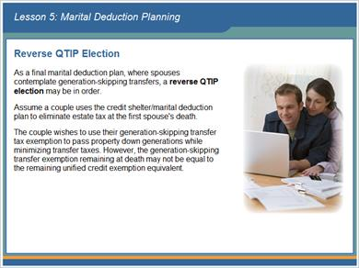

1.158 Reverse QTIP Election
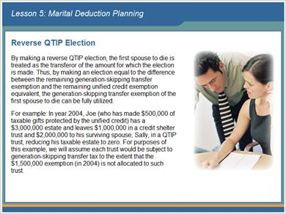

1.159 Reverse QTIP Election
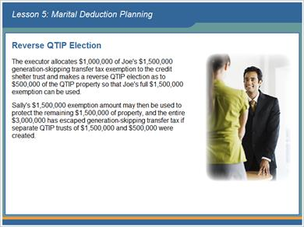

1.160 Credit Shelter and Marital Deduction Trusts
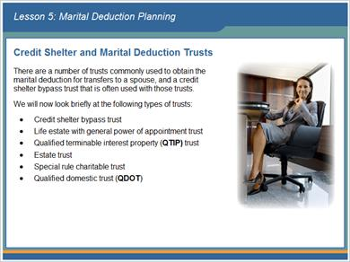

1.161 Definition of Terms
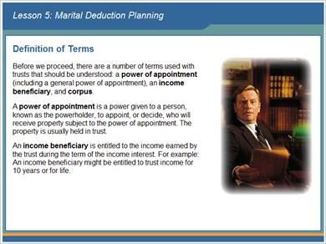

1.162 Definition of Terms
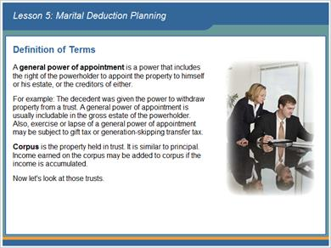

1.163 Credit Shelter Bypass Trust
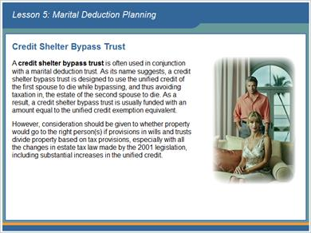

1.164 Credit Shelter Bypass Trust
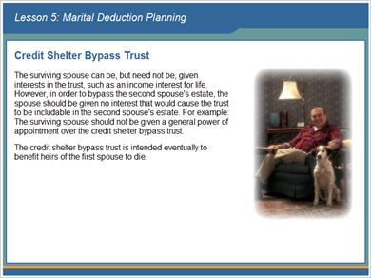

1.165 Life Estate with General Power of Appointment Trust


1.166 Qualified Terminable Interest Property Trust (QTIP)
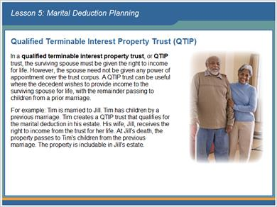

1.167 Estate Trust
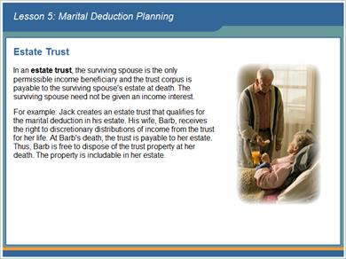

1.168 Estate Trust
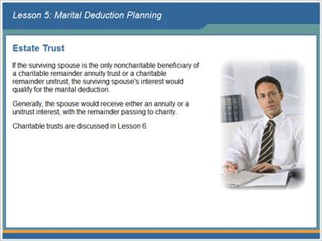

1.169 Qualified Domestic Trust (QDOT)
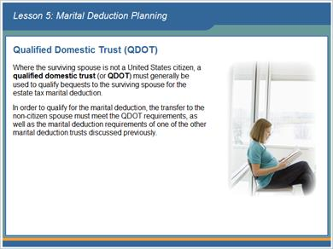

1.170 Qualified Domestic Trust (QDOT)
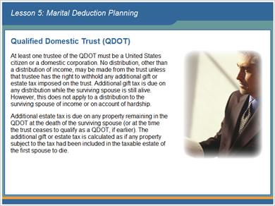

1.171 End of Lesson 5
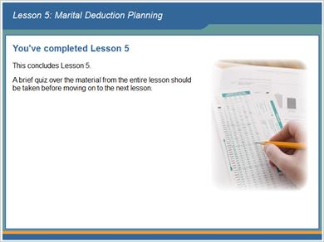

1.172 An estate equalizer marital deduction plan wastes the lower marginal estate tax rates of each spouse's estate.
(True/False, 10 points, 1 attempt permitted)
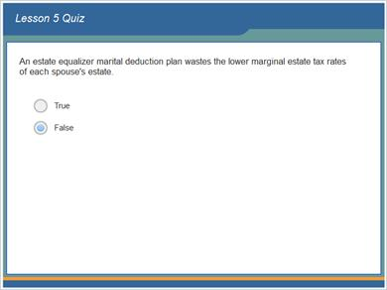
Correct | Choice
 | True
X | False

Feedback when correct:
That's right! An estate equalizer marital deduction plan permits each estate to take advantage of the lower marginal estate tax rates in each spouse's estate.
Feedback when incorrect:
Sorry, this is false. An estate equalizer marital deduction plan permits each estate to take advantage of the lower marginal estate tax rates in each spouse's estate.

Correct (Slide Layer)
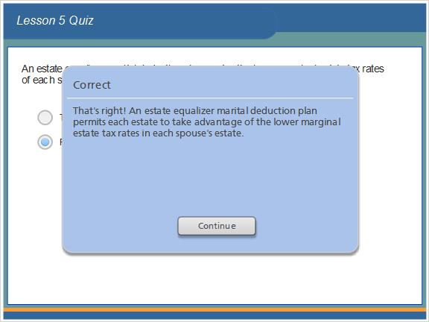

Incorrect (Slide Layer)
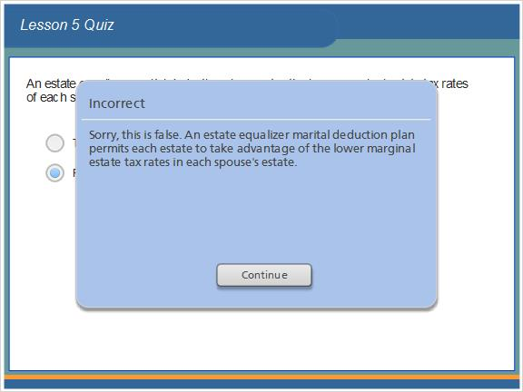

1.173 The none to spouse plan is often used where the surviving spouse has substantial property of his or her own.
(True/False, 10 points, 1 attempt permitted)
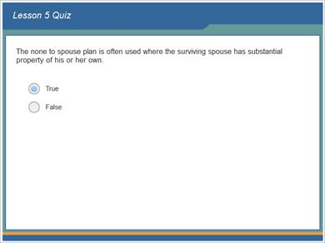
Correct | Choice
X | True
 | False

Feedback when correct:
That's right! The none to spouse plan is typically used where the surviving spouse has substantial property of his or her own. If both spouses have substantial property, the unified credit of each can be used.
Feedback when incorrect:
Sorry, this is true. The none to spouse plan is typically used where the surviving spouse has substantial property of his or her own. If both spouses have substantial property, the unified credit of each can be used.

Correct (Slide Layer)
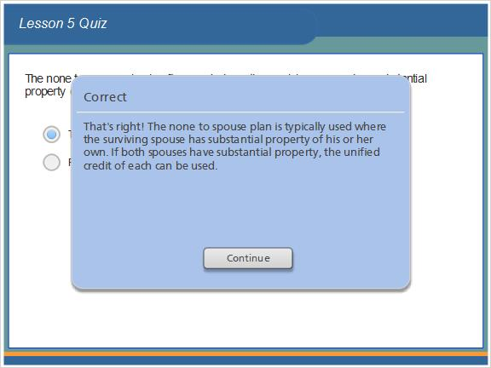

Incorrect (Slide Layer)
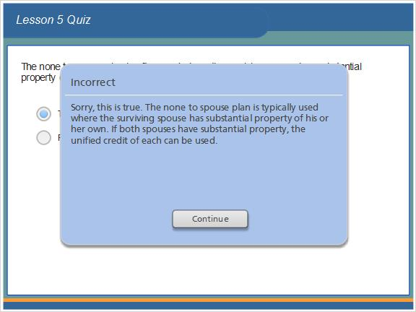

1.174 Where spouses contemplate generation-skipping transfers, a reverse QTIP election should not be used.
(True/False, 10 points, 1 attempt permitted)
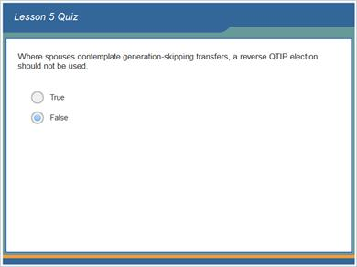
Correct | Choice
 | True
X | False

Feedback when correct:
That's right! Where spouses contemplate generation-skipping transfers, a reverse QTIP election may be in order.
Feedback when incorrect:
Sorry, this is false. Where spouses contemplate generation-skipping transfers, a reverse QTIP election may be in order.

Correct (Slide Layer)
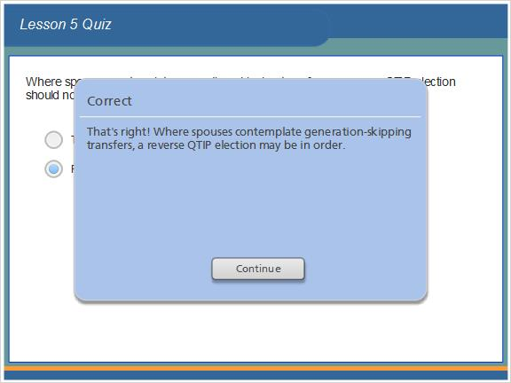

Incorrect (Slide Layer)
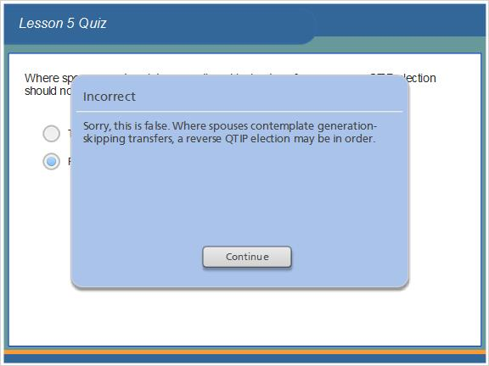

1.175 The surviving spouse cannot be given interests in a credit shelter bypass trust.
(True/False, 10 points, 1 attempt permitted)
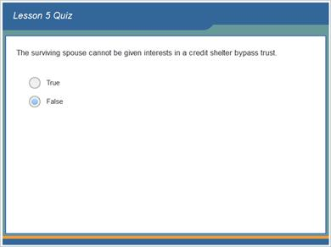
Correct | Choice
 | True
X | False

Feedback when correct:
That's right! The surviving spouse can be, but need not be, given interests in a credit shelter bypass trust.
Feedback when incorrect:
Sorry, this is false. The surviving spouse can be, but need not be, given interests in a credit shelter bypass trust.

Correct (Slide Layer)
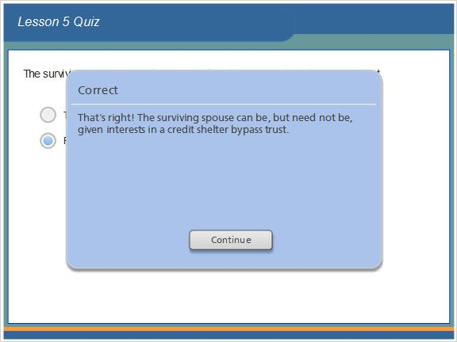

Incorrect (Slide Layer)
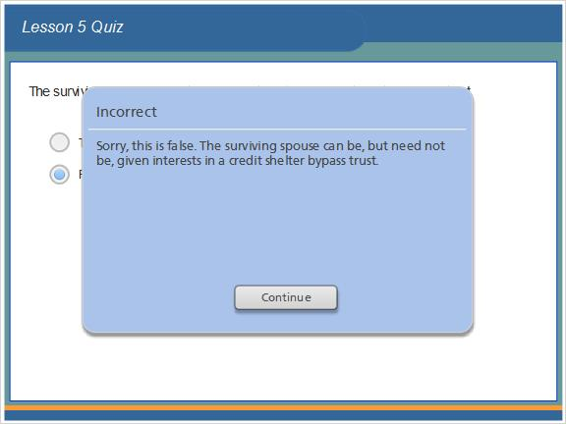

1.176 In an estate trust, the surviving spouse is the only permissible income beneficiary and the trust corpus is payable to the surviving spouse's estate at death.
(True/False, 10 points, 1 attempt permitted)
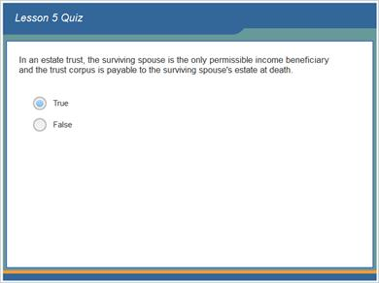
Correct | Choice
X | True
 | False

Feedback when correct:
That's right! In an estate trust, the surviving spouse is the only permissible income beneficiary and the trust corpus is payable to the surviving spouse's estate at death. The surviving spouse need not be given an income interest.
Feedback when incorrect:
Sorry, this is true. In an estate trust, the surviving spouse is the only permissible income beneficiary and the trust corpus is payable to the surviving spouse's estate at death. The surviving spouse need not be given an income interest.

Correct (Slide Layer)
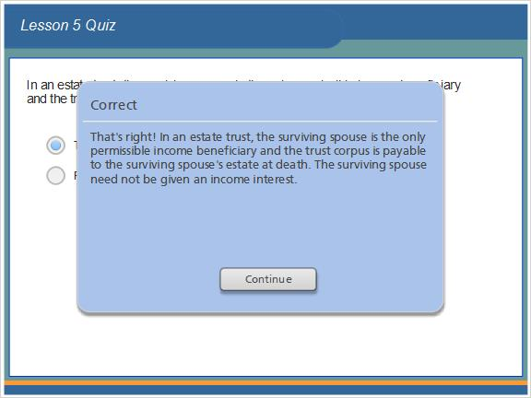

Incorrect (Slide Layer)
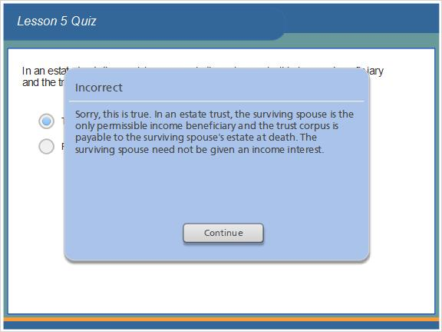

1.177 A qualified domestic trust (QDOT) is often used where the surviving spouse is not a United States citizen.
(True/False, 10 points, 1 attempt permitted)
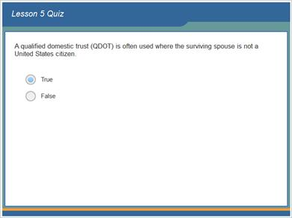
Correct | Choice
X | True
 | False

Feedback when correct:
That's right! Where the surviving spouse is not a United States citizen, a qualified domestic trust (or QDOT) must generally be used to qualify bequests to the surviving spouse for the estate tax marital deduction.
Feedback when incorrect:
Sorry, this is true. Where the surviving spouse is not a United States citizen, a qualified domestic trust (or QDOT) must generally be used to qualify bequests to the surviving spouse for the estate tax marital deduction.

Correct (Slide Layer)
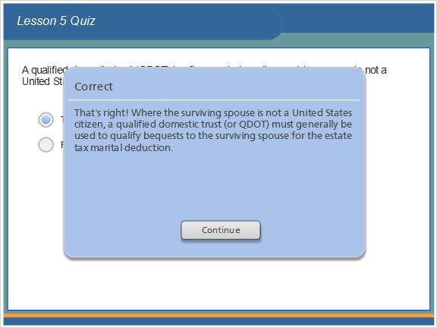

Incorrect (Slide Layer)
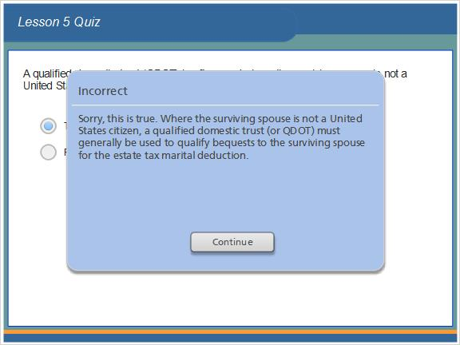

1.178 Results Slide
(Results Slide, 0 points, 1 attempt permitted)
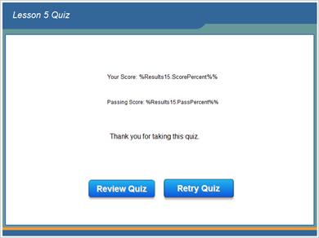

Results for
1.172 An estate equalizer marital deduction plan wastes the lower marginal estate tax rates of each spouse's estate.
1.173 The none to spouse plan is often used where the surviving spouse has substantial property of his or her own.
1.174 Where spouses contemplate generation-skipping transfers, a reverse QTIP election should not be used.
1.175 The surviving spouse cannot be given interests in a credit shelter bypass trust.
1.176 In an estate trust, the surviving spouse is the only permissible income beneficiary and the trust corpus is payable to the surviving spouse's estate at death.
1.177 A qualified domestic trust (QDOT) is often used where the surviving spouse is not a United States citizen.

Result slide properties
Passing Score | 70%

1.179 Lesson 5 Read More Supplement
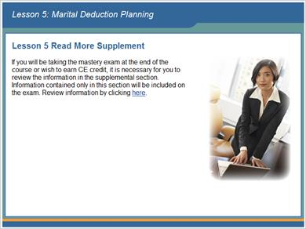

1.180 Lesson 6: Charitable Deduction Planning
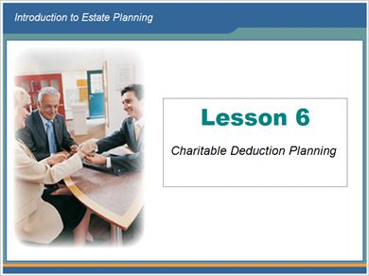

1.181 Lesson 6 Objectives
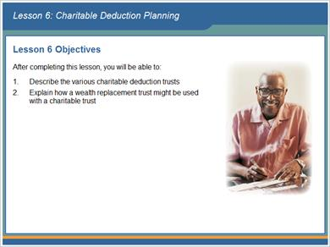

1.182 Introduction
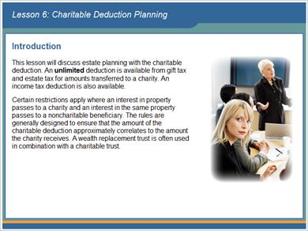

1.183 Availability of Charitable Deductions
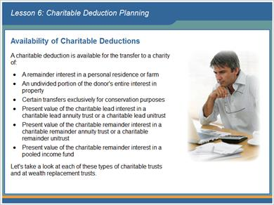

1.184 Charitable Lead Trusts
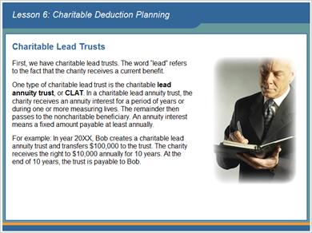

1.185 Charitable Lead Trusts
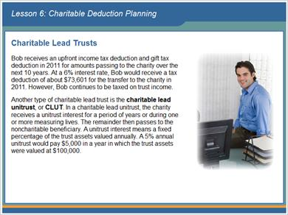

1.186 Charitable Lead Trusts
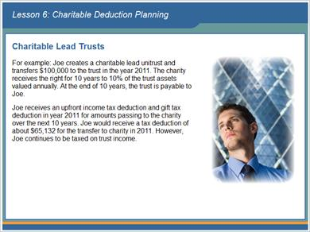

1.187 Charitable Remainder Trusts
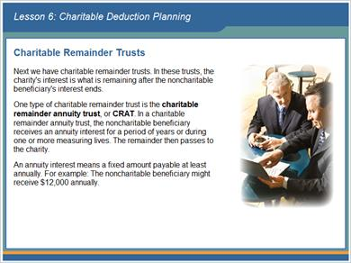

1.188 Charitable Remainder Trusts
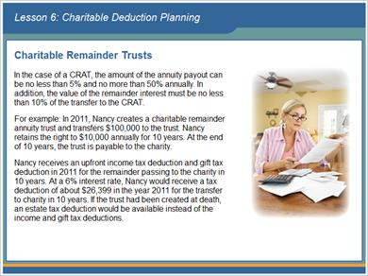

1.189 Charitable Remainder Trusts
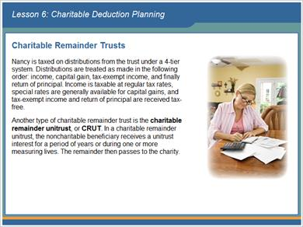

1.190 Charitable Remainder Trusts
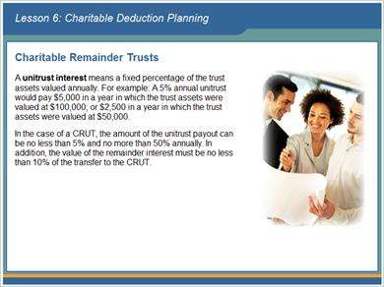

1.191 Charitable Remainder Trusts
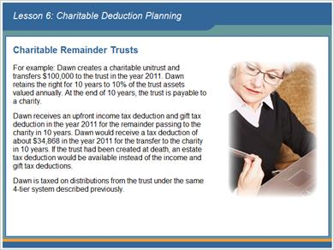

1.192 Pooled Income Fund
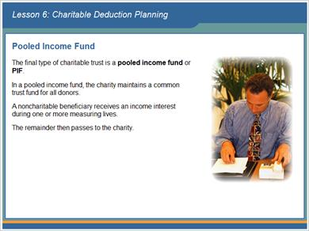

1.193 Pooled Income Fund
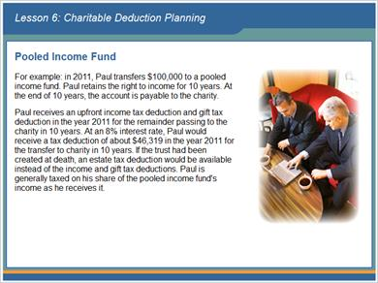

1.194 Wealth Replacement Trusts
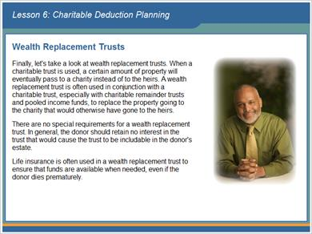

1.195 Wealth Replacement Trusts
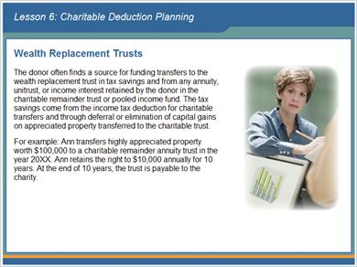

1.196 Wealth Replacement Trusts
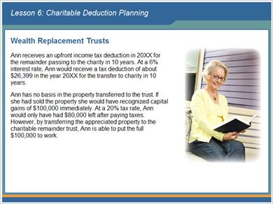

1.197 Wealth Replacement Trusts
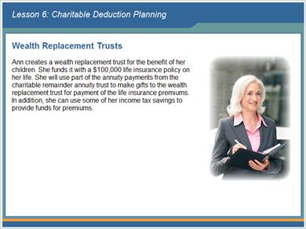

1.198 End of Lesson 6
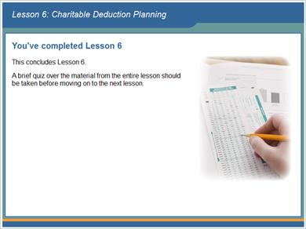

1.199 Lesson 6 Quiz
(True/False, 10 points, 1 attempt permitted)
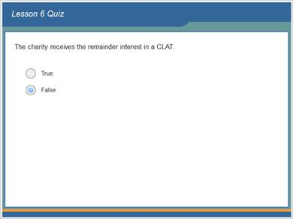
Correct | Choice
 | True
X | False

Feedback when correct:
That's right! The charity receives the lead annuity interest in a CLAT.
Feedback when incorrect:
Sorry, this is false. The charity receives the lead annuity interest in a CLAT.

Correct (Slide Layer)
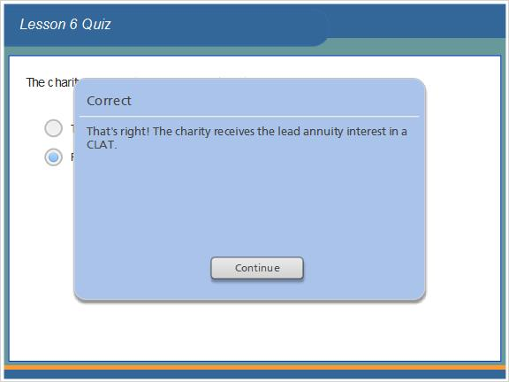

Incorrect (Slide Layer)
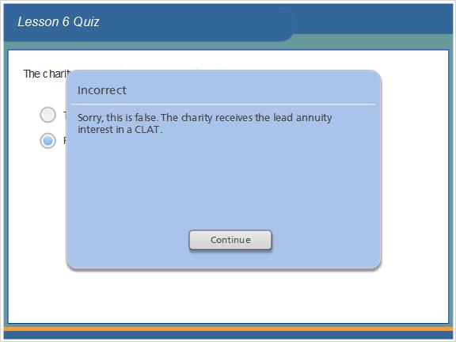

1.200 An annuity interest means a fixed amount payable at least annually.
(True/False, 10 points, 1 attempt permitted)
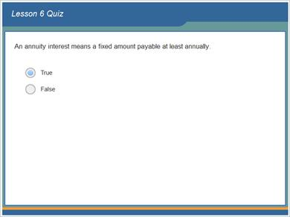
Correct | Choice
X | True
 | False

Feedback when correct:
That's right! An annuity interest means a fixed amount payable at least annually.
Feedback when incorrect:
Sorry, this is true. An annuity interest means a fixed amount payable at least annually.

Correct (Slide Layer)
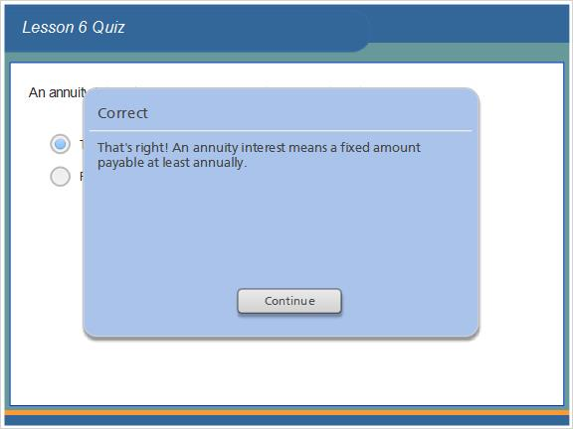

Incorrect (Slide Layer)
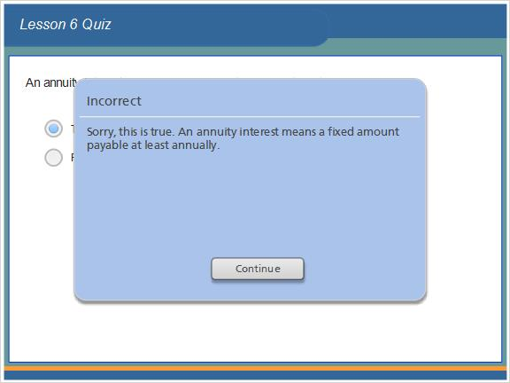

1.201 A unitrust interest means a fixed percentage of the trust assets valued.
(True/False, 10 points, 1 attempt permitted)
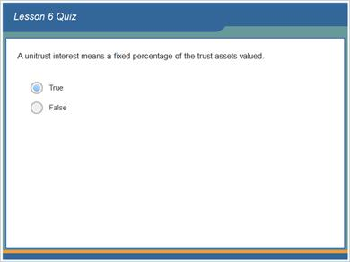
Correct | Choice
X | True
 | False

Feedback when correct:
That's right! A unitrust interest means a fixed percentage of the trust assets valued annually.
Feedback when incorrect:
Sorry, this is true. A unitrust interest means a fixed percentage of the trust assets valued annually.

Correct (Slide Layer)
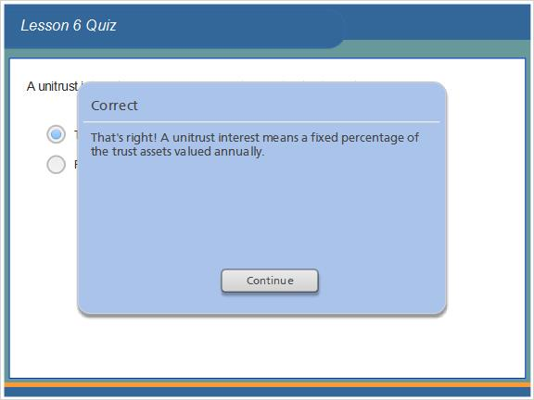

Incorrect (Slide Layer)
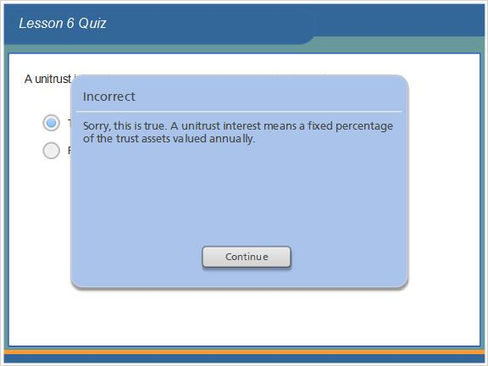

1.202 The value of the remainder interest must be no less than 10% of the transfer to the CRAT.
(True/False, 10 points, 1 attempt permitted)
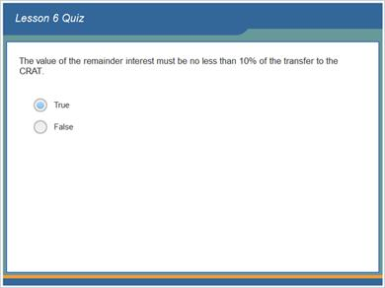
Correct | Choice
X | True
 | False

Feedback when correct:
That's right! The value of the remainder interest must be no less than 10% of the transfer to the CRAT.
Feedback when incorrect:
Sorry, this is true. The value of the remainder interest must be no less than 10% of the transfer to the CRAT.

Correct (Slide Layer)
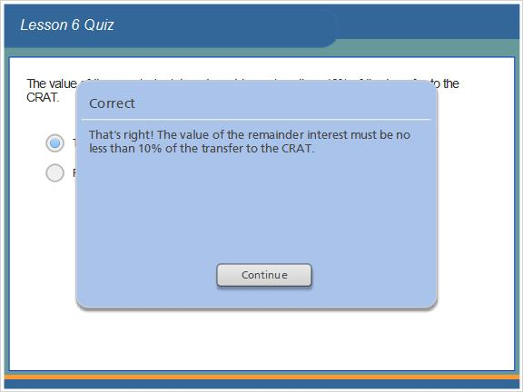

Incorrect (Slide Layer)
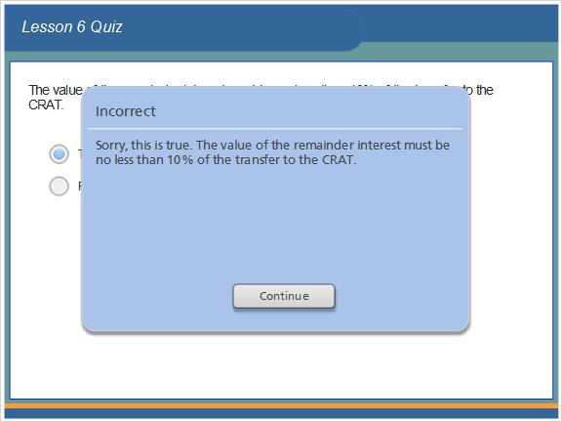

1.203 In the case of a CRUT, the amount of the unitrust payout can be no less than 5% and no more 10% annually.
(True/False, 10 points, 1 attempt permitted)
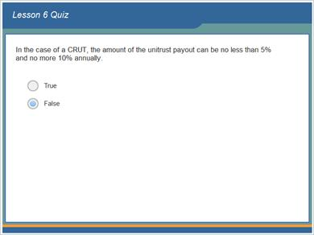
Correct | Choice
 | True
X | False

Feedback when correct:
That's right! In the case of a CRUT, the amount of the unitrust payout can be no less than 5% and no more 50% annually.
Feedback when incorrect:
Sorry, this is false. In the case of a CRUT, the amount of the unitrust payout can be no less than 5% and no more 50% annually.

Correct (Slide Layer)
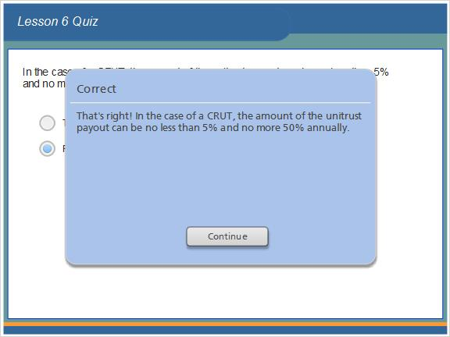

Incorrect (Slide Layer)
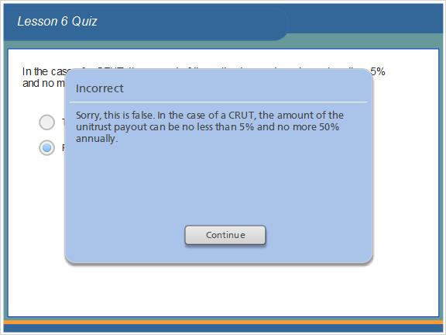

1.204 The charity receives the income interest in a pooled income fund.
(True/False, 10 points, 1 attempt permitted)
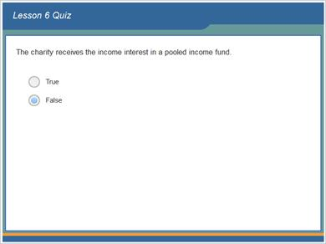
Correct | Choice
 | True
X | False

Feedback when correct:
That's right! The charity receives the remainder interest in a pooled income fund.
Feedback when incorrect:
Sorry, this is false. The charity receives the remainder interest in a pooled income fund.

Correct (Slide Layer)
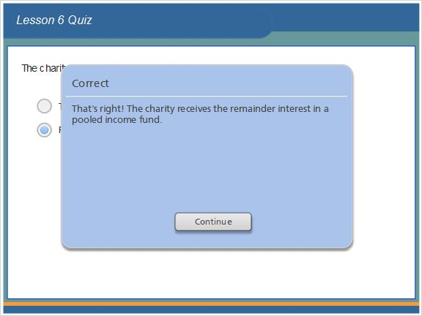

Incorrect (Slide Layer)
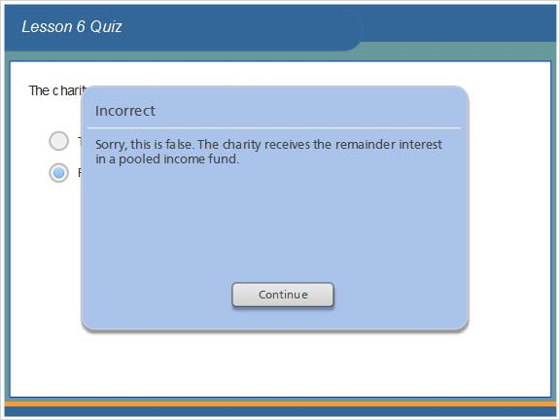

1.205 Results Slide
(Results Slide, 0 points, 1 attempt permitted)
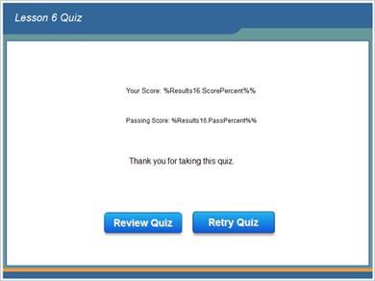

Results for
1.199 Lesson 6 Quiz
1.200 An annuity interest means a fixed amount payable at least annually.
1.201 A unitrust interest means a fixed percentage of the trust assets valued.
1.202 The value of the remainder interest must be no less than 10% of the transfer to the CRAT.
1.203 In the case of a CRUT, the amount of the unitrust payout can be no less than 5% and no more 10% annually.
1.204 The charity receives the income interest in a pooled income fund.

Result slide properties
Passing Score | 70%

1.206 Lesson 6 Read More Supplement
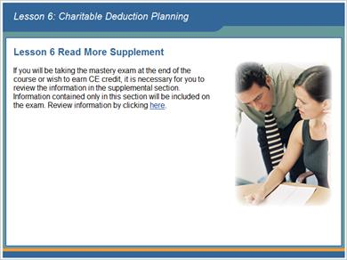

1.207 Exam Access Instructions
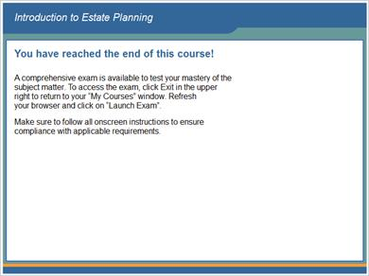

1.208 End of Course!


