Chapter 9
FINANCIAL GOALS – CURRENT LIFESTYLE
INTRODUCTION
How important is it to you to have one car, or two cars, or even three cars? Do you believe you need an SUV, a Lexus, or a Jaguar?
Is eating dinner out seven nights a week a part of your normal life style that you clearly cannot do without?
Do you need to get away on two-week luxury vacations two times or three times a year, or is a modest one-week road trip and a few days at home around holiday times enough?
These and numerous similar questions define an individual’s lifestyle. There is no right or wrong, no excess or excessive sacrifice that is or should be viewed as the appropriate norm. The financial aspects of your personal lifestyle are quite simply determined by:
1. how much you want to spend to maintain your desired lifestyle;
2. where current lifestyle fits into your personal financial priority spectrum; and
3. what resources you have available to fund your desired lifestyle and your other financial goals.
For example, if a retired client has accumulated investment and retirement assets totaling $5,000,000 and is happy (comfortable?) with an after-tax lifestyle of $200,000 a year, leaving aside issues of inflation, a 4% after-tax current yield covers his cost of living. Even if the $5,000,000 never earned a penny, the funds would last 25 years with withdrawals of $200,000 a year.
If the client ultimately wanted to leave his heirs the full $5,000,000 that he had accumulated during his lifetime, the funds would need to earn the 4% a year. If the client were concerned with the effects of inflation on his spending and the value of his heirs’ inheritance, the investments would require a higher yield. For example:
Assume the client expects to live for another 20 years and that he assumes an annual inflation rate of 3%:
- To leave his heirs the future value of the $5,000,000 at the end of the 20 years, the value of the assets at that time would need to grow to approximately $9,030,000. In order to maintain an inflation-adjusted lifestyle of $200,000 a year for all 20 years, and to accumulate the desired $9,030,000, the client’s investments would have to earn an average of approximately 7.14% a year for the entire 20 years.
- If his lifestyle expenditures were to remain flat at $200,000, in order to accumulate the planned $9,030,000 3% inflation-adjusted inheritance, the assets would have to earn an average of approximately 6.25% per year.
All of the alternatives discussed in this example can be summarized as follows:

Current Lifestyle | Inflation  Rate for  Lifestyle | Inflation Rate for  End Value Growth | Asset  Value  in 20 Years | Required Earnings Rate
$200,000 | 0% | 0% | $ 1,000,000 | 0%
$200,000 | 0% | 0% | $ 5,000,000 | 4%
$200,000 | 0% | 3% | $ 9,030,000 | 6.25%
$200,000 | 3% | 3% | $ 9,030,000 | 7.15%

This example provides a simple reminder of the basic investment adage: in order to attain a higher rate of return, you will be facing a higher level of risk.
Although 7.15% does not appear to be much more than 6.25% (only 90 basis points), it is a 14.4% higher rate of return. If you could be certain that the investment you choose will yield at least the lower target of 6.25%, then you really have no downside risk. But, it is unrealistic to expect such guarantees, and the true downside or worst-case risk may be that you have less security than you are willing to accept.
The lesson to learn here is only partially related to rates of returns and expected returns. The real message concerns the importance of the information derived from effective analysis. One should make decisions with the highest degree of understanding of the resulting consequences. Most mistakes people make are due to ignorance of the range and probability of results and the lack of planning for the contingencies of the underperformance of chosen strategies.
LIFESTYLE AND PRIORITIES
Where does lifestyle fit in among a client’s priorities? There are two levels of analysis to consider:
1. How high a priority is lifestyle among the following basic goals of financial planning?
(a) Current lifestyle
(b) Children’s education
(c) Retirement funding
(d) Parental issues
(e) Estate planning
(f) Other special needs (such as a disabled child)
2. What elements of current lifestyle are most important to the client? (Refer to Chapter 16, Budgeting and Cash Management, for a more detailed analysis of personal budget planning and the components of individual spending.)
Figure 9.1 provides a simple pie chart illustration of the allocation of financial resources among the basic goals of financial planning, while Figure 9.2 provides a similar illustration of the allocation of the resources devoted to current lifestyle among various non-discretionary (fixed) and discretionary components.
Figure 9.1
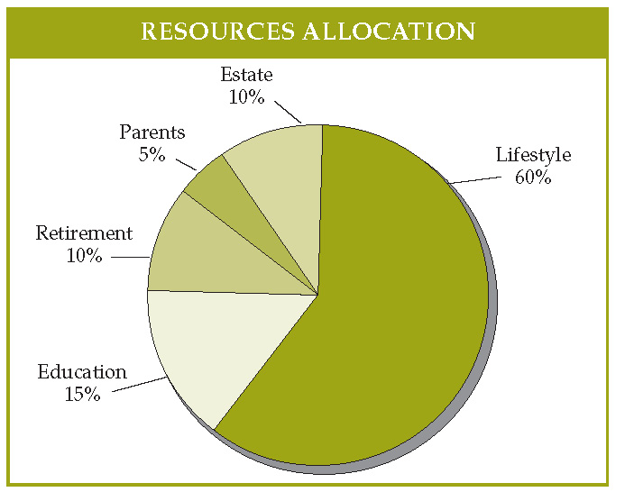

The chart in Figure 9.1 demonstrates a resource allocation of an individual who views current lifestyle as a relatively low priority. Allocations of 90% or 95% are not unusual. Two reasons for only 60% of resources being used for common lifestyle are easily identified: (1) the person is very (overly?) concerned about the other priorities of his funds, limited though they may be; or (2) the individual has far more assets than are necessary to maintain current lifestyle so that the the individual easily can save and invest excess funds for other, future needs.

Figure 9.2
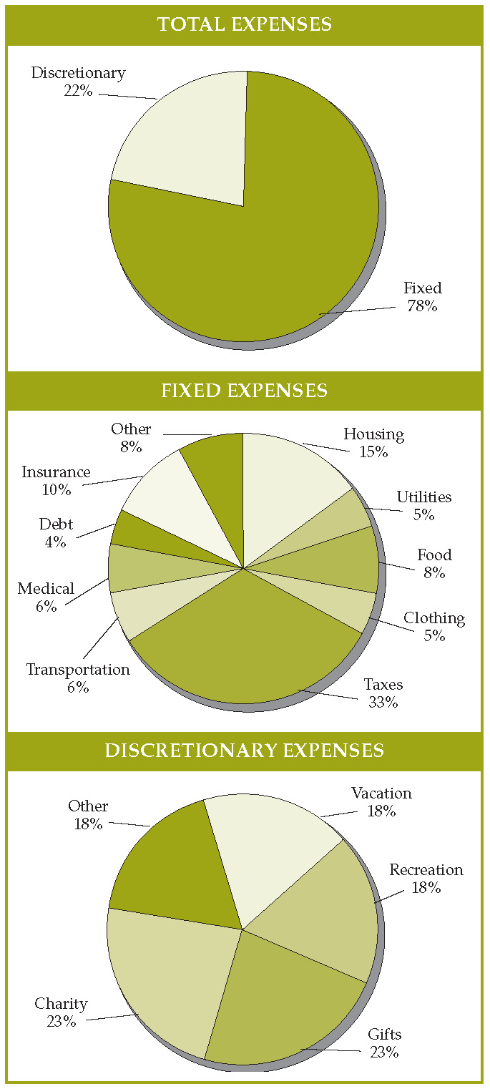

Most of our clients have potential goals and financial objectives that exceed the available resources, making the choice of prioritizing current lifestyle well above other needs a more difficult choice. Sometimes the allocation choices are eased by outside factors, such as:
- not having any children;
- children receiving college scholarships;
- exceptional employer-funded pension plans; or
- trust funds and anticipated inheritances to fund retirement needs, children’s education or inheritances for children.
Knowing and understanding all of the outside funding factors that individuals may have available makes it easier to determine how much they will be able to spend now for a greater lifestyle.
The basic allocation between fixed and discretionary expenses obviously is influenced by available resources. Fixed, required expenses, such as food, housing and clothing, must come first. But, even within this category of expenditures, there are options. How big a house do you need, or want? How often do you eat at home or eat out? Do you serve more steak or hamburger?
Among discretionary expenses, for many families vacations tend to be a major expenditure, as do general recreational expenses. Season tickets to the local professional baseball, football, ice hockey, and basketball teams can be a huge expense, yet for some people these expenditures represent more important objectives than eating steak rather than hamburger every night.
Chapter 5, discussing “Attitudes and Behavioral Characteristics of Financial Planning Clients,” is worth mentioning at this point. As that chapter explains, many non-financial factors influence basic financial planning decisions. These factors, which include: (1) cultural background; (2) family experiences; (3) emotional and medical issues; (4) life cycle stage and age; and (5) education, expertise, and personal experiences, usually are as important as the resources available to a client when making important allocation decisions. These influencers are less obvious and consequently more difficult to assimilate and understand with respect to their impact on the decision-making process.
A simple example, as is discussed in Chapter 5, is the effect of being raised in a household with parents who were scarred by the Great Depression. Such children will tend to be either very conservative in their own spending, constantly worried about the future, or they will be so turned-off by their parent’s stinginess that they will become big spenders or even spendthrifts, heavily in debt.

