Municipal Bonds
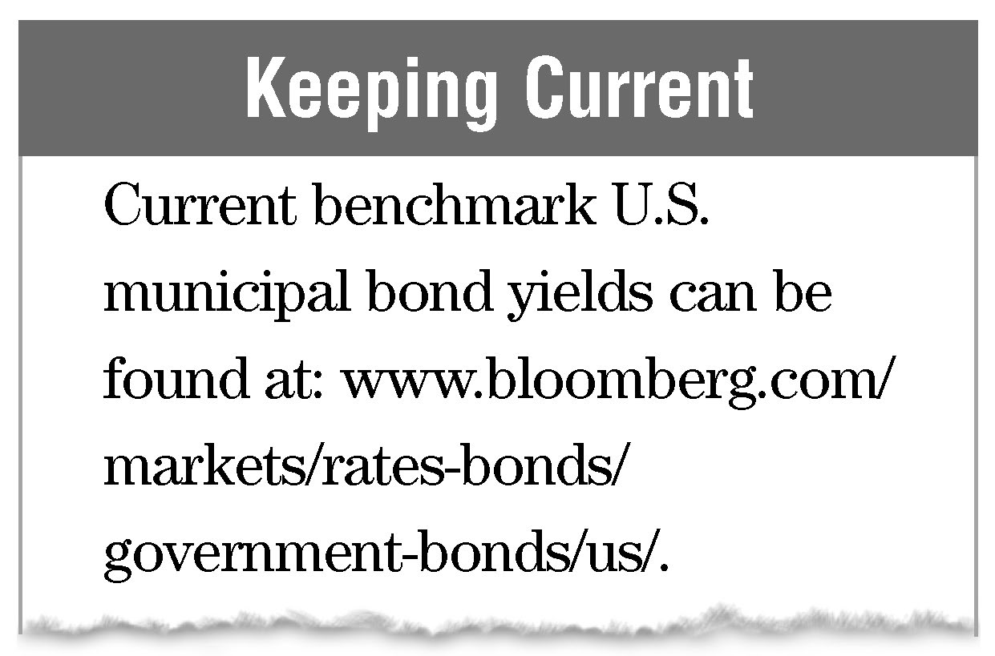
Municipal bonds, also referred to as “tax-exempt bonds,” are issued by states, counties, cities, and other political units in order to fund a variety of projects. The main attraction for the investor of “munis” has been the exemption from federal, and sometimes, state income taxes. Because munis typically pay lower coupon rates, they are most attractive to high-income investors whose after-tax return will be higher despite lower rates of interest (see table of Equivalent Taxable Yields on page 118). As with corporate bonds, municipal bonds often have call provisions, meaning that bonds with coupon rates exceeding market rates are likely to be redeemed by their issuer.
Types Of Municipal Bonds. The two basic categories of municipal bonds are general-obligation bonds and revenue bonds. The general-obligation bond, also referred to as a “full faith and credit bond,” is backed by the taxing authority of the issuer. If the taxing power of the issuer is subject to a legal limit, then the general obligation bond is known as a limited tax bond. When there is no such limit, the general obligation bond is referred to as an unlimited tax bond. In contrast to the general obligation bond, the revenue bond relies upon income produced by the underlying project to pay bond principal and interest. The industrial development bond is a variation of the revenue bond issued by development agencies as established by local authorities. This bond is secured only by the lease payments made by a corporation for use of the underlying facility. Industrial development bonds issued after 1987 may be subject to federal income taxes, unless they are used to fund civic services, such as pollution control facilities and airports.
Municipal Bond Ratings & Insurance. Many municipal bonds are rated by the same rating services that rate corporate bonds (see page 100). As with corporate ratings, a bond rating of BB and below is considered below investment grade, whereas a bond rating of BBB, Baa, or better is considered “investment grade.” Investment grade municipal bonds are generally viewed as being more secure than highly rated corporate bonds (given the ability for the municipality to raise taxes to pay the bond) but less than government agency bonds that may have the implicit or explicit backing of the federal government .
To enhance their ratings, private municipal bond insurance companies frequently insure municipal bonds. Typically these bond insurers will themselves have very high ratings of AAA or AA from the ratings services. Insurance guarantees that the bond investor will
Municipal Bonds
receive timely payments of both interest and principal, but it does not insure against the risk of a bond’s market value falling due to increased interest rates. The investor assessing an insured municipal bond’s credit worthiness would be better advised to ignore the issuer’s ratings, relying instead on the insurer’s rating.
Federal Taxation. Depending upon their purpose and date of issue, the interest paid on municipal bonds may or may not be tax-exempt, and some types of nongovernmental purpose revenue bonds are subject to the alternative minimum tax. The following chart provides an overview of how interest payments are treated for federal income tax purposes. The funding examples are not all inclusive.
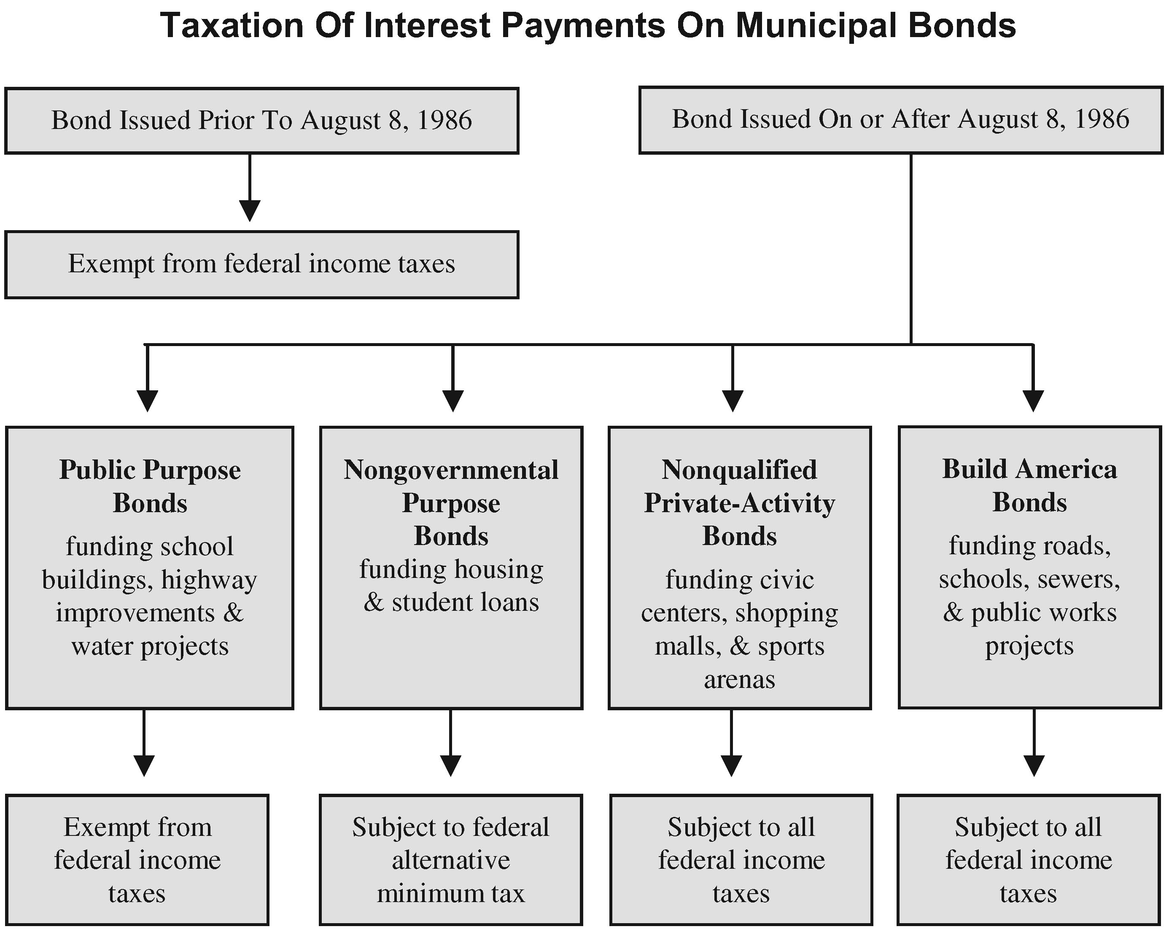
Profit from price changes between the purchase and sale of municipal bonds may be subject to federal taxation. For example, if a bond is purchased at a premium the premium amount must be amortized over the remaining life of the bond and this affects the bondholder’s basis. The holder’s basis in the bond includes the amount originally paid for the bond plus any additions to basis, such as original issue discount (OID). When the bond is sold or redeemed prior to maturity any amounts received in excess of basis are generally taxed as capital gains. These calculations can be quite complicated and the advice of tax counsel should be sought.
State Taxation. Most states and municipalities do not tax interest income received from tax-exempt bonds issued by that state, its agencies, or its political subdivisions. In
Municipal Bonds

contrast, virtually every state imposing an income tax also taxes interest income received from bonds issued by other states, out-of-state agencies and political subdivisions. The state exemptions for interest on in-state bonds may not extend to: (1) capital gains resulting from a sale or other disposition of the bonds; and (2) ordinary income resulting from application of the market discount rules. Again, the advice of tax counsel should be sought.
Build America Bonds. Build America Bonds (BABs) are taxable bonds that were issued by state and local governments that gave them access to the conventional corporate debt markets. There are two types of BABs. With “Tax Credit BABs,” refundable tax credits were provided directly to the bondholders. With “Direct Payment BABs,” the Treasury Department makes payments to the issuers in an amount equal to 35 percent of the interest payments on the BABs. As a result, state and local governments have lower net borrowing costs and are able to reach more sources of borrowing than with more traditional tax-exempt bonds. For example, if a state were to issue BABs at a 10 percent taxable interest rate, the Treasury Department would make a payment directly to the state of 3.5 percent of that interest, and the state’s net borrowing cost would thus be only 6.5 percent on a bond that actually pays 10 percent interest (i.e., 35 percent of 10 percent is 3.5 percent). Average yields to investors in these bonds have actually been a little over 6 percent. This program terminated at the end of 2010.
Tax-Free vs. Taxable Yield Comparisons. Due to their tax-free nature, municipal bonds typically offer lower interest rates than comparable corporate and Treasury bonds. (However, in 2008 selling at historically high ratios relative to U.S. Treasuries municipal bonds actually offered higher yields than U.S. Treasuries.) Depending upon the investor’s individual marginal income tax bracket, a higher interest paying taxable bond may provide more after-tax earnings than a lower interest tax-free municipal bond. The following table provides equivalent taxable yields based upon assumed tax-exempt yields in one-quarter percent increments from 2.00 percent to 6.00 percent.
Municipal Bonds

Equivalent Taxable Yields
2014 Federal Income Tax Brackets
Tax Exempt Yield | 15% | 25% | 28% | 33% | 35% | 39.6%
2.00 | 2.35 | 2.67 | 2.78 | 2.99 | 3.08 | 3.31
2.25 | 2.65 | 3.00 | 3.13 | 3.36 | 3.46 | 3.73
2.50 | 2.94 | 3.33 | 3.47 | 3.73 | 3.85 | 4.14
2.75 | 3.24 | 3.67 | 3.82 | 4.10 | 4.23 | 4.55
3.00 | 3.53 | 4.00 | 4.17 | 4.48 | 4.62 | 4.97
3.25 | 3.82 | 4.33 | 4.51 | 4.85 | 5.00 | 5.38
3.50 | 4.12 | 4.67 | 4.86 | 5.22 | 5.38 | 5.79
3.75 | 4.41 | 5.00 | 5.21 | 5.60 | 5.77 | 6.21
4.00 | 4.71 | 5.33 | 5.56 | 5.97 | 6.15 | 6.62
4.25 | 5.00 | 5.67 | 5.90 | 6.34 | 6.54 | 7.04
4.50 | 5.29 | 6.00 | 6.25 | 6.72 | 6.92 | 7.45
4.75 | 5.59 | 6.33 | 6.60 | 7.09 | 7.31 | 7.86
5.00 | 5.88 | 6.67 | 6.94 | 7.46 | 7.69 | 8.28
5.25 | 6.18 | 7.00 | 7.29 | 7.84 | 8.08 | 8.69
5.50 | 6.47 | 7.33 | 7.64 | 8.21 | 8.46 | 9.11
5.75 | 6.76 | 7.67 | 7.99 | 8.58 | 8.85 | 9.52
6.00 | 7.06 | 8.00 | 8.33 | 8.96 | 9.23 | 9.93
This table assumes the investor is subject to federal income taxes only.
For example, assume John, an investor in a 28 percent tax bracket had the choice of investing in a 4.25 percent tax-free municipal bond or a 6.15 percent Treasury bond. For John, a 4.25 percent tax-free yield is the same as a 5.90 percent taxable yield, meaning that any taxable return over 5.90 percent will provide greater after-tax earnings than the 4.25 percent tax-free return. Therefore, John would choose to invest in the taxable 6.15 percent Treasury bond. On the other hand, if the choice was between investing in a 4.25 percent tax-free municipal bond or a 5.75 percent Treasury bond, John would choose the 4.25 percent tax-free municipal bond for its superior after-tax return.
When a municipal bond is also exempt from state and local income taxes it is important to consider the investor’s maximum effective tax bracket including these state and local taxes.
Municipal Bonds
Assume Jane, an investor, is in a 28 percent federal tax bracket, but is also subject to an additional 6 percent of state income taxes, for a total maximum tax rate of 34 percent. The following formula can be used to determine the equivalent taxable yield for Jane, who is considering investing in a 4.25 percent tax-free municipal bond.
Equivalent Taxable Yield = | Tax-Free Yield
 | 100 – Tax Bracket
Equivalent Taxable Yield = | 4.25
 | 100 – 34
Equivalent Taxable Yield = | 4.25
 | 66
Equivalent Taxable Yield = | .0644 or 6.44%

