Corporate Bonds
Types Of Corporate Bonds. Unlike government bonds, corporate bonds contain an element of default risk, which varies according to the issuer. Some bonds are secured by collateral, while others are unsecured and the ability to make timely payments of interest and principal depends upon the general income and creditworthiness of the company issuing the bonds. In general, senior bonds are secured and backed by some type of collateral, whereas junior bonds are backed by only the good faith and credit of the issuer; in addition, senior bondholders are repaid before any payments are made to junior bondholders. A large variety of corporate bonds are sold or auctioned on the initial issue market and traded on the secondary markets.
(1) Callable bonds can be “retired” by the issuer before their scheduled maturity date. The specific call provisions are set forth in the bond indenture (see Indenture, page 95). These provisions may stipulate a required time delay after the original issue date during which the bond is not vulnerable to being called. Furthermore, if a bond is called the issuer may be required to pay the bondholder a call premium above the par value of the bond . The process of recalling a bond is referred to as a redemption. It is then said that the bond has been called away. Bonds are typically called when interest rates have fallen to a point that the issuer will save money by issuing new bonds with lower coupons (interest rates). In fact, the process is similar to when a homeowner refinances his home mortgage at a lower interest rate. Callable bonds involve a reinvestment risk, because the bondholder whose bonds have been called away is faced with having to reinvest the proceeds at lower rates of interest than those paid on the original issue. This feature is an important consideration in selecting bonds, and it is clearly indicated in bond listings.
(2) Collateral trust bonds are similar to mortgage bonds but are secured by collateral such as other bonds, notes, or stocks.
(3) Convertible bonds offer bondholders the opportunity to exchange their bonds for a specific number of shares of the issuer’s common stock. In exchange for this conversion feature, the bonds generally carry a lower coupon (interest rate). The terms of conversion, such as the number of shares of the stock, are established when the bonds are issued. Although conversion is at the discretion of the bondholder, the decision can be forced (e.g., a bond containing a call option is called in a low-interest market and the bondholder can either convert or allow the bond to be redeemed by the call). Investors purchase convertible bonds because of their
Corporate Bonds

upside potential. For example, if the issuer’s stock increases in price, the bond will increase in value, and the bondholder can then chose to either convert the bond to stock or sell the bond at the higher price. On the other hand, if the issuer’s stock decreases, the bond will generally still retain its intrinsic value based on its anticipated interest and principal payments. Zero-coupon convertible bonds are also issued.
(4) Debentures or debenture are terms that are generally interchangeably with the terms bonds or bond.
(5) Equipment trust certificates are issued by a trust (the lessor) that is formed to purchase specific assets and lease them to a lessee (e.g., purchase of a freight car that is leased to a railroad).
(6) Guaranteed bonds are guaranteed by someone other than the issuer. Typically the guarantee extends to interest and principal payments. With corporate bonds, the guarantor is often an affiliate or parent company.
(7) Income bonds provide for interest payments that are contingent upon the issuer’s earnings, but typically guarantee repayment of principal. In this sense income bonds are similar to preferred stock. These bonds are generally not investment grade, and are often used after a business has been reorganized due to financial difficulties.
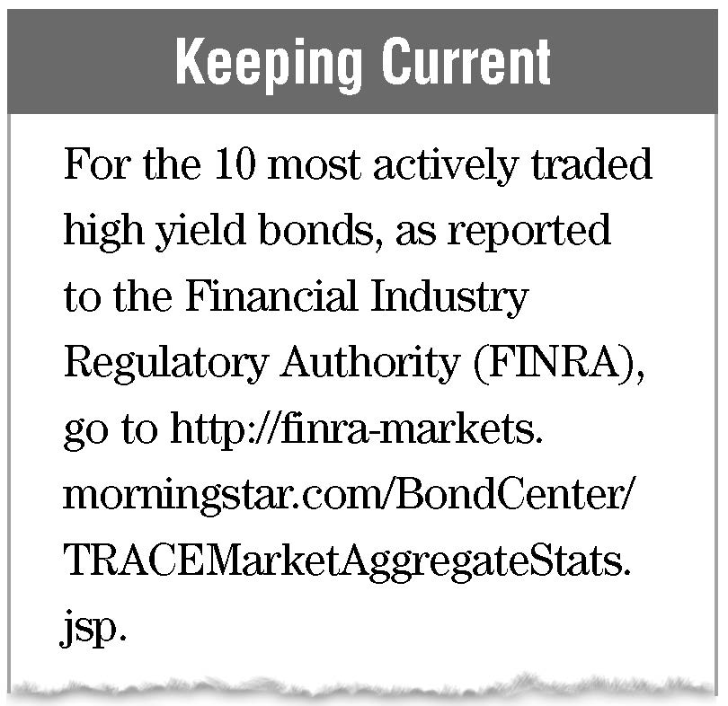
(8) Junk bonds, also referred to as high yield bonds, these bonds carry ratings below BBB from Standard & Poor’s or Baa from Moody’s. They are considered speculative and, therefore, entail a relatively high default risk. Junk bonds are often less liquid then investment grade bonds. Junk bonds may be originally issued with below investment grade ratings, or junk status can result from a decline from an original investment grade rating. In order to attract investors, junk bonds will typically offer interest rates that are from three to four percentage points higher than safer government issues (i.e., 300 to 400 basis points). This difference is known as the “junk yield spread”.
(9) Corporate mortgage bonds are secured by a mortgage lien against the issuer’s real property (e.g., a mortgage against property interests of a utility company)
(10) Participation bonds provide for a minimum coupon (interest rate), but then make additional interest payments based upon the issuer’s earnings. In contrast, convertible bonds allow the bondholder to participate in the issuer’s earnings growth by purchasing stock.
Corporate Bonds
(11) Original Issue Discount (OID). This is a bond that is issued at a price that is less than its par, or maturity value (the principal amount). OID is considered to be a form of interest that must be reported as income over the life of the bond. Both corporate and Treasury bonds are available as OID securities.
Zero-coupon bond is a particular form of OID that pays no interest prior to maturity (in bondspeak, they are said to have no “periodic coupon”), and instead is issued at a discount; the difference between the issue price and the price paid at maturity (typically $1,000 per bond) represents the return to the investor.
For example, a ten-year zero-coupon bond might be issued at a purchase price of $725. No interest would be paid until maturity, at which time the $1,000 redemption payment would represent a return of principal of $725, plus accrued interest of $275, compounded semiannually. Another variation of zero-coupon bonds is created from bonds that are originally issued as interest paying bonds, but are then subsequently stripped of their coupons and resold as zero-coupon bonds.
The benefit of zero-coupon bonds (and OID bonds more generally) is that when interest rates fall, there are no coupon payments to reinvest at lower rates; instead, the internal return implied in the bond’s price at purchase continues to accrue. Conversely, though, zero-coupon bonds work to the owner’s disadvantage when interest rates rise and the coupon payments are not received as cash to reinvest. This feature causes zero-coupon bonds to be far more volatile in the secondary markets than coupon (interest paying) bonds. The bondholder is required to pay income taxes annually on the accrued interest, even though no interest is received during the life of the bond. However, federal income taxes can be deferred by purchasing zero-coupon bonds within a qualified retirement plan, or avoided by purchasing zero-coupon municipal bonds . As with coupon bonds, zero-coupon bonds may be issued with call and conversion features . Zero-coupon bonds are issued by corporations, municipalities, and the United States Treasury.
When a bond is purchased at a market price that is lower than par and lower than its issue price, the discount is referred to as a “market discount” (as opposed to an Original Issue Discount).
Taxation of Corporate Bonds. From a corporation’s perspective, the interest payments made to bondholders have the advantage of being deductible for federal income tax purposes, whereas dividends paid to stockholders are nondeductible. From the investor’s perspective, interest payments are included in income at ordinary income tax rates, but any
Corporate Bonds
gain on the sale of a bond held for more than one year offers the advantage of being taxed at lower long-term capital gains rates. Also, if a bond is purchased for less than its maturity (par) value, the excess of the amount received at maturity over the purchase price is treated as long-term capital gain (provided the bond has been held for over one year).
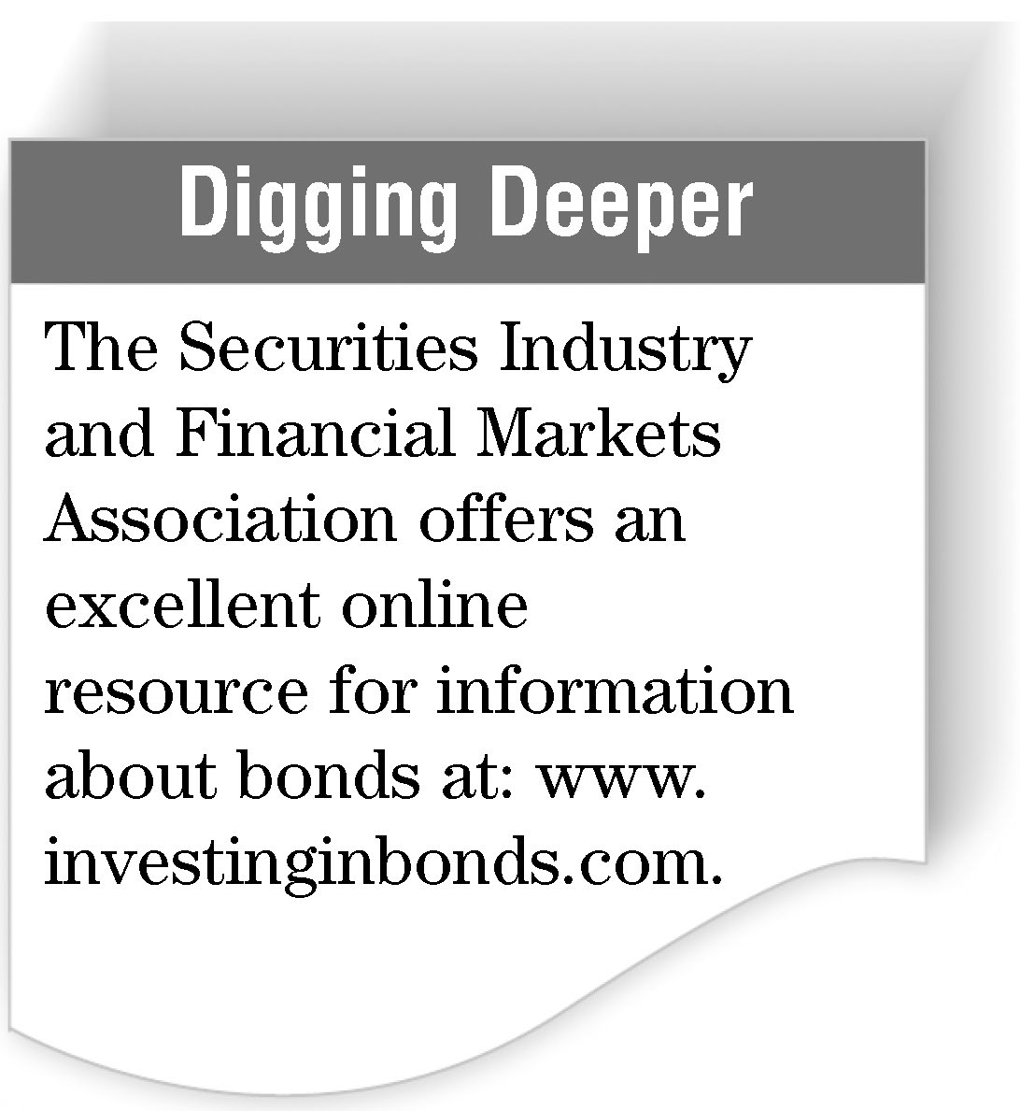
Tracking Availability & Performance. Corporate bond prices are printed daily in newspapers throughout the country. Typically these consist of tables of representative bond prices from recent bond trading. However, it is important to recognize that the bond market is primarily a dynamic, over-the-counter market in which bond prices are negotiated continually throughout the day. Going online offers a very easy way to appreciate the dynamic nature of this market. The bond quotation below contains the essential information needed by an investor who is contemplating purchase of corporate bonds, except for the specific markup or sales charge.
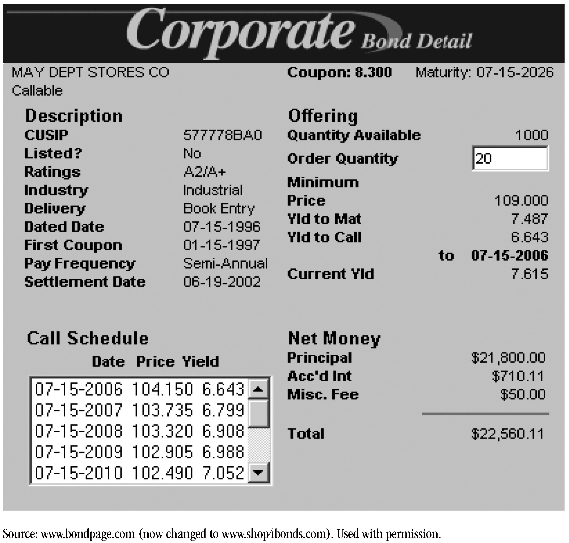
Corporate Bonds
The quotation above was obtained on June 14, 2002. The bond was issued by May Department Stores Company with a maturity of July 15, 2026, and a coupon of 8.3 percent. It is rated A2 by Moody’s and A+ by Standard & Poor’s. Purchasing the bond at the current price of 109.000 percent of face (i.e., $1,090 each) would produce a yield to maturity of 7.487 percent. However, this bond is callable, with the first call date being July 15, 2006. If it were called on that date at a redemption price of 104.150 percent of face (i.e., $1,041.50 for a $1,000 par bond), the yield to call would be 6.643 percent. If it were not called on July 15, 2006, the next call date would be July 15, 2007. If then called at $1,037.35 per $1,000 par bond, the yield to call would be 6.799 percent. The total price for 20 bonds is $22,560.11, consisting of: a principal payment of $21,800.00; accrued interest of $710.11; and a miscellaneous fee of $50.00 charged on orders of less than 100 bonds. The first coupon payment was on January 15, 1997; therefore, interest is payable on January 15 and July 15. If 20 bonds were purchased, the semiannual interest payment would be $830 (1,000 × .083 = 83 ÷ 2 = 41.50 × 20 = 830).

