Laddering
Laddering bonds means buying a staggered series of bonds with incrementally longer maturities (like steps on a ladder), such that every year (or other time interval) a bond matures that can be reinvested at then-current interest rates without being forced to liquidate an existing bond. Ladders can be established for various lengths of time.
For example, to establish a “three-year ladder” in 2014, the investor who has $30,000 to invest would purchase three CDs, one $10,000 CD paying 5.0 percent maturing in one year, another $10,000 CD paying 5.5 percent maturing in two years, and another $10,000 CD paying 6.0 percent maturing in three years. Assuming interest rates remain constant, when the one-year CD matures in 2015, it is replaced with a CD paying 6.0 percent maturing in three years. When the two-year CD matures in 2016, it also is replaced with a CD paying 6.0 percent maturing in three years. At this point the ladder has been established and can thereafter be continued by replacing CDs as they come due each year with a three-year CD at the prevailing interest rate. The rolling maturity dates and periodic reinvesting opportunities of a laddered portfolio provide a consistent pattern of investment similar to dollar-cost-averaging.
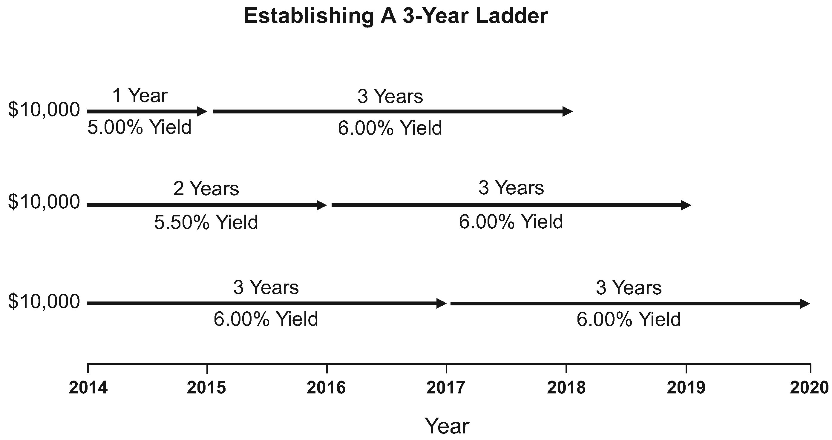
Ladders of five and ten years are often used when investing in corporate, municipal, and federal bonds. In the following five-year ladder, beginning in year two the maturing 5.00 percent bond is replaced with a five-year bond yielding 6.00 percent. Notice that the average maturity remains the same each and every year, but the yield of the portfolio is increased each year during the first five years (assuming 6.00 percent five-year bonds continue to be available) as the initial short-term bonds that formed the early steps of the ladder are renewed for long-term bonds that extend past the end of the ladder. For example, in year two the 5.00 percent bond is replaced by a longer-term 6.00 percent bond yielding 1 percent more interest, and $200 of additional interest earnings, that will mature past the end of the
Laddering
original ladder. This $200 represents an increase of twenty basis points in the portfolio (6.00 - 5.00 = 1.00 ÷ 5 = .2).
Year 1 |  |  |  | Year 2
Amount | Yield | Maturity | Interest | Amount | Yield | Maturity | Interest
$20,000 | 5.00% | 1 year | $1,000 | $20,000 | 5.25% | 1 year | $1,050
20,000 | 5.25% | 2 year | 1,050 | 20,000 | 5.50% | 2 year | 1,100
20,000 | 5.50% | 3 year | 1,100 | 20,000 | 5.75% | 3 year | 1,150
20,000 | 5.75% | 4 year | 1,150 | 20,000 | 6.00% | 4 year | 1,200
20,000 | 6.00% | 5 year | 1,200 | 20,000 | 6.00% | 5 year | 1,200
$5,500 | $5,700
Year 3 |  |  |  | Year 4
Amount | Yield | Maturity | Interest | Amount | Yield | Maturity | Interest
$20,000 | 5.50% | 1 year | $1,100 | $20,000 | 5.75% | 1 year | $1,150
20,000 | 5.75% | 2 year | 1,150 | 20,000 | 6.00% | 2 year | 1,200
20,000 | 6.00% | 3 year | 1,200 | 20,000 | 6.00% | 3 year | 1,200
20,000 | 6.00% | 4 year | 1,200 | 20,000 | 6.00% | 4 year | 1,200
20,000 | 6.00% | 5 year | 1,200 | 20,000 | 6.00% | 5 year | 1,200
$5,850 | $5,950
 |  | Year 5
 |  | Amount | Yield | Maturity | Interest
 |  | $20,000 | 6.00% | 1 year | $1,200
 |  | 20,000 | 6.00% | 2 year | 1,200
 |  | 20,000 | 6.00% | 3 year | 1,200
 |  | 20,000 | 6.00% | 4 year | 1,200
 |  | 20,000 | 6.00% | 5 year | 1,200
 |  | $6,000
The many advantages of laddering include:
(1) Reduces reinvestment risk caused when interest rates fall – the investor does not have to reinvest a large amount of funds at lower rates.
Laddering
(2) Reduces interest rate risk caused when interest rates rise – as investments mature, the investor can take advantage of new investment opportunities paying a higher rate of interest, without liquidating bond investments at a loss.
(3) Maturing CDs or bond investments can be used for current income, thereby avoiding the sale of stocks at depressed prices in a down stock market (i.e., the ladder would not be continued).
(4) Maturing CDs or bond investments can be used for unanticipated emergencies.
(5) Liquidity can be maintained while enjoying the higher rates of return or yields offered by longer-term investments.
(6) Gain greater stability and reduce volatility by purchasing shorter-term bonds that are less sensitive to changes in interest rates, thereby reducing market price risk.

Interest rates are hypothetical.

