Balanced Financial Growth
A sound plan for achieving financial security requires balanced financial growth. In seeking balanced financial growth, the investor must continually evaluate risk and return. It is said that risk and reward go hand in hand. An investment providing the opportunity for higher returns will generally involve higher risk. Conversely, an investment offering lower returns will generally involve lower risk. In seeking higher returns, only the individual investor can determine exactly how much risk to take. The higher on the investment pyramid, the greater is the risk . . . the lower on the investment pyramid, the lower is the risk.
Cash reserves and equivalents provide a financial cushion for emergencies, repairs, and other unexpected cash needs. Typically, this base will include money market accounts, regular savings, and certificates of deposit, and may also include life insurance cash values. Adequate health, property, and casualty insurance are also essential to provide protection from financial disaster.
Equity assets - i.e., stocks - can be purchased if the investor’s primary objective is to achieve capital appreciation. However, it is important to understand that the market value of these investments can go down as well as up, and rates of return can vary, even after the investments are purchased. Stocks can be found in many investment portfolios, held as either individual securities, or in pooled investment vehicles ranging from exchange-traded funds (ETFs) to mutual funds to variable annuities. Some investors may use their equity investments to provide current income by spending dividends as received, while others will reinvest dividends and other distributions with the expectation of realizing greater long-term appreciation.
Income assets should be considered if the investor’s primary objective is to obtain income, as opposed to growth. Some investments will provide immediate interest income; others will accrue earnings until maturity. A variety of debt assets are available with many different characteristics. In many cases, income assets are also used to reduce the volatility of an overall portfolio that also holds equity assets. Examples of fixed income assets include corporate, municipal, state, and federal bonds, which are issued in a variety of forms and maturity dates.
Income asset held via pooled vehicles like mutual funds offer active investment management with a typical objective of providing maximum income consistent with security of principal.
Balanced Financial Growth
Other types of fixed income assets include fixed annuities, which may pay a specified rate of interest, or offer a guaranteed and stable lifetime income no matter how long a person lives.
Tangible asset investments present unique challenges and opportunities because of their tangible nature, and may include real estate ventures, research and development partnerships, oil and gas partnerships, farming, cattle and coal operations, leasing arrangements, gold and commodities. The nature of some of these investments involves the greatest risk, although others may be relatively stable. Because of the frequent complexity in how tangible asset investment offerings are structured, and their associated tax consequences (which sometimes are a major feature of the investment opportunity), they are often recommended only for the sophisticated investor who has already established a firm financial foundation.

Risk and Return by Asset Class
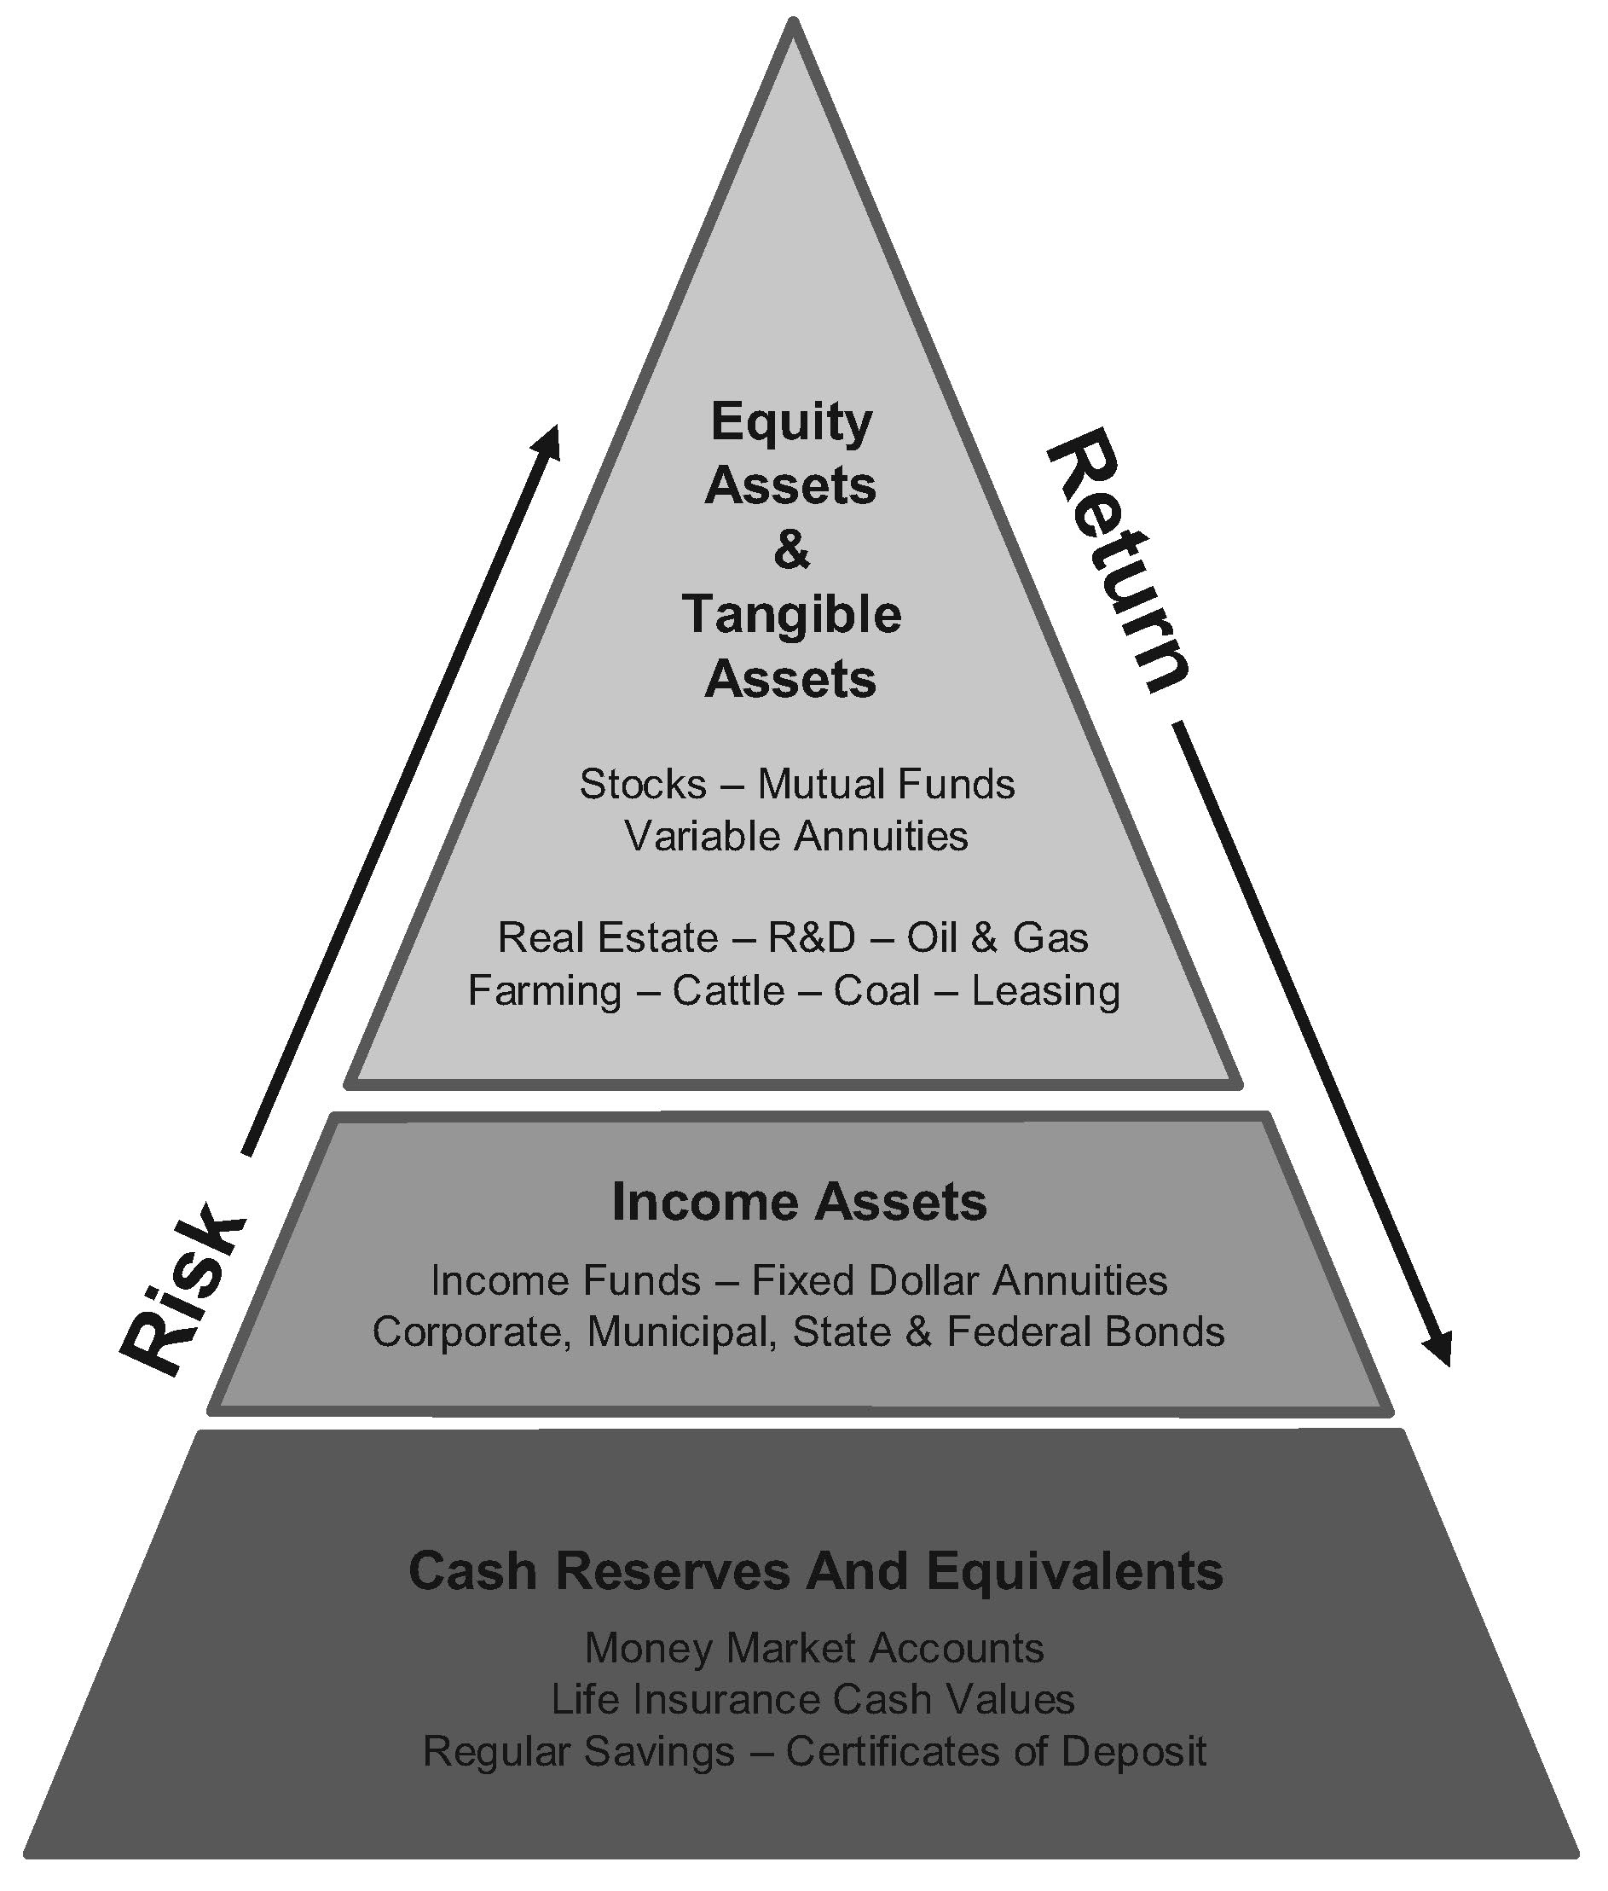
Balanced Financial Growth

Asset Classifications
An asset class can be defined as a grouping of investments with similar risk and return characteristics. The value of assets within the same class will tend to rise and fall in tandem as they are affected by the economic environment. The grouping of assets into classes is extremely important when discussing modern portfolio theory, diversification, reallocation, and other such concepts. The context within which the term “asset class” is used will influence how assets are classified. For example, the major mutual fund asset classes are either debt instruments or equity instruments, or some combination of both debt and equity instruments. In contrast, in assembling a diversified portfolio, asset classes might be further broken down into U.S. Treasury bills, long-term corporate bonds, international bonds, large company stocks, small company stocks, international stocks, and equity REITS.
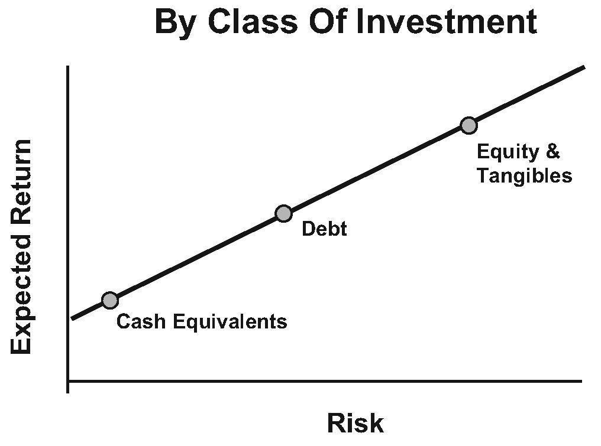
But there appears to be no general consensus regarding asset classes and their appropriate rankings. Some commentators believe that “tangibles” are deserving of a class onto themselves. Other commentators have broken down assets into the two major classes of debt and equity. Finally, others just list them, with no attempt at sorting them out according to relative risks. When grouping assets by class, it may be difficult to accurately determine the relative risk of the various options within that class . For example, bonds come in many shades of risk; from government bonds with no risk of default, to utility and corporate bonds that may well have a substantial degree of risk.
The Risk and Return By Asset Class chart refers to assets in the following four major classes: (1) cash equivalents such as money market accounts, life insurance cash values, savings accounts, certificates of deposit and Treasury bills; (2) income (debt) assets such as income funds, fixed-dollar annuities, corporate bonds, municipal bonds, and treasury notes; (3) equity assets such as stocks (in turn broken down into large cap stocks, medium cap stocks, small cap stocks, and international stocks), mutual funds, and variable annuities; and tangible assets such as real estate, raw land, farming, cattle, lumber, coal, oil and gas, leasing, research and development, art, metals, coins, collectibles, and commodities. Other classifications might justifiably consider domestic common stocks a separate class from foreign common stocks, domestic bonds a separate class from foreign bonds, and high-yield (junk) bonds a separate class from high quality corporate bonds. As can be seen from this chart, the higher the risk, the higher the expected return, and the lower the risk, the lower the expected return.
Balanced Financial Growth

General Concepts of Risk
Although there are many definitions of risk, the single common denominator is the uncertainty of the possibility of loss. There are many categories and types of risks, from physical risks to social risks, and ethical risks to monetary risks. The following risks are those most often associated with risk management in financial planning.
Active Risk vs. Passive Risk. Some risks are considered active risks, whereas other risks are considered passive risks. An active risk is investing in the stock market, where the investment will be subject to a market risk. A passive risk is putting your money under your bed, where it will be subject to an inflation risk.
Legal Liability Risk. This is a pure risk involving only the possibility of loss. When a person injures someone else or his or her property, the person is subject to a liability risk. Automobile accidents, dog bites, and household accidents are all examples of situations involving legal liability risk. It is considered a major risk since the legal system often places few limits on the amount of damages that an individual may be sued for when another person is injured through negligence or another tort. Financial planning must anticipate and plan for liability risks.
Personal Risk. Premature death, disability, unemployment, and poor health are all examples of personal risks. Financial planning must anticipate and plan for personal risks.
Property Risk. Homes, cars, business, and personal property are all subject to property risk from theft, fire, accident, and natural causes. The losses can be both direct and indirect. A direct loss is the damage to a house when it burns down, whereas an indirect loss would be the cost of renting an apartment while the house is being rebuilt. Financial planning must anticipate and plan for property risks.
Pure Risk vs. Speculative Risk. Pure risk involves only the possibility of either loss or no loss, whereas speculative risk involves the possibility of either loss or gain. The risk of a house burning down is a pure risk that is insurable, but investing in the commodities market, or betting on a horse race, is a speculative risk that is generally not insurable.

Risks Associated with Investing
The following risks have an unequal impact on specific investments, both as to severity and frequency. Some will more specifically impact fixed-income securities, whereas others will have a greater impact upon equity (stock) investments. Although they are
Balanced Financial Growth
listed alphabetically, the risks most affecting investors are inflation risk, interest rate risk, investment risk, and systematic risk.
Additional Commitment Risk. The risk that an investor will be forced to commit additional funds to an investment, should certain conditions occur that are beyond the investor’s control. If the additional investment is not made, the investment may be subject to losses. For example, some limited partnerships may require additional contributions, and certain types of real estate investments can require substantial outlays to build, repair, or improve properties. Additional commitment risk is also faced by the investor who gets a margin call . In order to restore the account to its original margin requirements, the investor is required to deposit additional funds in his or her account.
Call Risk. The risk that the issuers of callable bonds (or some types of preferred stock) will redeem them when comparable market interest rates fall significantly below the rates paid by the securities. Whereas interest rate risk (discussed below) can actually result in a loss of value, call risk results in lower returns by forcing funds to be subsequently reinvested for less yield. This risk is also referred to as “redemption risk.”
Concentration Risk. The risk that concentration of investments in a particular stock, bond, or market segment could result in a large loss of portfolio value (e.g., investing 75 percent of a portfolio in a particular stock). Acquiring a combination of fixed and equity investments, including mutual funds, can reduce this risk.
Currency Risk. The risk that a decrease in the underlying value of a nation’s currency will reduce the purchasing power of income or investments paid in that currency or lead to investment losses when converted back into the investor's home currency.
Default Risk. The risk that a business enterprise will fail from a variety of causes, including deteriorating market position or the business's products or services, poor management, or an economic recession. Most often applied to investments in bonds that fail to pay interest as scheduled, or default in the repayment of principal. This risk is also variously referred to as “business risk,” “credit risk,” “financial risk,” or “fundamental risk.”
Economic Risk. The risk that the economic environment will decrease the value of an investment or other source of income. For example, the value of a stock might decline if an economic recession occurs that raises concerns about the growth, profitability, or viability of the company.
Balanced Financial Growth
Event Risk. The risk that an individual event, more limited in scope than what happens to the overall market, will affect the value of a particular investment. For example, takeover moves involving leveraged buyouts can increase the debt to equity ratio of the target company, thereby causing a fall in the price of previously issued bonds.
Inflation Risk. The risk that goods and services will cost more in future years and that inflation will erode the purchasing power of fixed income or investments. Inflation risk is also referred to as “purchasing-power risk.”
Interest Rate Risk. The risk that interest rates will rise, decreasing the value of bonds or other fixed interest rate investments. On the other hand, interest rate risk goes both ways, and can also result in a gain if interest rates decline.
Investment Risk. Investment risk refers to the uncertainty of an investment outcome. It can be distinguished from many other risks, in that it involves the potential for gain as well as loss.
Liquidity Risk. The risk that there may be a loss of value if an asset must be converted into cash within a very short period of time (e.g., the loss of interest if a certificate of deposit is redeemed prior to its redemption date). Some commentators maintain that this is not really a risk, but rather a condition inherent in the underlying investment.
Longevity Risk. The risk that a person’s longevity will result in outliving his or her income or suffering a loss of purchasing power.
Political Risk. The risk that the political climate will result in changes in regulations and laws that impact the economy, tax laws, and Social Security benefits.
Reinvestment Risk. The risk that an investment will mature at a time of lower interest rates and that the funds must be reinvested at lower yields. This is similar to the call risk, except that in the case of call risk the issuer of the security forces the reinvestment to occur, while reinvestment risk refers generally to the risk that the investment matures at a time ill-suited to reinvestment at then-current interest rates.
Systematic Risk. The inherent risk of being invested in the securities market, which can decline in value in the aggregate due to external factors, even if no particular company or investment is facing difficulty. As such, it is said to be a nondiversifiable risk. This risk is also referred to as “market risk.”
Balanced Financial Growth
Tax Risk. The risk that changes in the tax laws will result in greater taxes, or impact the value of securities whose price is affected by the associated tax treatment. For example, dividend-paying stocks have become relatively more and less appealing over the years as their tax treatment has varied from being treated as ordinary income or more preferentially; another example would be several types of limited partnerships in the 1980s, which experienced a dramatic (and generally negative) change in value when their tax treatment was altered by an act of Congress.
Unsystematic Risk. The risk associated with a particular economic sector, industry, company, or an individual security. It is considered a diversifiable risk. This risk is known as “security risk.”
Time and Risk. The element of time is an essential consideration in investment planning, and can have a direct impact upon the risks assumed with individual investments. For example, a short time frame may cause the “late start” investor to be “forced” to accept greater degrees of risk in attempting to earn the higher returns necessary to meet desired retirement goals . In contrast, the disciplined “early start” investor may be able to afford to assume far less risk in reaching the same retirement goals.

Investment Strategies
The following investment strategies, or styles, are not mutually exclusive. More often than not, the individual investor, or mutual fund manager, will employ one or more strategies, depending upon the investment objectives.
Buy-and-Hold. Buy-and-hold is a fairly passive investment strategy under which the investor takes a long-term view of the market. The investor who employs a buy-and-hold strategy may use fundamental analysis to select strong stocks that offer good value , or may simply seek to use indices to own the market in the aggregate. Little attention is paid to any short- or intermediate-term market or economic trends. Once purchased, bonds are typically held to their maturity date, and stocks are held through both bull and bear markets. Given time, the strategy can be very effective, provided the investor is successful in initially selecting fundamentally strong stocks, and/or assuming that economic growth in the aggregate continues to lift the value of the overall market. The advantages of a buy-and-hold strategy include: (1) transaction costs are kept to a minimum; (2) time devoted to portfolio maintenance is comparatively low; and (3) taxation is delayed until the investment is sold. The buy-and-hold strategy is the opposite of market timing.
Balanced Financial Growth
Market Timing. The strategy of market timing generally focuses on short-term market trends in an attempt to generate quick profits from short-term changes in security prices. With the objective of buying low and selling high, individuals who employ market timing use a variety of indicators and models that they believe will signal a time to either buy or sell. Although widely practiced by professionals and day traders, the long-term track records documenting the validity of any particular system are limited.
In contrast to a buy-and-hold strategy, the disadvantages of market timing include: (1) transaction costs are incurred; (2) much time must be devoted to trading and portfolio maintenance; and (3) taxation is potentially triggered each time a security is sold. Because the largest market gains tend to be concentrated in short time periods, the biggest disadvantage of market timing is that the investor may be out of the market when stocks experience their largest gains.
Tactical Asset Allocation. Tactical asset allocation is a broad term to label strategies where the asset allocation of the investor's portfolio shifts over time, generally in response to market or economic trends or fundamental valuation. Changes tend to be significantly more gradual than the often all-in-all-out transactions of market timing, but represent far more variability than the stable asset allocation of buy-and-hold portfolios that are typically not altered at all unless there is a material change in goals or time horizon. The key characteristic of tactical asset allocation is that the focus on investment changes tends to be at the asset class level, rather than in the equity or debt securities of specific companies.
Contrarian Investing. As the term indicates, the contrarian investor sells when others are buying, and buys when others are selling. By going against the crowd, the contrarian hopes to buy low and sell high while the market is doing the opposite. Contrarians recognize that stock prices are driven up when the demand for stocks is greater than supply (i.e., there are more buyers than sellers). Once prices increase, most investors who intended to purchase have already done so and there is no one left to buy (i.e., the demand for stock evaporates). Without buyers, stocks peak and then lose momentum, and this causes a chain reaction of more selling and less buying as a decline emerges. The same phenomenon occurs when the market bottoms, only in reverse. Once a contrarian investor has purchased a stock, he is most likely to patiently follow a buy-and-hold strategy, waiting for the market to reverse itself in order to sell for long-term capital gain. The key characteristic of contrarian investing is that buy and sell transactions are typically done exactly opposite the general trend of the market at the time (thus, the “contrarian” label).
Balanced Financial Growth
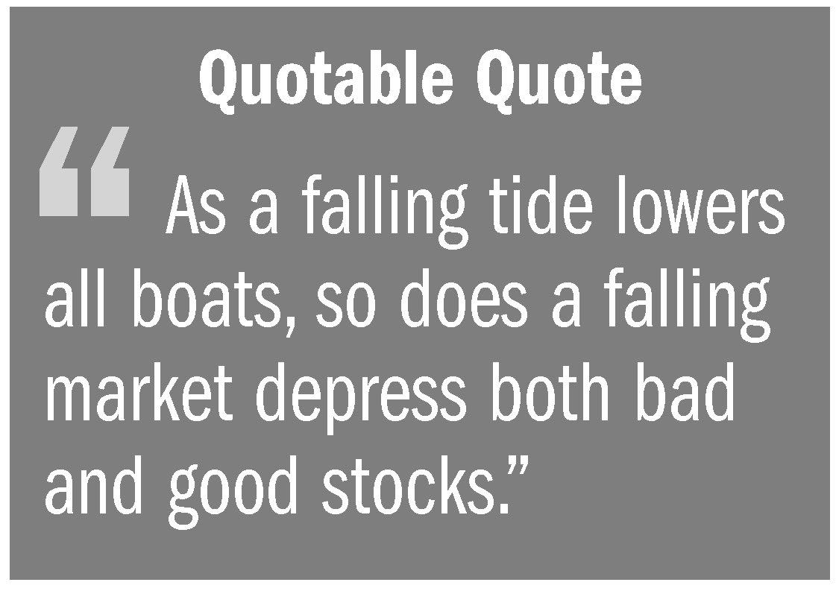
Value Investing. Value investors believe the best indicator of a stock’s value is not necessarily the price in the market on any particular day. Stocks fall in and out of favor with investors and, over the short term, the market frequently overreacts to bad news, thus depressing the prices of both good stocks and bad stocks. Likewise, whole industries fall out of favor with investors, often without regard to their future earnings potential. Value investors look for both stocks and industries that are out of favor in the market, yet represent good potential for earning long-term returns. The value investor looks at factors such as sales, earnings history and outlook, assets, and stockholder equity, and compares them to the stock’s current market price. If the stock is judged to be under-valued, it is purchased. Value can flow from low price-earnings ratios, low price-to-book ratios, and high dividend yields. Value investors look for companies where book value may exceed market value, new companies not yet “discovered” by other investors, and hidden value that other investors have failed to find (e.g., a restructuring that will turn the company around or a new product about to be launched). Value investing involves elements of both the fundamentalist (focusing on the financials), and the contrarian (buying what others are not), both combined with a buy-and-hold strategy (patiently waiting for the stock to rise in price). Although the value investor feels that he can cull out the good from the bad, value investing is not without risk. A failing industry or company with a low price earnings ratio may never recover.
Growth Investing. The growth investor employs a strategy of finding and investing in growth stocks of companies within industries that are expected to experience substantial growth. The investor is typically looking for that well managed small to medium size company that is well positioned to generate revenues or earnings greater than the market as a whole. Returns from growth investing are expected to come from increases in stock values, not from dividends paid to stockholders.
Socially Responsible Investing. The concept of socially responsible investing (SRI) has been evolving for many years. Begun by churches that refused to invest in gambling, alcohol, and tobacco stocks, the practice was adapted by social movements to express their protests and concerns by avoiding specific investments (e.g., by not investing in companies with foreign subsidiaries employing child labor). The concept of SRI has expanded to include environmental, community, other societal or corporate governance (ESG) issues. The term “socially responsible investing” continues to be used, but a variety of other terms are also
Balanced Financial Growth
used, including responsible investing, sustainable investing, ESG investing, mission-related investing, or ethical investing. SRI generally involves investing with one’s values by avoiding certain stocks, whereas ESG investing entails seeking out stocks of companies that demonstrate good environmental practices, provide socially responsible products and services, and exercise good corporate governance (openess, honesty, integrity, etc.). For example, ESG investors might seek out companies that have taken steps to minimize their environmental footprint, divest themselves of subsidiaries manufacturing unhealthy products, or improve labor relations. The 2012 Trends Report from the US SIF Foundation found that the total net assets of both mutual funds and alternative investment funds that considered ESG criteria increased significantly with mutual funds doubling from 2010 to $641 billion. Alternative investment funds were $132 billion, a 250 percent increase from the corresponding assets identified at year-end 2009.

Modern Portfolio Theory
Under modern portfolio theory, focus is placed on the entire portfolio, rather than on the individual investments within the portfolio, with the objective of optimizing portfolio returns relative to portfolio risk. Modern portfolio theory (MPT) provides a framework for integrating together the expected returns, volatility, and correlations of individual asset classes, to construct a portfolio that in the aggregate maximizes return for a given level of risk, or minimizes risk for a given level of return. The user of modern portfolio theory must still develop appropriate inputs for expected return, volatility, and correlation.
Modern portfolio theory was later expanded upon with the capital asset pricing model (CAPM), which is used to evaluate returns of an investment relative to the market.
The following are some of the key concepts, tools, and measurements used in MPT and CAPM.
Portfolio. A portfolio is the blend of investment assets held by an investor. Building a portfolio is the process of adding additional stocks, bonds, and other investments to the mix, with the goal of accumulating a diverse selection of investment assets.
Beta. This is the measure of what is called “systematic risk,” that part of a stock’s (or mutual fund’s) volatility coming from sensitivity to changes in the overall market (see page 18). To track beta, the stock is compared to a benchmark such as the S&P 500 Index. A stock having a beta of 1 is expected to be as volatile as the S&P 500 Index, a stock having a beta greater than 1 is expected to be more volatile than the S&P 500
Balanced Financial Growth
Index and a stock having a beta less than 1 is expected to be less volatile than the S&P 500 Index. Notably, while a stock with a low beta (e.g., 0.76) is likely to be more stable, that stability is also likely to lead it to underperform the S&P 500 Index in a rising market. On the other hand, a stock with a high beta (e.g., 1.54) is likely to be somewhat unstable and more volatile than the S&P 500 Index, but that volatility also leads to an expectation that it will outperform the S&P 500 Index in a rising market. Stocks that are considered growth stocks will tend to have high beta values. Income stocks will generally have low beta values.
Alpha. This is the measure of what is called “unsystematic risk,” that part of a stock’s (or mutual fund’s) volatility that is unique to the particular company (i.e., not coming from sensitivity to changes in the overall market). For example, when an analyst assigns an alpha of 2 percent to a stock, this means that it is estimated that the stock’s price will rise 2 percent more than the overall return of the market. Stocks with high alphas are generally considered undervalued in light of current financial performance and expected earnings growth. Stocks with an alpha less than zero are viewed as undesirable investments in this framework.
Efficient frontier. Under modern portfolio theory, a portfolio that achieves the highest return commensurate with the risk assumed is considered to be efficient, as by definition no portfolio could achieve a higher return without taking on more risk. For example, in the chart below the upward-sloping curve represents the efficient frontier. Typically, portfolios lying on the efficient frontier are the ones that are the most highly diversified, with less diversified portfolios tending to be closer to the middle of the achievable area. Portfolio risk is measured by what is called the standard deviation (see page 38). The higher the standard deviation, the more volatile is the portfolio (i.e., the returns are likely to be more variable).

Balanced Financial Growth
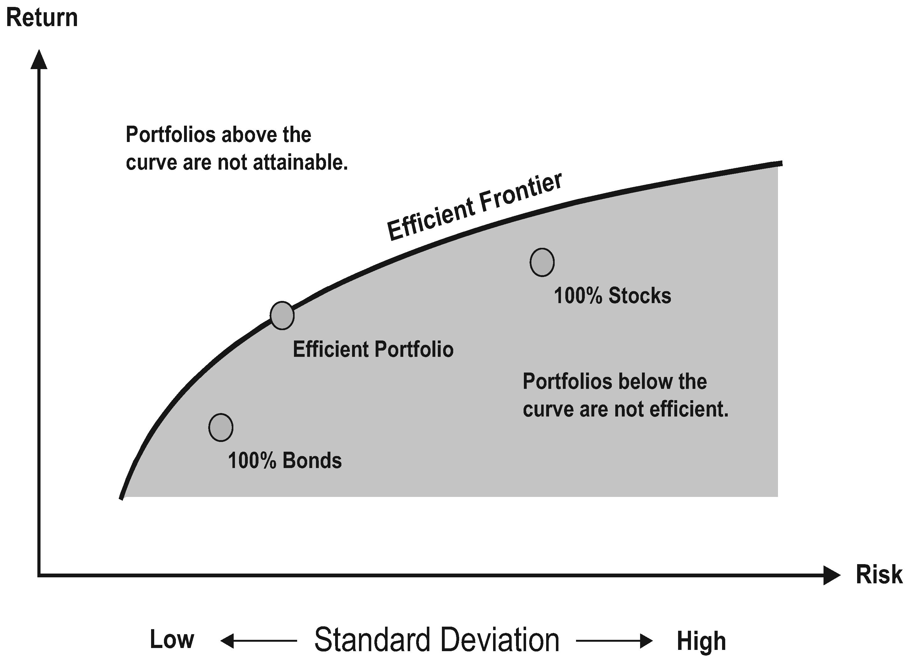Achievable portfolios fall within the gray region. For every point within this region, there is at least one portfolio that could be constructed from all the investments in the universe that would have a risk and return profile corresponding to that point. The area above the gray region is unachievable and no portfolio could be constructed corresponding to a point in this area.
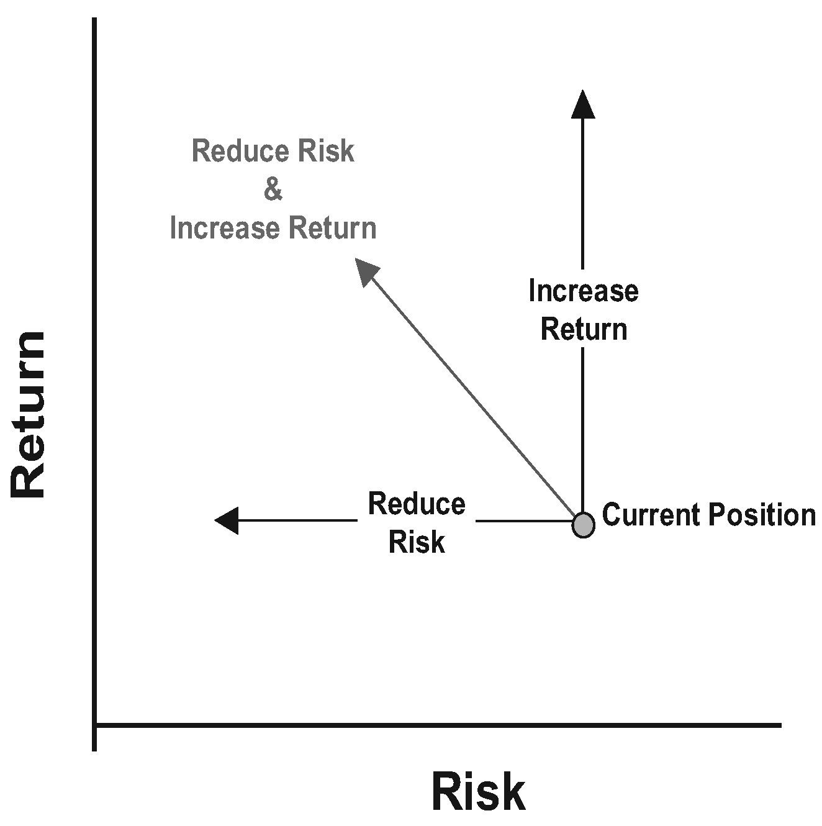
Allocation. Although modern portfolio theory was developed for individual securities, it is equally relevant for overall asset allocation as well. Asset allocation involves the allocation of investments between different asset classes. Research has well demonstrated that a portfolio’s asset allocation policy is the overwhelming determinant of investment performance. Successful investing depends more upon selecting the right mix of asset classes, rather than selecting specific stocks, bonds, mutual funds, or other assets within a class. The process of asset allocation involves: (1) defining investment objectives or goals by considering factors such as age, time horizon, family situation, risk tolerances, income level, liquidity needs, and tax status; (2) selecting asset classes consistent with these investment objectives; (3) determining the weight to be given each asset class within the portfolio (see page 14); and (4) rebalancing as required. In selecting asset classes, and assigning a weight to each class, it is most beneficial to choose classes that are dissimilar (i.e., not covariant). Asset allocation models prepared by brokerage houses and other financial institutions are typically focused upon equity assets, income assets, and cash equivalents (see Asset Allocation Pie Charts, page 46). For example, an investor might allocate 60 percent of his or her portfolio to common stocks, 30 percent to corporate bonds, and the remaining 10
Balanced Financial Growth
percent to cash equivalents. However, it is entirely appropriate to include other investments, such as real estate and tangibles.
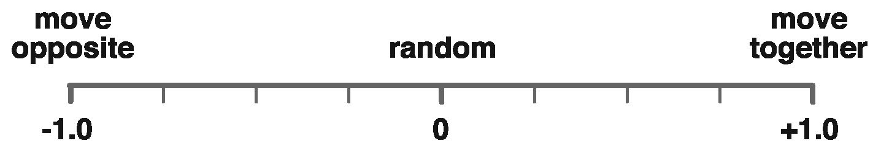
Correlation. If a portfolio is to be well diversified, it is extremely important to consider the correlation of assets within the portfolio. Two assets are said to be correlated if they tend to move together. Analysts use correlation coefficients to measure the strength of such relationships by means of a single number varying between +1.0 and -1.0. The higher the number, the more the assets move in tandem or similarly (+1.0 is considered a perfect match); however, a positive correlation does not necessarily indicate a causal relationship. Conversely, the lower the number, the more the assets move opposite each other (-1.0 is a perfect negative, or inverse correlation).
When there is no relationship between the predicted asset values and the actual values, the correlation coefficient is 0 or very low (i.e., the predicted values are no better than random numbers). The term covariance is also used to describe the concept of correlation. As the term indicates, covariance means varying together.
The lower or more negative the correlation, the more the individual “zigs and zags” of the investments can potentially offset each other, reducing overall portfolio volatility even if the individual investments are volatility on their own. It takes considerable statistical effort to create and maintain a useful table of asset correlations. Tables are typically constructed in the form of a matrix with asset names listed on both the X and Y-axis. The numerical correlation coefficients are then placed at the points of intersection.
Rebalancing. Portfolio rebalancing, also known as reallocation, is the periodic transfer of funds between various asset classes in order to maintain or achieve a desired mix of assets. There are many reasons to consider rebalancing a portfolio. Most often, rebalancing is designed to counter what is called “risk creep” (as equities have higher returns on average, over time their compounding will lead to equities comprising a higher overall percentage of the portfolio, which in turn increases the overall risk profile of the portfolio). Other reasons for rebalancing include the need to modify asset allocations in response to changed investment objectives, age, or investment horizons .
The rebalancing technique is particularly useful in a tax-deferred retirement plan, where the sale of individual securities does not trigger the current payment of income taxes (i.e., taxation on the gain is deferred until funds are distributed from the plan)
of the portfolio.

Cross-Correlation Matrix
 | U.S.  Treasury  Bills | Long-term  corporate  bonds | Inter-  national  bonds | Large  company  stocks | Small  company  stocks | Inter-  national  stocks | Equity  REITS
U.S. Treasury bills | 1.00
Long-term corporate bonds | .05 | 1.00
International bonds | -.09 | .35 | 1.00
Large company stocks | -.06 | .39 | .12 | 1.00
Small company stocks | -.08 | .24 | .02 | .79 | 1.00
International stocks | -.09 | .24 | .64 | .48 | .38 | 1.00
Equity REITS | -.09 | .27 | .13 | .65 | .75 | .41 | 1.00

Cross-Correlation Matrix
The values shown for the seven asset classes listed are based upon the 22-year time period from 1973 through 1994.
Source: Adapted from Roger C. Gibson, Asset Allocation: Balancing Financial Risk, 3rd ed. (New York: McGraw-Hill, 1996), p. 183. Used with permission.

Rebalancing Worksheet
Investments | Target  Allocation | Current  Value | Current  Allocation | Required  Purchase (Sale) | Resulting  Value
Aggressive Growth | 16.00% |  | 21.72%
Asset A | 6.00% | $101,690 | 8.69% | ($31,475) | $70,215
Asset B | 5.00% | $56,844 | 4.86% | $1,668 | $58,512
Asset C | 5.00% | $95,678 | 8.18% | ($37,166) | $58,512
Growth | 40.00% |  | 38.03%
Asset D | 12.00% | $128,900 | 11.01% | $11,530 | $140,430
Asset E | 10.00% | $101,343 | 8.66% | $15,682 | $117,025
Asset F | 10.00% | $125,966 | 10.76% | ($8,941) | $117,025
Asset G | 8.00% | $88,789 | 7.59% | $4,831 | $93,620
Income | 30.00% |  | 28.27%
Asset H | 12.50% | $146,733 | 12.54% | ($452) | $146,281
Asset I | 12.50% | $141,943 | 12.13% | $4,338 | $146,281
Asset J | 5.00% | $42,189 | 3.61% | $16,323 | $58,512
Cash Equivalents | 14.00% |  | 11.98%
Asset K | 9.00% | $84,500 | 7.22% | $20,822 | $105,322
Asset L | 5.00% | $55,672 | 4.76% | $2,840 | $58,512
Totals | 100.00% | $1,170,247 | 100.00% |  | $1,170,247
Balanced Financial Growth

Laddering
Laddering bonds means buying a staggered series of bonds with incrementally longer maturities (like steps on a ladder), such that every year (or other time interval) a bond matures that can be reinvested at then-current interest rates without being forced to liquidate an existing bond. Ladders can be established for various lengths of time.
For example, to establish a “three-year ladder” in 2014, the investor who has $30,000 to invest would purchase three CDs, one $10,000 CD paying 5.0 percent maturing in one year, another $10,000 CD paying 5.5 percent maturing in two years, and another $10,000 CD paying 6.0 percent maturing in three years. Assuming interest rates remain constant, when the one-year CD matures in 2015, it is replaced with a CD paying 6.0 percent maturing in three years. When the two-year CD matures in 2016, it also is replaced with a CD paying 6.0 percent maturing in three years. At this point the ladder has been established and can thereafter be continued by replacing CDs as they come due each year with a three-year CD at the prevailing interest rate. The rolling maturity dates and periodic reinvesting opportunities of a laddered portfolio provide a consistent pattern of investment similar to dollar-cost-averaging (see page 31).
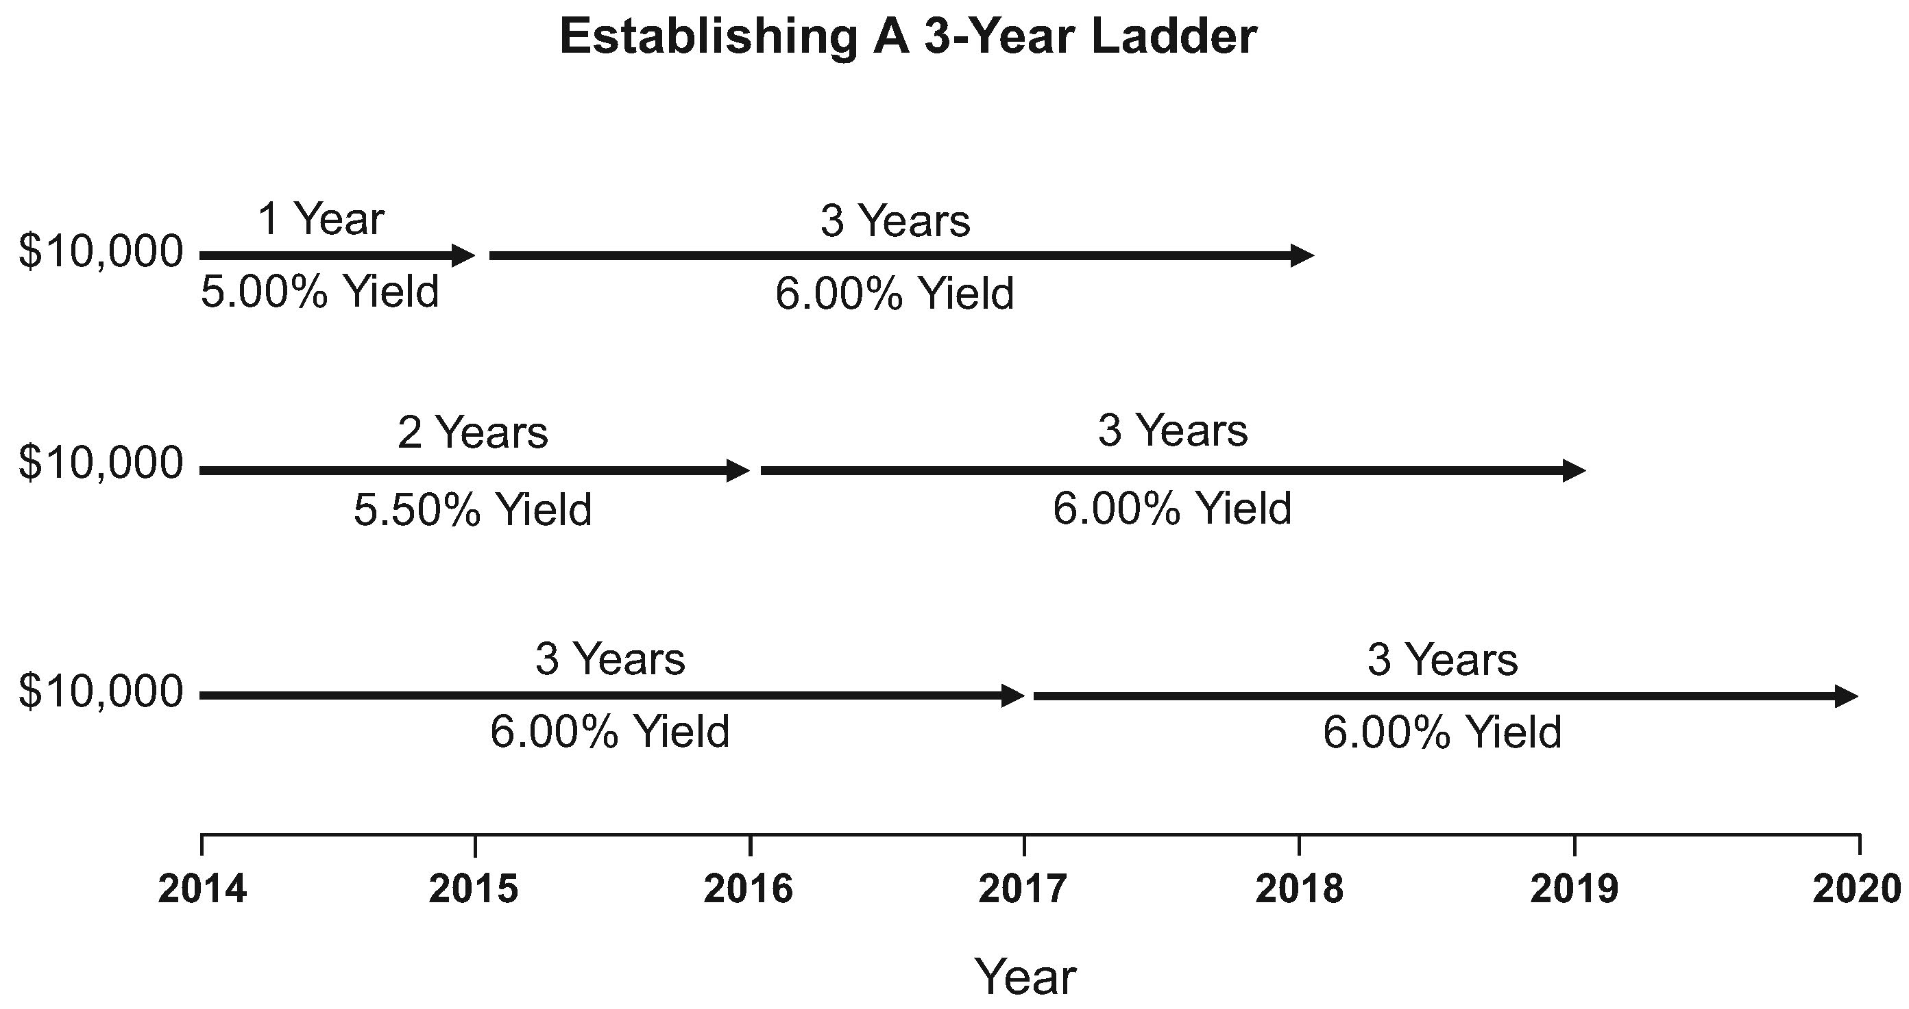
Ladders of five and ten years are often used when investing in corporate, municipal, and federal bonds. In the following five-year ladder, beginning in year two the maturing 5.00 percent bond is replaced with a five-year bond yielding 6.00 percent. Notice that the average maturity remains the same each and every year, but the yield of the portfolio is increased each year during the first five years (assuming 6.00 percent five-year bonds continue to be available) as the initial short-term bonds that formed the early steps of the ladder are renewed for long-term bonds that extend past the end of the ladder. For example, in year two
Balanced Financial Growth
the 5.00 percent bond is replaced by a longer-term 6.00 percent bond yielding 1 percent more interest, and $200 of additional interest earnings, that will mature past the end of the original ladder. This $200 represents an increase of twenty basis points in the portfolio (6.00 - 5.00 = 1.00 ÷ 5 = .2).
Year 1 |  |  |  | Year 2
Amount | Yield | Maturity | Interest | Amount | Yield | Maturity | Interest
$20,000 | 5.00% | 1 year | $1,000 | $20,000 | 5.25% | 1 year | $1,050
20,000 | 5.25% | 2 year | 1,050 | 20,000 | 5.50% | 2 year | 1,100
20,000 | 5.50% | 3 year | 1,100 | 20,000 | 5.75% | 3 year | 1,150
20,000 | 5.75% | 4 year | 1,150 | 20,000 | 6.00% | 4 year | 1,200
20,000 | 6.00% | 5 year | 1,200 | 20,000 | 6.00% | 5 year | 1,200
$5,500 | $5,700
Year 3 |  |  |  | Year 4
Amount | Yield | Maturity | Interest | Amount | Yield | Maturity | Interest
$20,000 | 5.50% | 1 year | $1,100 | $20,000 | 5.75% | 1 year | $1,150
20,000 | 5.75% | 2 year | 1,150 | 20,000 | 6.00% | 2 year | 1,200
20,000 | 6.00% | 3 year | 1,200 | 20,000 | 6.00% | 3 year | 1,200
20,000 | 6.00% | 4 year | 1,200 | 20,000 | 6.00% | 4 year | 1,200
20,000 | 6.00% | 5 year | 1,200 | 20,000 | 6.00% | 5 year | 1,200
$5,850 | $5,950
 |  | Year 5
 |  | Amount | Yield | Maturity | Interest
 |  | $20,000 | 6.00% | 1 year | $1,200
 |  | 20,000 | 6.00% | 2 year | 1,200
 |  | 20,000 | 6.00% | 3 year | 1,200
 |  | 20,000 | 6.00% | 4 year | 1,200
 |  | 20,000 | 6.00% | 5 year | 1,200
 |  | $6,000
The many advantages of laddering include:
Balanced Financial Growth
(1) Reduces reinvestment risk caused when interest rates fall – the investor does not have to reinvest a large amount of funds at lower rates.
(2) Reduces interest rate risk caused when interest rates rise – as investments mature, the investor can take advantage of new investment opportunities paying a higher rate of interest, without liquidating bond investments at a loss.
(3) Maturing CDs or bond investments can be used for current income, thereby avoiding the sale of stocks at depressed prices in a down stock market (i.e., the ladder would not be continued).
(4) Maturing CDs or bond investments can be used for unanticipated emergencies.
(5) Liquidity can be maintained while enjoying the higher rates of return or yields offered by longer-term investments.
(6) Gain greater stability and reduce volatility by purchasing shorter-term bonds that are less sensitive to changes in interest rates, thereby reducing market price risk (page 18).

Monte Carlo Simulation
Monte Carlo simulation is an analytical technique for solving a problem by performing a large number of trial runs involving probability modeling. As employed by financial planners, it is used as a forecasting tool to help individuals make better decisions regarding financial and investment decisions, particularly when planning for retirement. Monte Carlo simulations are used by computer software to simulate retirement cash flows 1,000 or more times, thereby creating a range of possible outcomes which can be subsequently analyzed. For instance, the software can determine how many times out of the maximum number of simulations a plan actually functions as anticipated (e.g., portfolio assets are not depleted before the end of the projected time period), which in the aggregate represents its probability of success. Given the importance of not running out of money in retirement, an 85 percent to 90 percent probability of success (or even higher) is often sought.
If the probability of success is unacceptably low, adjustments can be made, and then tested by rerunning the Monte Carlo simulation program. These adjustments might include: increasing the diversification of portfolio assets, adjusting the retirement age, making increased preretirement contributions, or reducing the cash flow needed in retirement.
Monte Carlo simulations consider two important factors that linear forecasting often ignores: uneven cash flow and the impact of volatility drag and the sequence of returns. For example, assume an investor is able to invest $500,000 in a retirement account and
Balanced Financial Growth
realize returns that mimic the S&P 500 returns from 1995 to 2004 (see “Historical Order Of Annual Returns” in the following table). Assuming no withdrawals, the investor would accumulate $1,562,816 in ten years. The investor could withdraw $70,000 each year for ten years and still have $645,880 remaining. But what if the sequence of returns were reversed (see “Reversing Order Of Annual Returns” in the following table)? After withdrawing $70,000 per year the investor would run out of money in year nine (i.e., the account would be a negative $21,514 in the ninth year). Assuming that an investor will receive an average rate of return each and every year, or a particular sequence of returns, are both flawed assumptions. By using randomly ordered returns based on a set of reasonable parameters, Monte Carlo simulations avoid such flawed assumptions.

Projections Of Retirement Account Values
$500,000 Investment Assuming S&P 500 Returns 1995-2004
(14% × $500,000 = $70,000)
Year | Historical Order Of Annual Returns |  |  | Reversing Order Of Annual Returns
 | Annual  Return | Value If Withdrawals Are |  | Annual  Return | Value If Withdrawals Are
 |  | $0/Yr | $70,000/Yr |  | $0/Yr | $70,000/Yr
1 | 37.58 | 687,900 | 617,900 | 10.88 | 554,400 | 484,400
2 | 22.96 | 845,842 | 689,770 | 28.68 | 713,430 | 553,326
3 | 33.36 | 1,128,015 | 849,877 | -22.10 | 555,740 | 361,041
4 | 28.58 | 1,450,401 | 1,022,772 | -11.89 | 489,663 | 248,113
5 | 21.04 | 1,755,566 | 1,167,963 | -9.10 | 445,103 | 155,535
6 | -9.10 | 1,595,809 | 991,678 | 21.04 | 538,753 | 118,259
7 | -11.89 | 1,406,068 | 803,768 | 28.58 | 692,729 | 82,058
8 | -22.10 | 1,095,327 | 556,135 | 33.36 | 923,823 | 39,432
9 | 28.68 | 1,409,466 | 645,635 | 22.96 | 1,135,933 | -21,514
10 | 10.88 | 1,562,816 | 645,880 | 37.58 | 1,562,816
Avg. | 14.00% |  |  | 14.00%
NOTE: S&P annual returns consist of both capital appreciation and dividends reinvested. Source of returns is www.standardandpoors.com.
Balanced Financial Growth

Derivatives
Derivatives are financial instruments used to eliminate or reduce risk by hedging, to generate risk-free returns via arbitrage, or to acquire risk through speculation. Their value is based upon the performance of an underlying security, commodity, asset, index, condition, or event (these are known as the “underlyings”). Examples of specific underlying financial assets include bonds, mortgage-backed securities, stock market indexes, and foreign currencies. Derivatives are often highly volatile, in that a small movement in the underlyings can cause a large change in the derivative’s value, similar to the effects of leverage. Common types of derivative contracts include options, futures, forwards, and swaps.
Options contracts give the owner the right, but not the obligation, to purchase (referred to as a call option) or sell (referred to as a put option) an asset. The price at which an option can be exercised [the sale takes place] is known as the strike price, and is specified at the time the parties enter into the option. A stock option is a form of derivative because its value changes in relation to the price movement of the underlying stock (see generally the materials on pages151-163). The majority of options are standardized and traded on an exchange.
Futures contracts are standardized and require the holder to make or take delivery of an underlying asset such as a commodity, bond, currency, stock index, or interest rate, at a specified price, on a specified future date. They are exchange-traded and transferable, and during the life of the futures contract intermediate gains or losses are posted each day (a feature known as “marking to market”). The contract can stipulate either physical settlement, requiring delivery of the underlying asset, or cash settlement.
Forward contracts are similar to futures contracts, except that they are privately negotiated non-standardized contracts, gains or losses are not posted each day, and the parties are exposed to each other’s credit risk (i.e., unlike futures contracts, there is no clearinghouse to guarantee fulfillment).
Swaps are used to “swap” the returns of certain investments between two investors; for example, an investment firm that holds a fixed income investment but wishes for variable returns could engage in a swap transaction with another firm that holds variable income investments but wants a fixed return. On a periodic basis, the swap is applied by requiring a cash flow from one party to another to swap the returns. Swaps are used to hedge certain risks such as interest rate risk, or to speculate on changes in the expected direction of underlying prices. For example, an interest rate swap can have
Balanced Financial Growth
the effect of either transforming a fixed rate loan into a floating rate loan, or transforming a floating rate loan into a fixed rate loan. Other types of swaps include currency swaps, credit default swaps, commodity swaps, and equity swaps (see page 93 for a discussion of credit default swaps).
Derivatives are acquired or sold in one of two ways. Over-the-counter (OTC) derivatives are traded directly between buyer and seller, whereas exchange-traded derivatives (ETD) are traded on specialized derivatives exchanges and other exchanges. In the United States, the Chicago Mercantile Exchange (CME) trades in financial instruments such as interest rates, equities, currencies, and commodities, as well as alternative investments such as weather and real estate derivatives. Options and futures contracts are traded on the Chicago Board of Trade (CBOT) and futures contracts for energy products, metals, and other commodities are bought and sold on The New York Mercantile Exchange (NYMEX).
Derivatives serve many legitimate business purposes. For example, airlines use derivates for hedging to reduce the risk of volatile price swings in jet fuel costs by locking in the cost of future jet fuel purchases with futures contracts. Unfortunately, derivatives are also associated with financial abuse and excess. Examples of such activities include the securitization of subprime mortgage-backed securities and subsequent repackaging into collateralized debt obligations, and the use of credit default swap derivatives by banks to rid themselves of these risky mortgage-backed securities (see pages 93 and 124).

Dollar Cost Averaging
With dollar cost averaging, the investor engages in systematic investing, allocating a consistent amount of money into an investment at regular intervals. Investing a series of fixed sums in this manner means that more shares are bought at low prices than high prices, and as a result the average cost is lower than average share price.
Dollar cost averaging often supports a buy-and-hold approach to building a diversified investment portfolio over time. While an investor who uses dollar cost averaging in a falling market acquires more shares for his or her money then would be purchased in a raising market, the strategy does not assure a profit or protect against a loss in a declining market.
Balanced Financial Growth

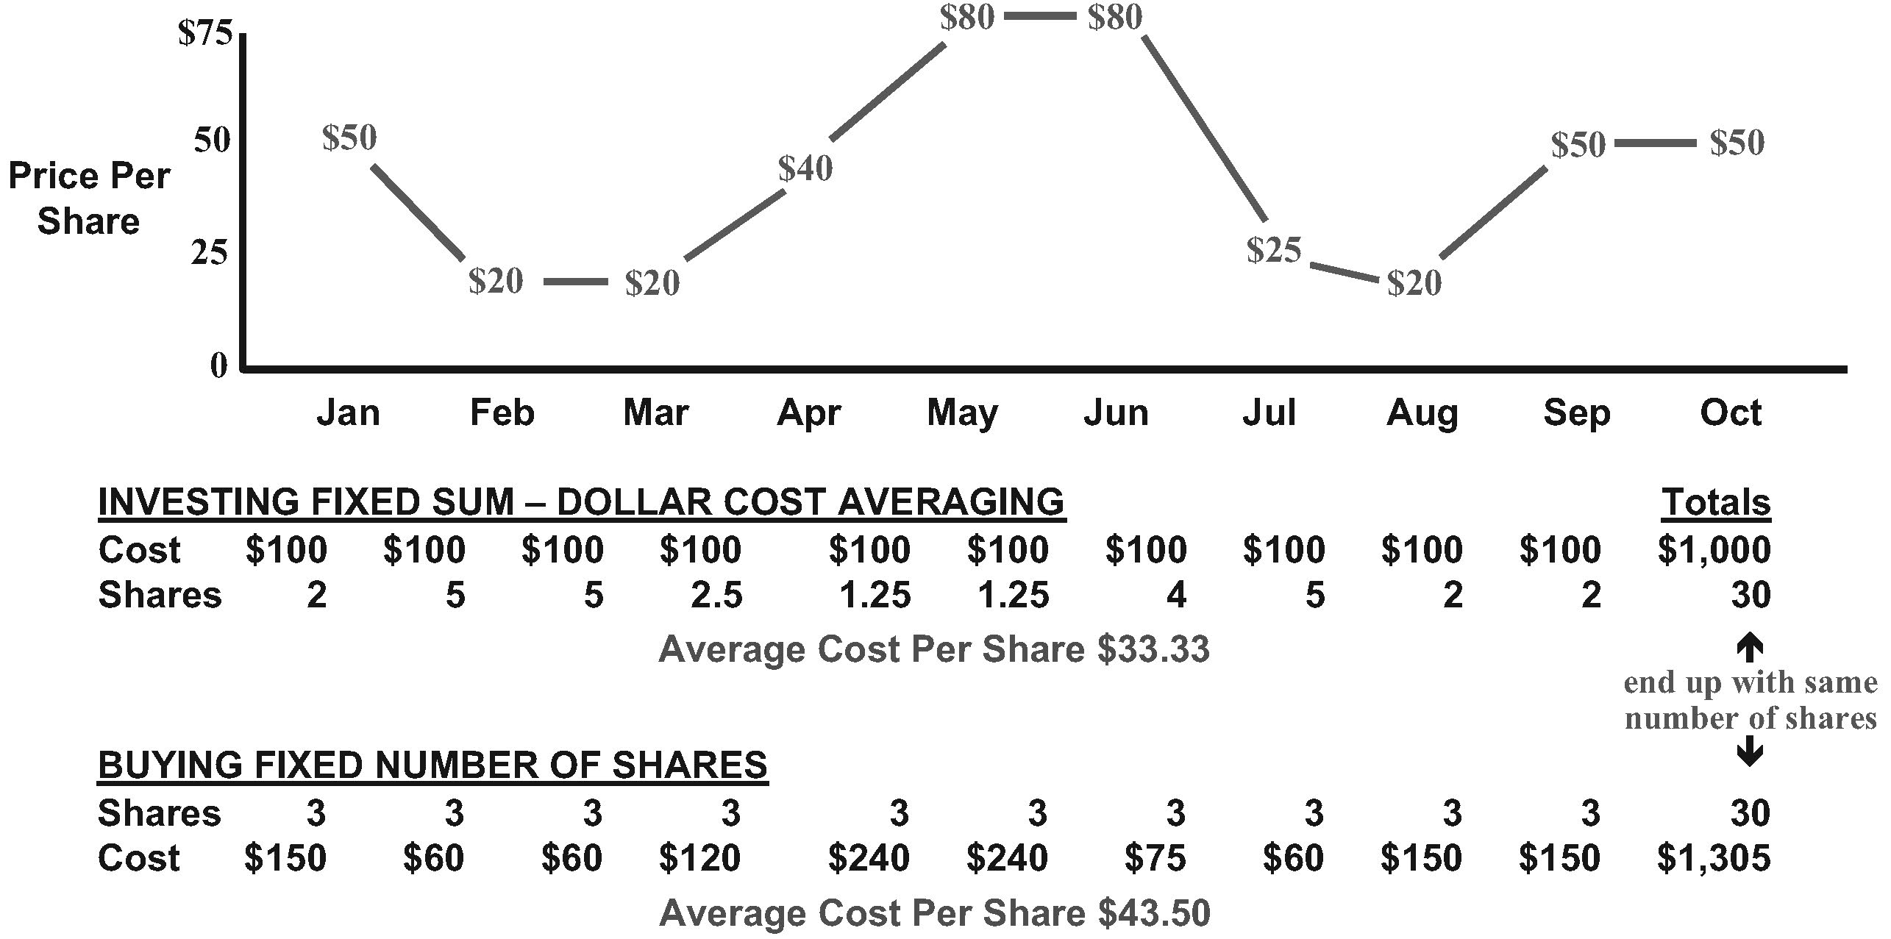
For example, the above chart demonstrates the effects of dollar cost averaging. Assume investor #1 commits to purchasing $100 of stock each month for a period of ten months. At the end of ten months, he has invested $1,000 and purchased thirty shares of stock for an average cost of $33.33 per share. Compare these results with investor #2, who commits to purchasing three shares of stock each month, no matter the cost. Buying a fixed number of shares requires investor #2 to pay $1,305 to purchase thirty shares of stock, for an average cost of $43.50 per share.

Fundamental Analysis
Fundamental analysis attempts to measure the intrinsic value of a particular stock based upon factors such as the overall economy, industry conditions, the financial condition and management of the company, and many other related factors. Focus is placed on analyzing the fundamentals of the company behind the stock rather than the market in which the stock is traded. As with most analysis, the goal is to derive a forecast for the future, thereby identifying currently undervalued stocks. If the estimated value of a stock is more than the current market price, then the stock is considered an attractive investment opportunity. Annual reports, talking to company management, evaluation of economic factors, and the analysis of a company’s balance sheet are all used to determine the value of the company. The ultimate objective is to buy the stock at a price that is lower than liquidation value, at a price that is low when compared to the valuation of company net assets, or at a price that is low when compared to future projected earnings. Whereas technical analysis (discussed in the next section) seeks to identify stocks that are either “overbought” or “oversold,”
Balanced Financial Growth
fundamental analysis focuses on identifying stocks that are either “overvalued” or “undervalued.” The following are some of the financial ratios used in fundamental analysis.
Book Value. Also known as shareholder equity or a company’s net asset value (NAV). Book value is calculated by subtracting all liabilities, including debt and the par value of preferred stock, from total assets. A company’s market value may be quite different from its book value. Book value is sometimes used as a means of determining if a company’s assets are sufficient to cover its outstanding obligations and equity issues.
Book Value Per Common Share. This is a variation of the book value calculation and is a measure of book value per share of outstanding common stock. The question addressed by this ratio: “Is a premium being paid by the investor for the future earnings and the goodwill of the company?” Uncertainty regarding operations of the company, or doubts regarding asset valuations, can result in companies being traded for less than book value. Alternatively, some investors may view a stock that is selling below book value as an indication that the stock is undervalued.
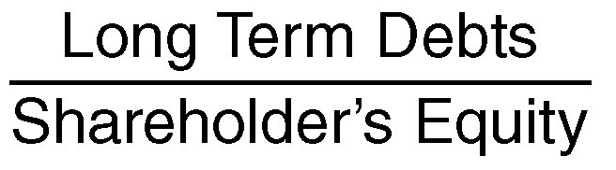
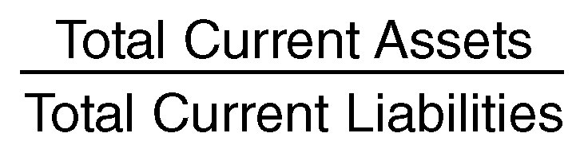
Current Ratio. Also called the “working capital” ratio. The question addressed by this ratio: “Does the business have enough current assets to meet the payment schedule of its current debts with a margin of safety for possible losses in current assets?” A two to one ratio is generally acceptable, although this can vary by industry and the nature of the business.
Debt Equity Ratio. This is an indication of the extent to which a company is reliant on debt financing. A high ratio is an indication that the company has borrowed extensively - ostensibly because it believes it will be fast growing - but also indicates a danger that the company has overextended itself. Average ratios differ considerably from one industry to another.
Earnings Per Share. This is a measure of the net earnings of the company that are available to common stockholders after paying taxes, bond holders, and owners of preferred stock. It is considered a measure of how well the company is doing by its common stockholders. Earnings will either be paid out to shareholders in the form of dividends, or retained by management to allocate to existing or new lines of business.
Balanced Financial Growth
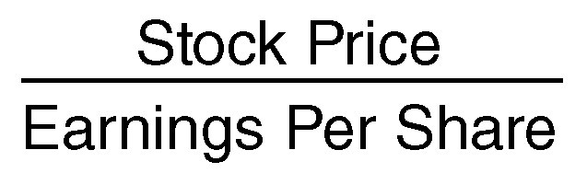
Price Earning Ratio (P/E Ratio). Also known as a stock’s multiple, this provides an estimate of the numbers of years it will take the company to generate the price paid for the stock (assuming income does not fluctuate). Companies with high P/E ratios are typically expected to experience rapid future growth to justify their long recovery period. A low P/E ratio may be an indication of a company not yet discovered by the market, or of a company considered a poor investment risk. A trailing P/E ratio uses earnings from the past, whereas a forward P/E ratio uses estimates of future earnings. See also, page 133.
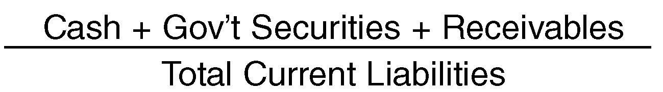
Quick Ratio. Also called the “acid-test” ratio and “quick current” test. The question addressed by this ratio: “If all sales revenues disappeared, could the business meet its current obligations with the readily convertible ‘quick’ funds at hand?” An acid test of one to one is typical. Quick funds are current assets minus inventory.
Working Capital. This is a measure of available cash to meet basic cash flow requirements to run the business and is considered an indication of the ability to withstand financial crises.
Debt/Worth Ratio. Indicates the extent to which the business is reliant on debt financing.
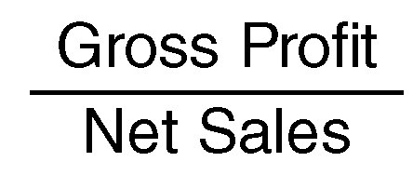
Gross Margin Ratio. Gross profit equals net sales minus cost of goods sold. This ratio measures the percentage of sales dollars remaining to pay overhead expenses.
Net Profit Margin Ratio. This ratio measures “return on sales” and can be used to evaluate performance in comparison with similar businesses.
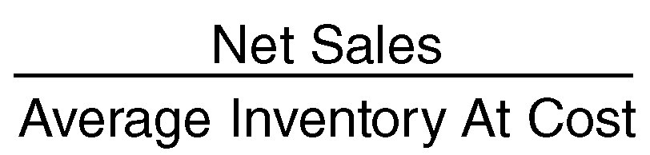
Inventory Turnover. Measures how well inventory is managed. The more inventory is turned in a given operating cycle, the greater the profit.
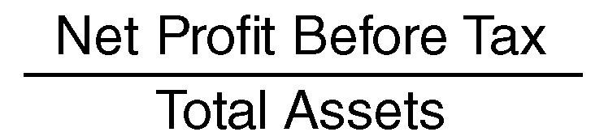
Return On Assets Ratio. Measures how efficiently profits are being generated from the assets employed in the business when compared with ratios of similar firms. A comparatively low ratio indicates an inefficient use of business assets.
Balanced Financial Growth
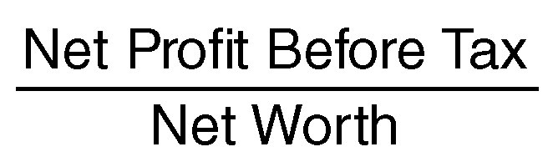
Return On Investment. A measure of the percentage of return on funds invested in the business. This is considered a very important ratio. If the ROI is less than the rate of return on an alternative, risk-free investment, the owner may wish to sell and invest elsewhere.
Current Ratio, Quick Ratio, and Working Capital are liquidity ratios that indicate the ease of turning assets into cash. Debt/Worth Ratio is a leverage ratio that measures how dependent the business is on debt financing. Gross Margin Ratio and Net Profit Margin Ratio are profitability ratios. Inventory Turnover, Return On Assets Ratio, and Return On Investment are ratios used to evaluate management.

Technical Analysis
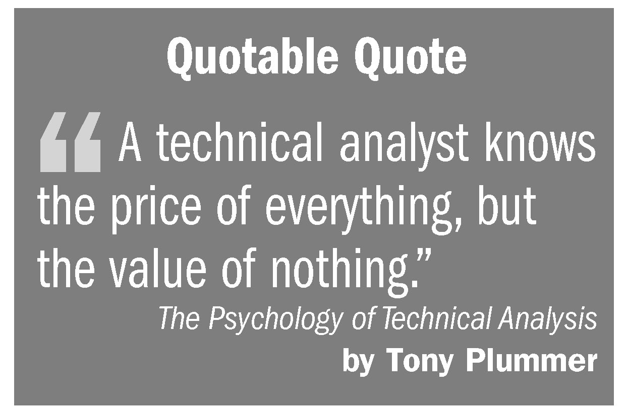
In contrast to fundamental analysis, technical analysis involves the evaluation of trading movements and trends, without regard to the underlying fundamentals of individual stocks. Technical analysis is the examination of past long-term and short-term price movements to forecast short-term trading patterns and future price movements. Such analysis looks only for repetitive price patterns and is unconcerned about the financial data used in fundamental analysis or the emotions of the market as used in sentiment analysis (although many traders who implement technical analysis also integrate sentiment analysis). See pages 31 and 41. Technical analysts are often referred to as chartists because they rely heavily on charts for their analysis.
Dow Theory. The Dow Theory recognizes three movements in the securities markets: major trends, intermediate trends, and short-term trends. Major trends are broad-market movements, typically lasting several years (e.g., a major decline occurs when successive rallies fail to penetrate previous highs, but previous lows are penetrated). An upward major trend is called a “bull market,” whereas a downward major trend is called a “bear market.” Bull markets occur when upward rallies exceed prior highs and declines stay above previous lows. Intermediate trends, occurring within the major trend, are influenced by current events and can last for several weeks or even months. Intermediate trends can give rise to technical corrections, a term used to describe the adjustments that occur when markets are either overbought or oversold. Short-term trends are daily ripples that are considered to have no particular significance.
Balanced Financial Growth
In order to predict what direction the market will take, the Dow Theory employs both the Dow Jones Industrial Average and the Dow Jones Transportation Average. Movement of both averages upward signals a strong bull market, whereas movement of both averages downward signals a bear market. Movement of both averages in opposite directions signals uncertainty. A trend continues so long as the averages confirm each other.
The following charts and analytic concepts are employed in technical analysis:
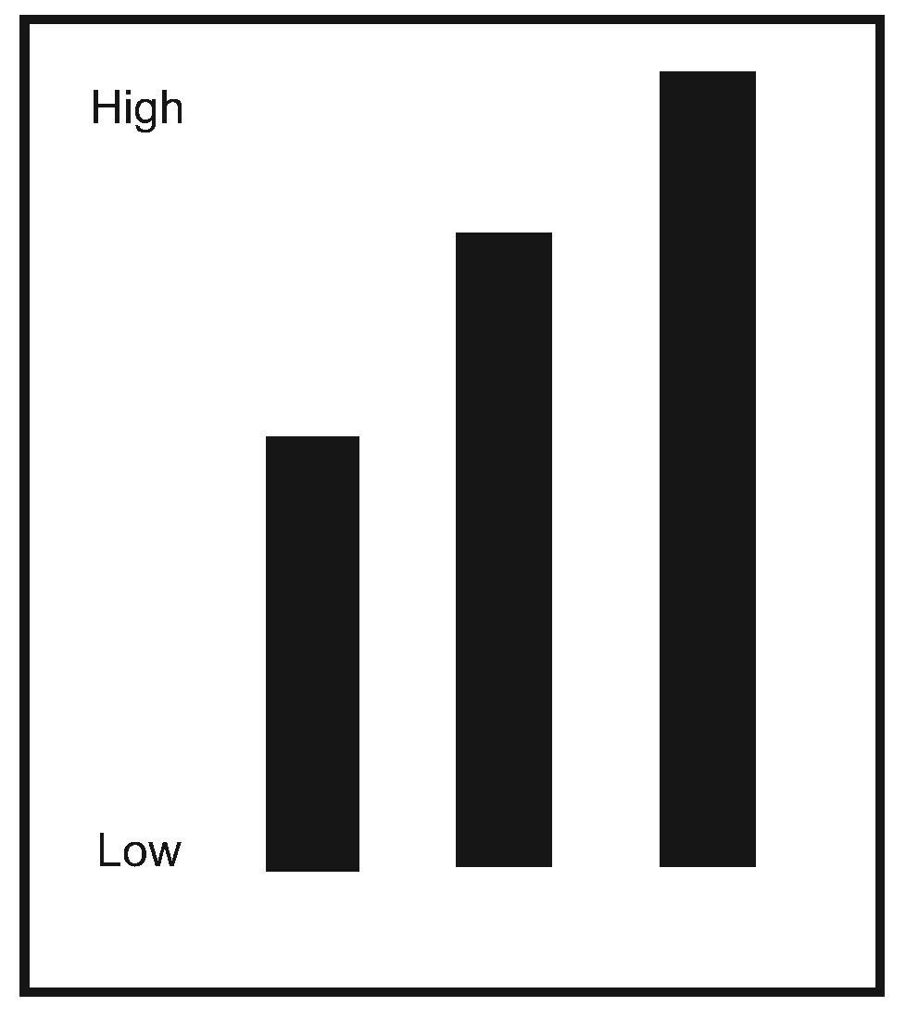
Bar Charts. A simple vertical bar chart is shown. Bar charts, or graphs, are often used to display single events as Y-values (vertical axis) and the differences between them using a bar for each X-value (horizontal axis). They can be used to compare data sets against some variable data such as time or frequency. Other variations of bar charts include vertical stacked bar charts, vertical stacked floating bar charts, horizontal bar charts, horizontal stacked bar charts, and horizontal stacked floating bar charts. Bar charts can also be used to group data series together by category, displaying multiple bars within each category. The bars are often color-coded according to the series represented. For examples of some of these see: www.ncsu.edu/labwrite/res/gh/gh-bargraph.html.
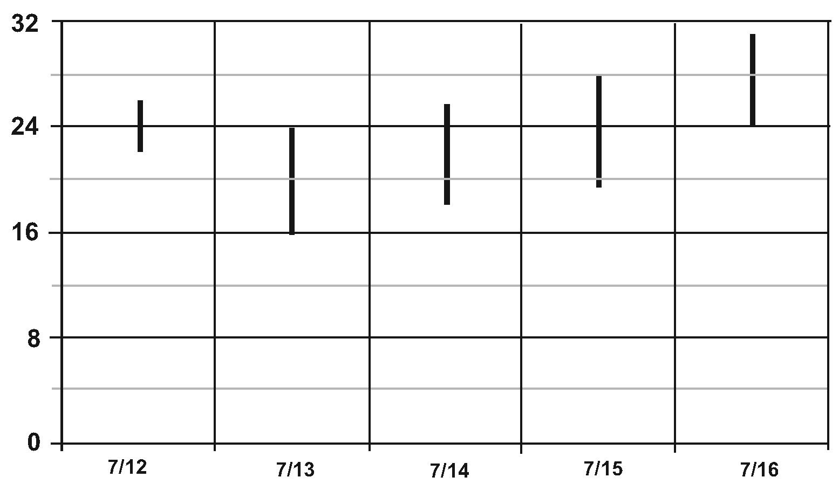
Bar Chart (high-low). High-low charts display a Y-value for each X-value, and a range of Y-values for a given X-Value. High-low charts are typically used to display a confidence range or the trading range of a stock. The range of Y-values represent the low and the high values for the given X value.

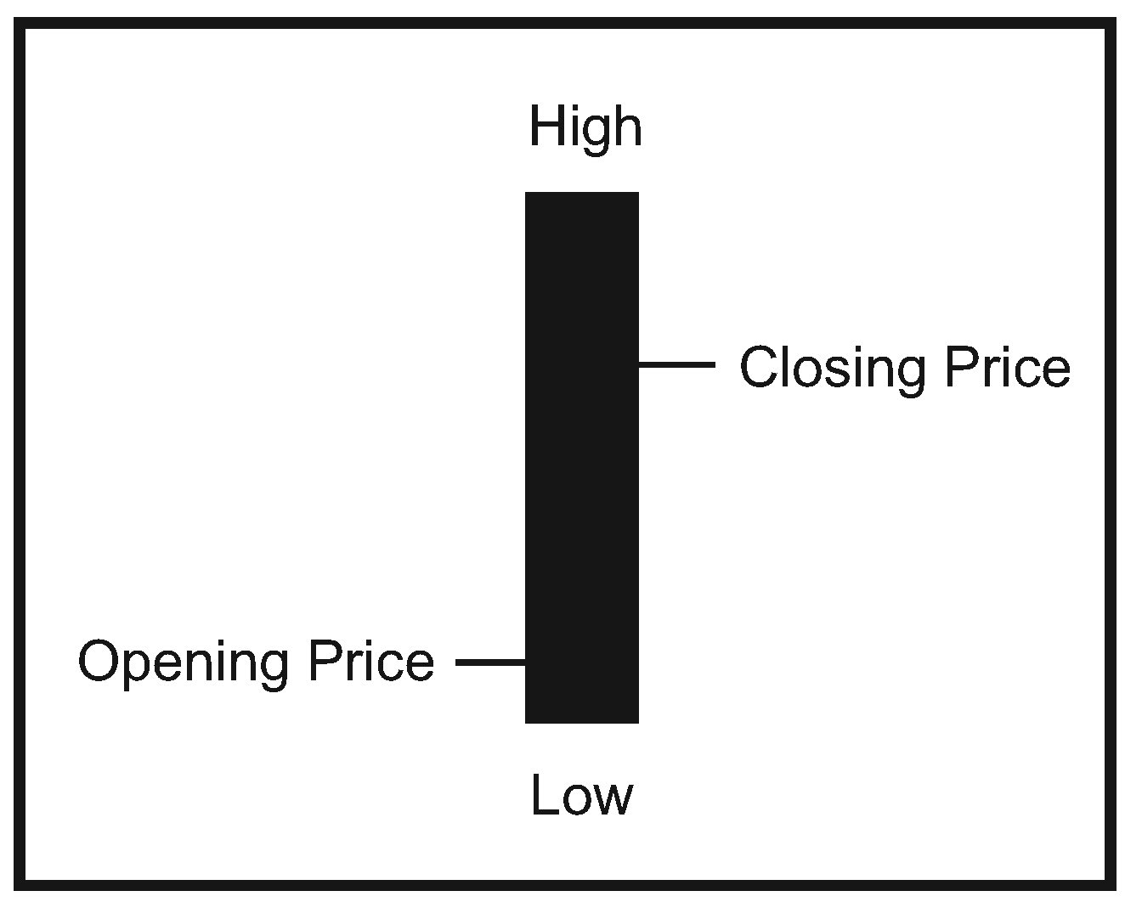
Bar Chart (high-low, open-close). Bar charts that incorporate the open-close feature display a Y-value for each X-value, a range of Y-values for a given X-value, and include an opening and closing point for the values. High-low open-close charts are typically used to display a confidence range or the trading range of a stock with opening and closing values included in the range. These charts are typically used for showing daily stock prices over time, and showing statistical data with a confidence range over time.
Balanced Financial Growth
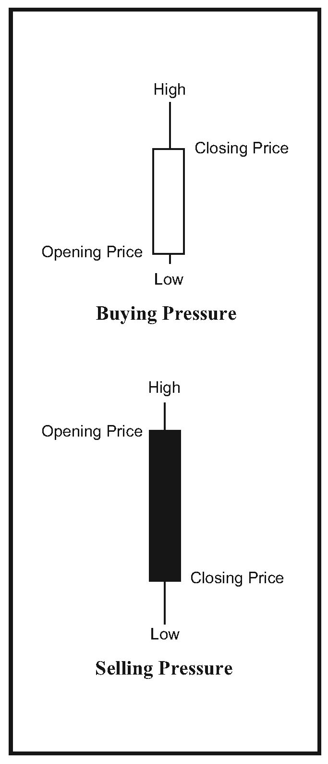
Candlestick Charts. Candlestick charts utilize a series of boxes with lines projecting vertically up and down from the ends of the box, and drawn on an X-Y grid. The top and bottom of each box indicates the open and close values and allow the user to compare the relationship between the open and close as well as the high and low. If the close price is higher, the box is not filled (buying pressure). If the open price is higher, the box is filled (selling pressure). The vertical lines indicate the high and low values. The relationship between the open and close is considered vital information and forms the essence of candlesticks. The candlestick graph requires four data sets (open, high, low, and close values). Candlestick charts are primarily used for stock price activity.
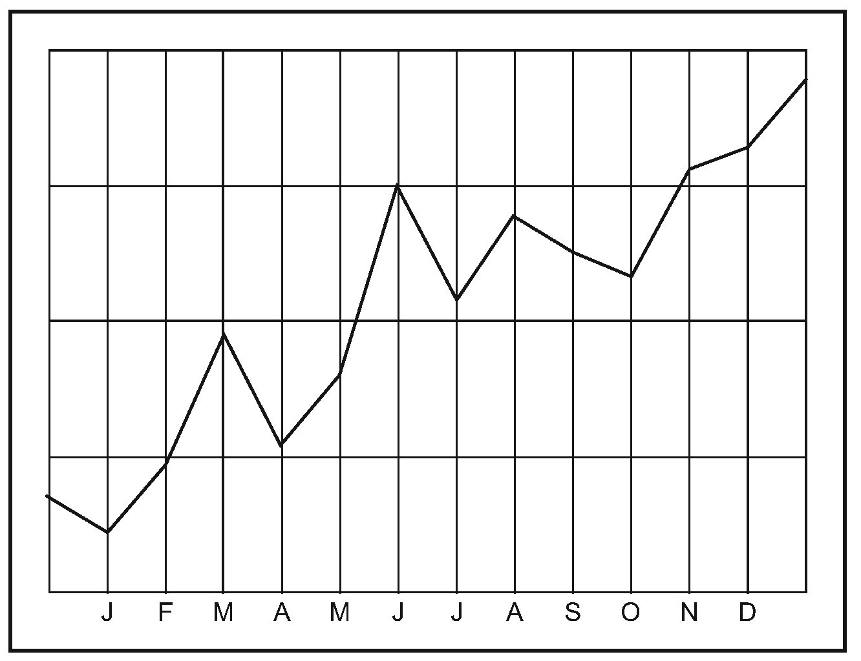
Line Charts. Line graphs are used to determine trends and cyclic variation based on interaction of data elements. The data points are plotted on the graph and connected with lines. Line graphs can display large amounts of data that varies along some accepted sequence such as price, time, volume, etc. Line graphs with multiple lines can be used to display several variables to conserve space and to facilitate comparison of more than one dependent variable on a single independent scale. Line graphs can be used for determining trends or cyclical variations, illustrating money distribution over time, depicting production over time, and showing price variations over time.
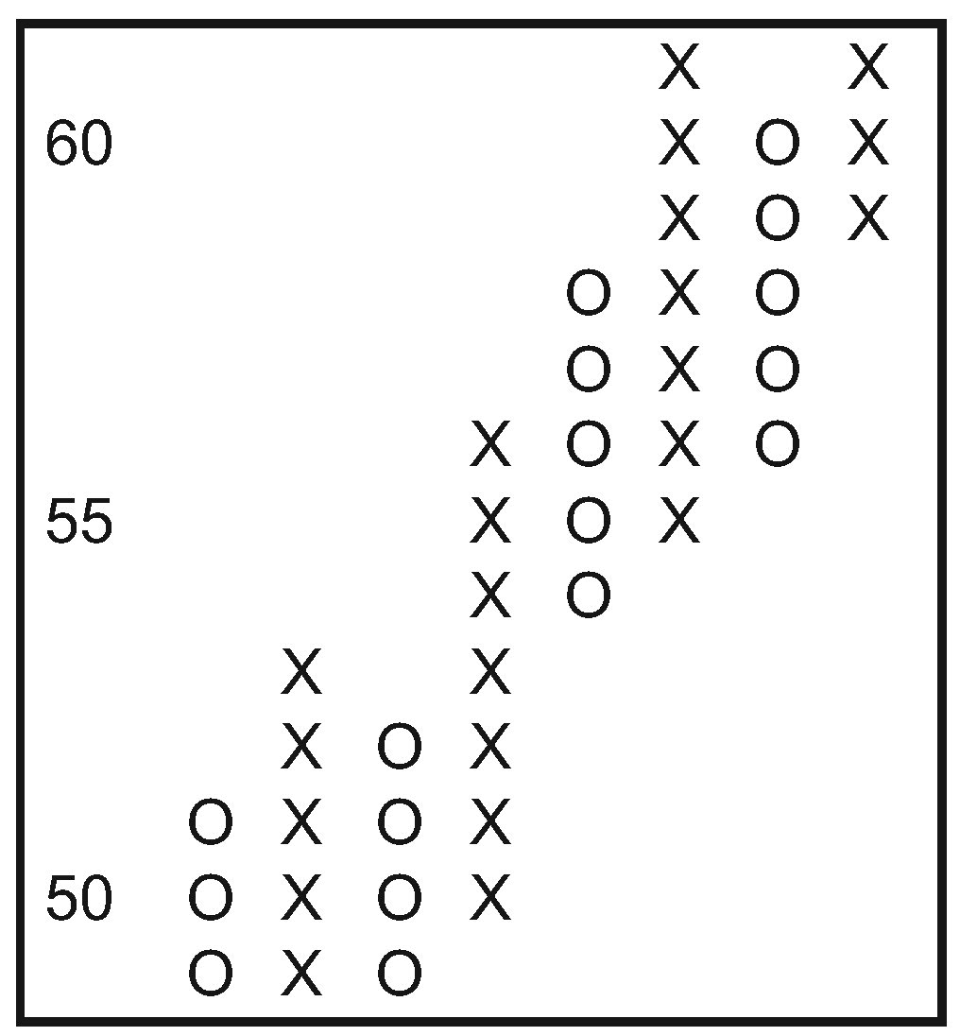
Point-and-Figure Charts. Point-and-figure charts consist of columns of X’s (uptrends) and O’s (downtrends) that represent filtered price movements over time. When compared to the more traditional bar and candlestick charts, the proponents of point-and-figure charts maintain that they offer the following advantages: (1) remove the potential misleading effects of time from the analysis process; (2) eliminate the insignificant price movements that often make bar charts appear “cluttered”; (3) make recognizing support and resistance levels much easier; (4) facilitate the recognition of trend lines; and (5) keep the user focused on important long-term price trends and developments.
Balanced Financial Growth
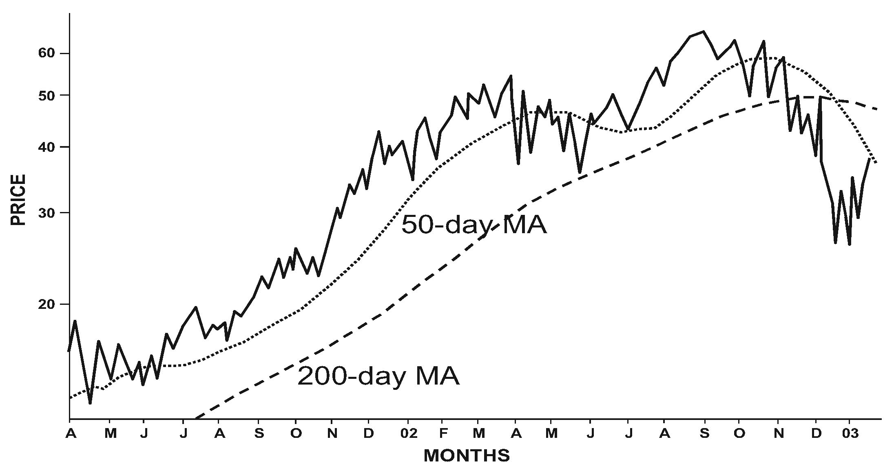
Moving Averages. Moving averages are used in an attempt to filter out “noise” and to uncover underlying signals and trends. The averages are calculated by adding sets of data, then dividing the sum by the periods. The results display a smoothed out version of the trend. When the price crosses the moving average line (considered a crossover point) this indicates a reversal in trend. The longer the time span used in calculating the moving average, the more significant the crossover signal. For example, a price line that crosses, or penetrates, a fifty-day moving average is not considered as significant as one that crosses a 200-day moving average. Before confirming a crossover, traders typically wait for the penetration to reach a predetermined number of days, or percentage of price. Different time periods are commonly used depending upon the type of trading (e.g., twenty-day moving averages for short-term trading, fifty-day moving averages for intermediate-term trading, and 200-day moving averages for long-term trading).
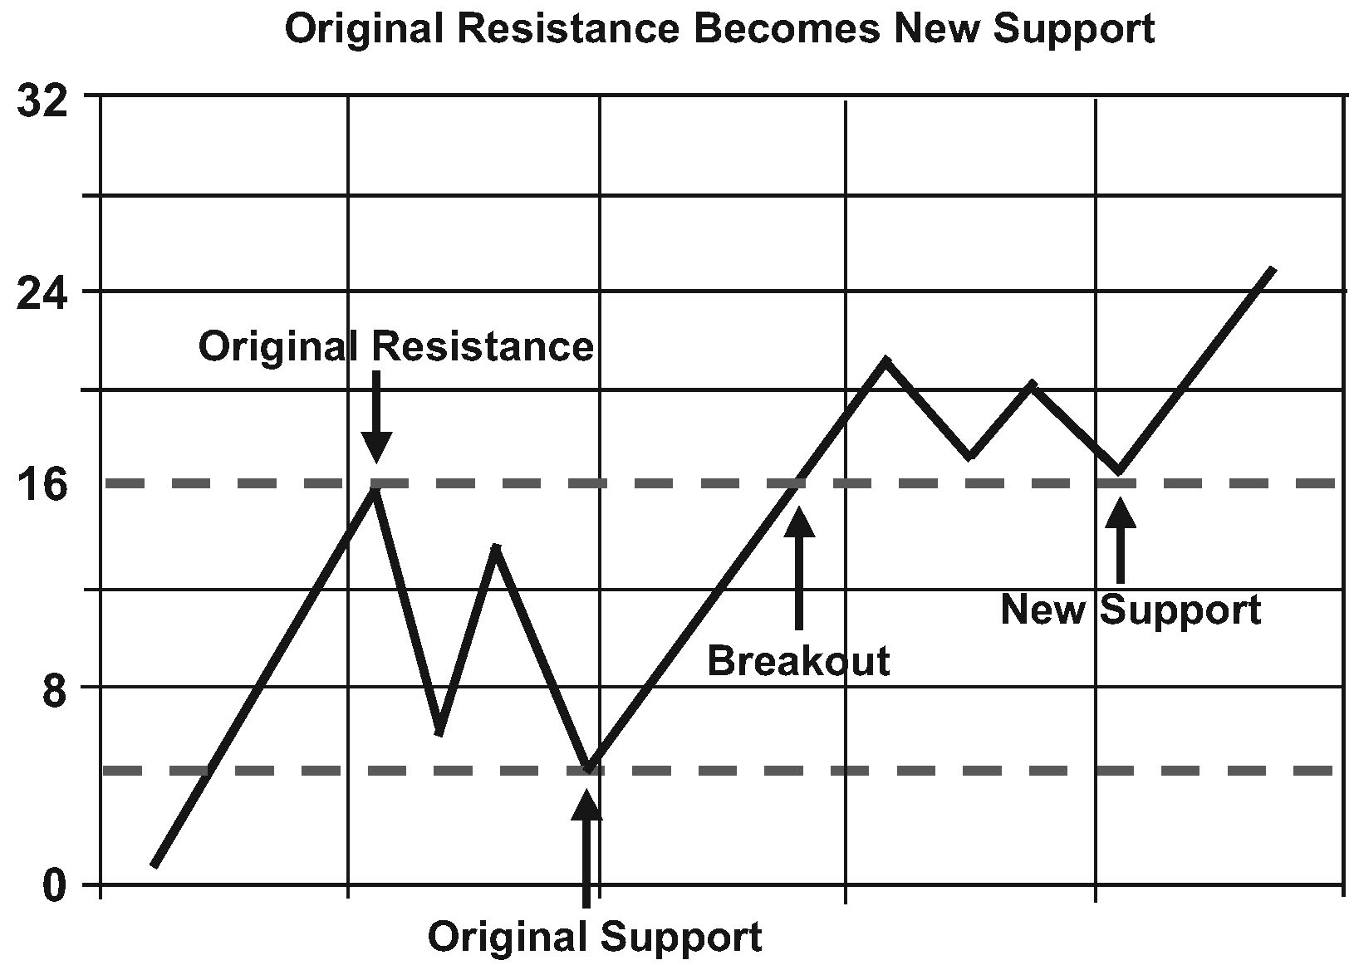
Resistance Level. This indicates the price above which it is difficult for a market or stock to rise. It is the upper level for trading, or the price at which sellers typically outnumber buyers. A “breakout” occurs when the price rises above the resistance level and a new level of resistance is formed that then becomes the new support level. Such a rise above the support level is considered bullish. Horizontal lines on stock price charts indicate resistance levels.
Support Level. This is the opposite of the resistance level and indicates the price below which it is difficult for a market or stock to fall. At this level there is more demand for the stock than supply and any decline in price is likely to stop. Support levels are formed over a period of time, typically months or even a year or more, and represent the accepted lower “trading range” for the stock. A “breakout” occurs when the price falls below the support level and a new level of resistance is formed that then becomes the
Balanced Financial Growth
new resistance level. Such a drop below the support level is considered bearish. Horizontal lines on stock price charts indicate support levels.
Standard Deviation. Standard deviation is a statistical measurement of the dispersion of a variable, such as the price of a stock or the return on an investment, moves above or below its average (mean) value. As such, it is a measure of volatility. An investment with high volatility is considered riskier than an investment with low volatility. Therefore, the lower the standard deviation, the lower the risk; and the higher the standard deviation, the higher the risk (i.e., the more spread apart the data is, the higher its typical or “standard” deviation).
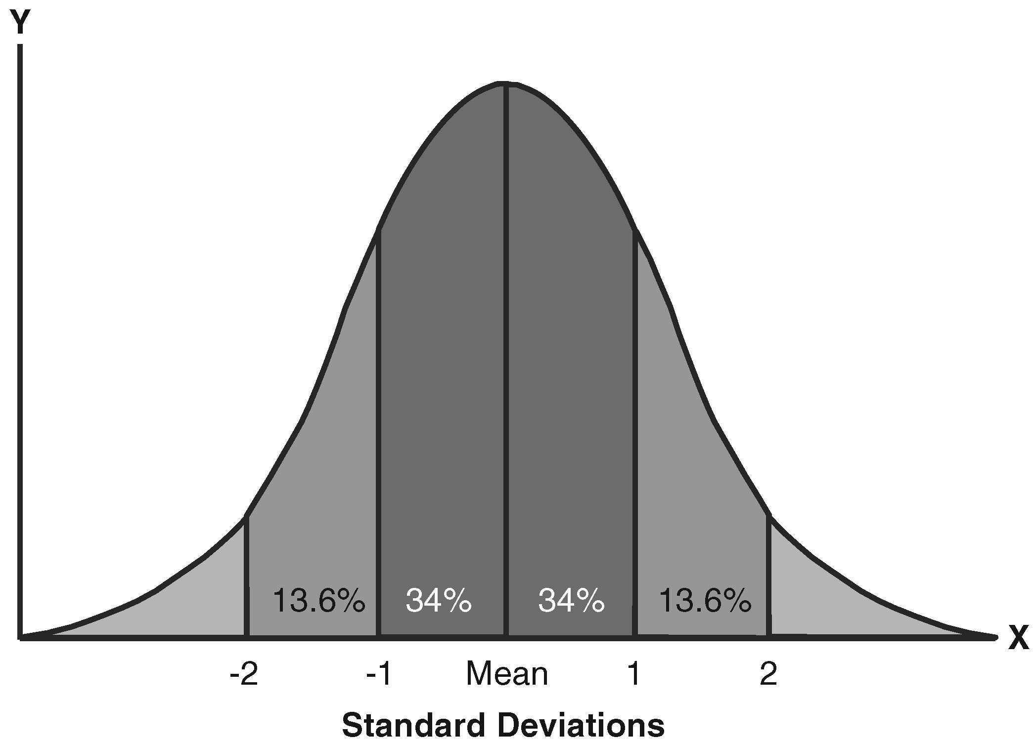
The bell curve (also known as the “normal distribution”) above will help explain the concept. Assuming normally distributed data, approximately 68 percent (roughly two-thirds) of the time total returns are expected to differ from the average (mean) total return by not more than plus or minus one standard deviation. And approximately 95 percent of the time total returns are expected to differ from the average (mean) total return by not more than plus or minus two standard deviations. A smaller standard deviation means the bell curve would cover a smaller range; the higher the standard deviation, the wider the dispersion of potential results. Note that the x-axis is the value that is being measured, such as annual, or monthly, returns from a stock mutual fund.
Calculation of the actual standard deviation is a bit complicated and consists of the following six distinct steps: (1) calculate the average return; (2) for each period subtract the average from the return in that period (this is the deviation for that period); (3) square the deviation for each period; (4) sum the squared deviations; (5) divide the sum by the number of periods (this is known as the variance); and (6) calculate the square root of the sum of the squared
Balanced Financial Growth
deviations (this is the standard deviation). The following table calculates the standard deviation for the indicated returns over a period of 10 years. The steps in the process are labeled #1 through #6. Note that the mean (also referred to as the “average”) return is 6.2 percent and the standard deviation is 11.9. The results are plotted in graph A.
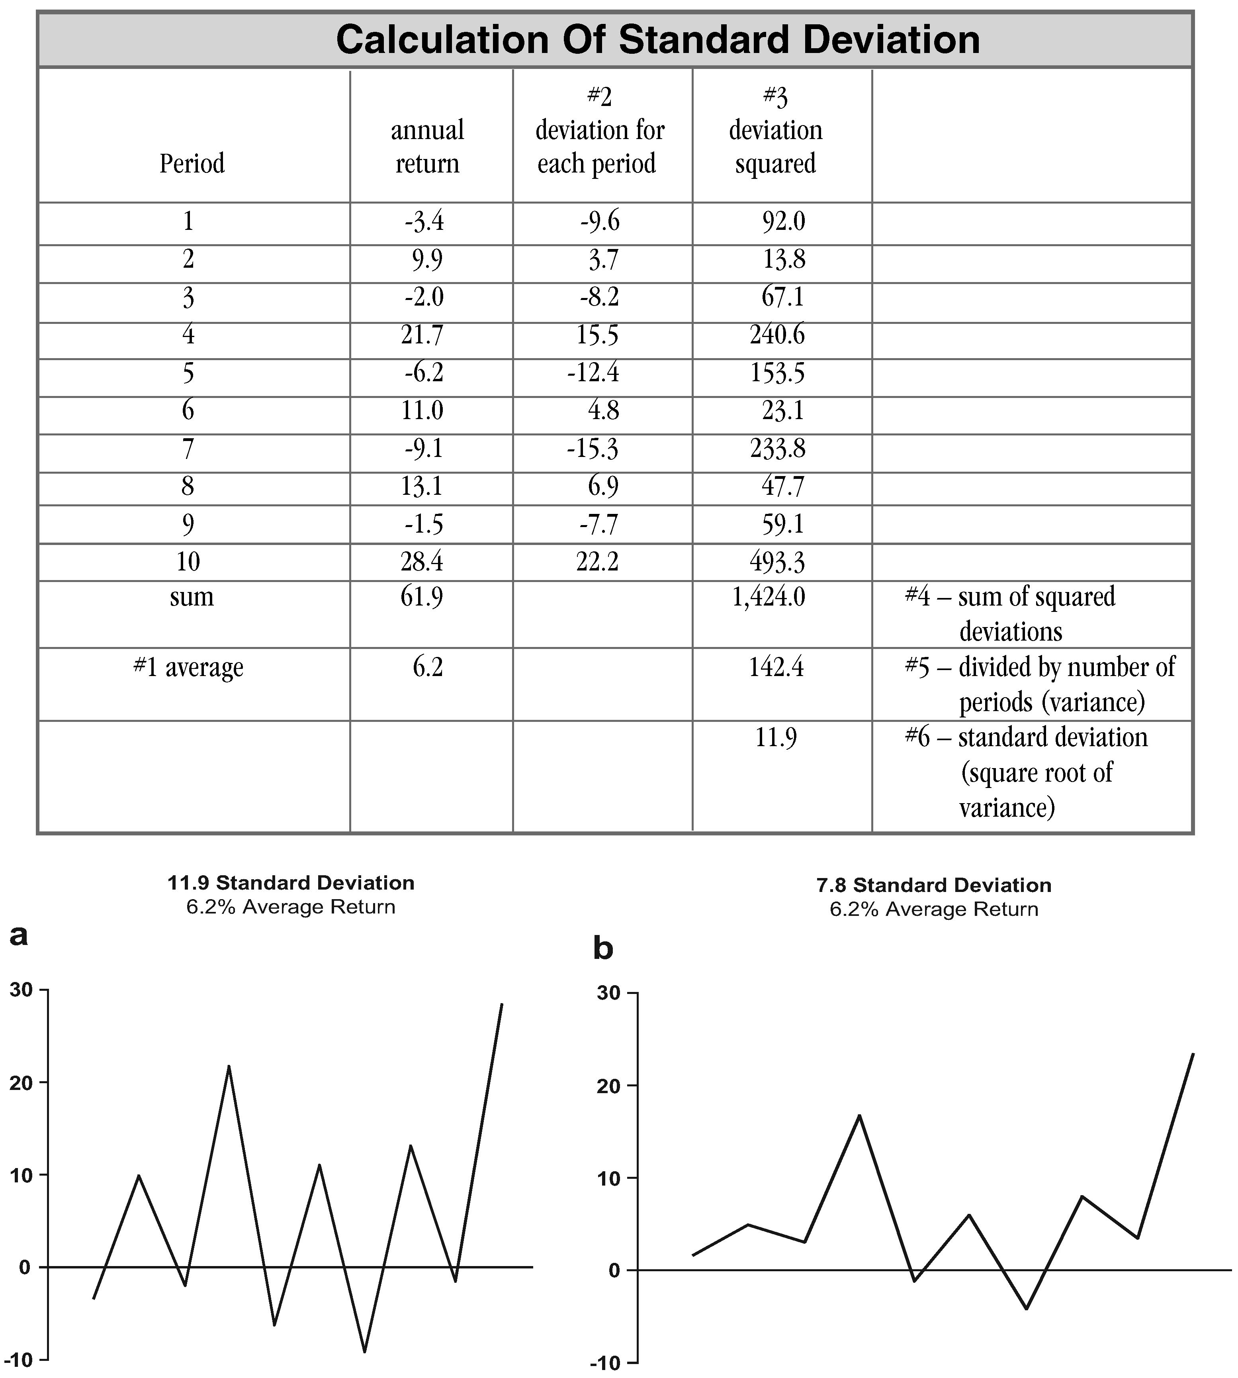
These swings in annual returns can be dampened while retaining the same average return by adding 5 percent to each negative return in years one, three, five, seven, and nine, and subtracting 5 percent from each positive return in years two, four, six, eight, and ten. As expected, average returns remain at 6.2 percent, but the volatility of returns are lowered as the standard deviation falls from 11.9 to 7.8 (the results are plotted in
Balanced Financial Growth
s graph B). The smaller tandard deviation indicates a more consistent investment with less volatility (and theoretically, less risk) to the investor. Armed with this information an investor would likely chose the less volatile investment (7.8 standard deviation); particularly if it is expected to produce the same 6.2 percent rate of return.
Standard deviation is often used in comparing the volatility and risk of various mutual funds. The Morningstar mutual fund ratings provide the standard deviation as an annualized statistic based on 36 monthly returns over a three-year period (see pages 189-190). Assuming a fund’s returns fall within the typical bell-shaped distribution, 68 percent of the time the fund’s total returns are expected to differ from its average (mean) return by no more than plus or minus one standard deviation, and 95 percent of the time by no more than plus or minus two standard deviations. Thus, a fund with a mean of 26.53 and a standard deviation of 20.20 can be expected to return between 6.33 percent (26.53 – 20.20) and 46.73 percent (26.53 + 20.20) roughly two-thirds of the time. In general, a wider range of returns can be expected from the fund with the higher standard deviation and a lower range of returns can be expected from the fund with a lower standard deviation. However, it is important to recognize that by itself a low standard deviation means only that returns have been fairly stable; it does not indicate anything about the absolute amount of expected returns.
Bollinger Bands. This indicator allows users to compare volatility and relative price levels over a period of time.
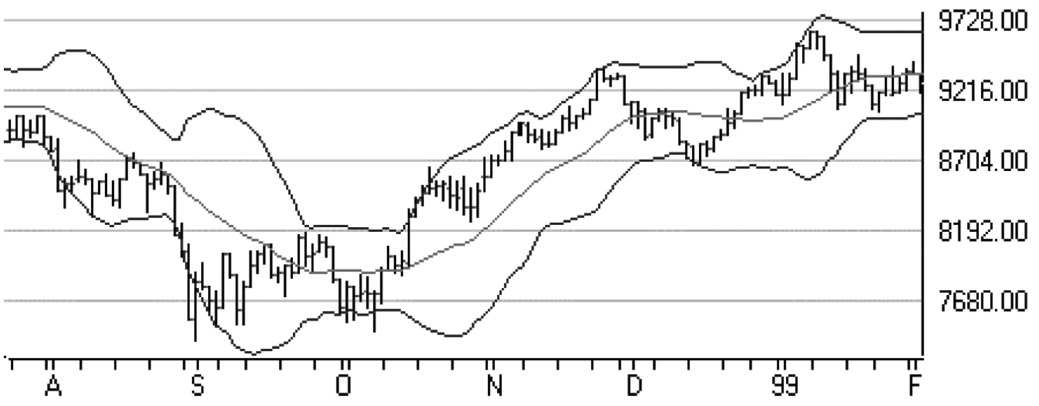
The indicator consists of three bands designed to encompass the majority of a security’s price action: (1) a simple moving average in the middle; (2) an upper band reflecting the simple moving average plus two standard deviations; (3) a lower band reflecting the simple moving average minus two standard deviations.
Balanced Financial Growth
Standard deviation is considered a good indication of volatility and ensures that the bands respond quickly to price movements, thereby reflecting periods of both high and low volatility.
In periods of greater volatility, when there are sharp price increases or decreases, the bands widen. When the market becomes less volatile, the bands narrow. As indicators of previous market volatility the bands are used to augment other analysis techniques and indicators, but are not designed to predict the future direction of a security. The two primary uses of Bollinger Bands are to identify periods of high and low volatility, and periods when prices are at possibly unsustainable levels.

Sentiment Analysis
Unlike fundamental and technical analysis, each of which attempt to evaluate the market in terms of the facts relating to a particular stock’s performance, or of the market as a whole, sentiment analysis attempts to measure the market environment in terms of the attitudes of investors and the “mass psychology” of the investment community as a whole. Sentiment analysis requires selection and interpretation of data by the individual analysts.
A key element of sentiment analysis is the contrarian’s belief that the average investor can often be wrong, particularly as the market approaches its highs and lows. Thus the investor using sentiment analysis will look to trade against the majority’s view of the market.
Many qualitative and quantitative methods have been developed in order to evaluate sentiment. Most of these relate to the overall market, but many are relative to market segments and even individual stocks. The following are examples of some of these psychological market indicators. Advisors who utilize sentiment analysis will typically choose a subset of these indicators that are believed to be most effective; notably, though, there is not universal agreement regarding which indicators are truly the most effective, and some subjectivity remains in the selection of indicators to use.
Volatility Index. The CBOE Volatility Index (ticker VIX) computes the implied volatility of eight S&P 100 (OEX) put and call options. A composite hypothetical option is developed by weighting the options according to the time remaining and the degree to
Balanced Financial Growth
either in or out of the money. When the market is expected to move which they are higher, excessive call contract buying will produce a low VIX. When the market is expected to move lower, disproportionate put buying will produce a high VIX. The investor using sentiment analysis views the volatility index from a contrarian’s perspective, buying when the index is high and selling when the index is low.
Options Trading Volume. As with the CBOE Volatility Index, put buying is considered bearish and call buying is considered bullish. Therefore the ratio between put volume and call volume is considered a good indication of market mood. From a contrarian’s perspective, a high volume of buyers or sellers is an indication that the small options investor is again wrong (a very high percentage of option contracts expire worthless). The investor using sentiment analysis will buy when there are a disproportionate number of put buyers and sell when there are a disproportionate number of call buyers.
Option Open Interest. Open interest is a measure of the number of outstanding option contracts that are available in a specific option series at the end of a trading day. Monitoring open interest provides a means of judging whether the market is bullish or bearish. A rise or fall in an option’s open interest is a signal to the contrarian investor to trade against the market.
Put And Call Premiums. This is another indicator that is viewed from a contrarian’s perspective. When put premiums are higher than call premiums, the market is bearish (i.e., the put premiums are higher because more investors are trying to sell than buy). When call premiums are higher than put premiums, the market is bullish (i.e., the call premiums are higher because more investors are trying to buy than sell). In either case, the contrarian investor interprets the indicator in order to trade against the market.
Professional Advisors. Apparently, professional advisors on a whole are no better or worse than everyone else at forecasting the market. A comparison of the number of bullish investment advisors to bearish investment advisors is interpreted as a contrarian indicator.
Mutual Funds. A large influx of cash and subsequent buying by mutual fund managers is seen as a bullish indicator, whereas a large number of mutual fund redemptions are viewed as bearish. As usual, the indicator is acted upon in a contrarian fashion in an attempt to buy low and sell high.
Balanced Financial Growth
Odd-Lot Sellers. Odd-lots are typically bought by small investors with limited investment savvy and even less capital (see page 141). An increase in odd-lot short sales is viewed as a bullish indicator and a decrease as a bearish indicator. The contrarian interpretation is to sell when odd-lot short sales increase and buy when odd-lot short sales decrease.

Risk Tolerance and Assessment
Understanding and measuring risk tolerance is essential to the process of investment planning. Some people are risk seekers, some are risk neutral, but most people are risk adverse to at least some degree. Being essentially risk adverse, an investor who accepts a degree of risk expects to be rewarded with a higher return on his or her investment than if no risk had been assumed (i.e., risk and return go hand in hand).
An individual’s risk profile can be broken into three categories: the individual’s pure risk attitude or tolerate (a measure of psychological willingness to engage in risky trade-offs); risk capacity (a measure of the individual’s finances to withstand a risky event without adversely impacting goals, heavily influenced by both financial assets, income needs, and time horizon); and risk perception (an individual’s subjective evaluation of how risky his/her investments are). Recent research has shown that for most individuals, risk attitude is very stable and changes little over time (although it does decrease slightly with age); on the other hand, risk perception fluctuates wildly as investors misperceive market risk based on various mental shortcuts.
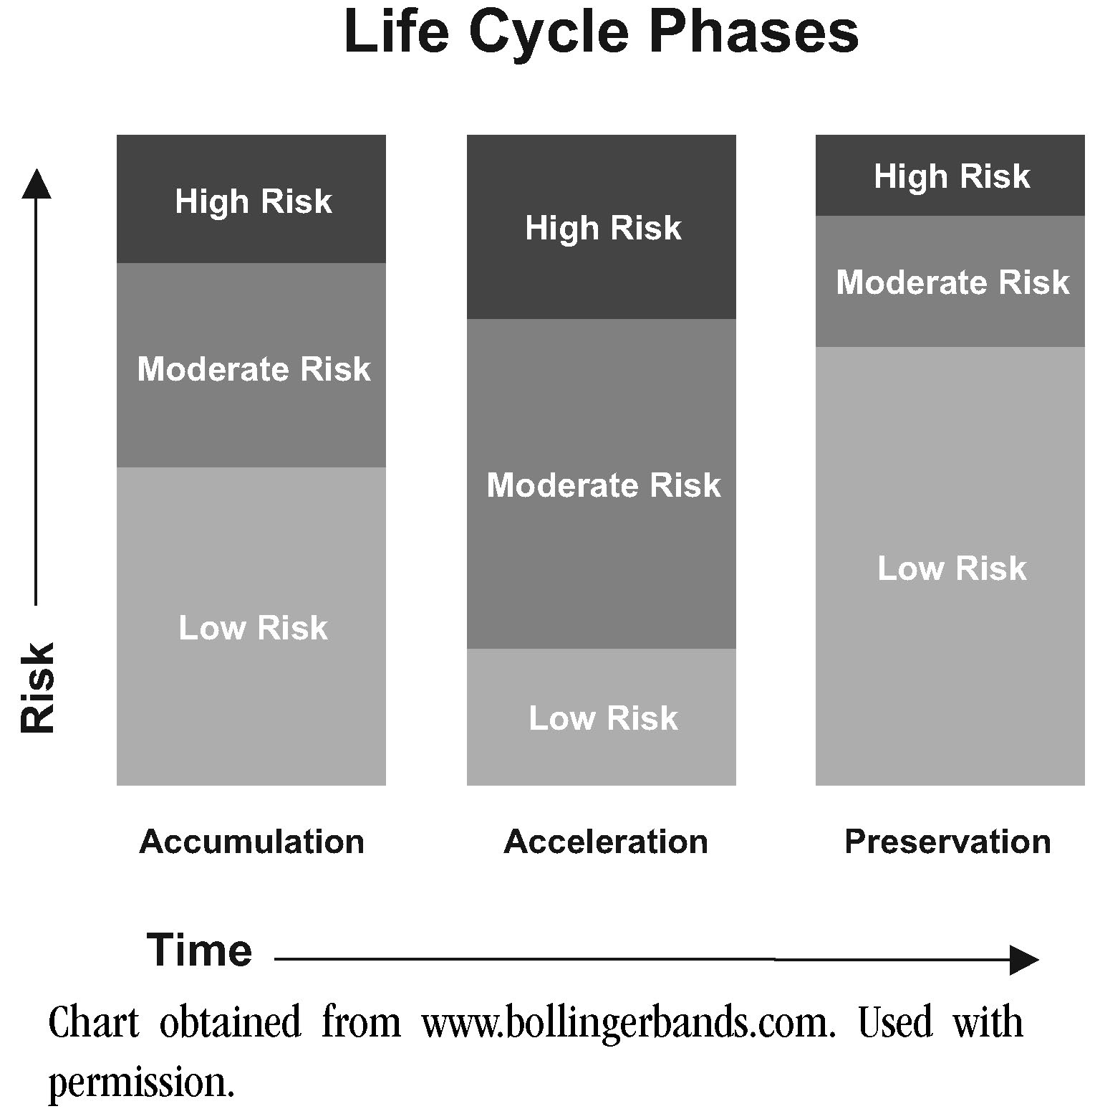
Time Horizon And Risk Capacity. The investor’s time horizon (sometimes referred to as a planning or investment horizon) is a critical element to be considered when determining an investor’s risk capacity and the appropriate mix of stocks and other risky assets the investor can afford to hold in the portfolio to achieve (or manage the risk of) the desired goals. In determining the impact of an investor’s time horizon, it is important to consider factors such as age, health, income potential, and near- and long-term term objectives.
An investor’s life cycle can typically be broken down into three phases. During the accumulation phase, he is purchasing a home, setting funds aside for emergency purposes,
Balanced Financial Growth
and saving for a college education. These relatively near term objectives cause him to accept limited amounts of risk. For example, assume the purpose of the funds is to pay for a child’s college education and the child is expected to graduate from high school within a couple of years. Such a near term objective would likely cause the investor to only accept low risk investments for these college education funds. However, once the child is educated, this same investor (being in the high-income years of his or her career) may well accept a moderate or even high-risk investment strategy in order to aggressively save for his or her retirement during the acceleration phase. As he approaches retirement, he then reaches the preservation phase and once again adapts to a more conservative and low risk investment profile.
Broadly speaking, a comprehensive financial planning process itself is an effective means of evaluating an investor’s risk capacity.
Measurements Of Risk Tolerance. In measuring risk tolerance, the planner attempts to determine the investor’s “comfort level” with engaging in risky trade-offs.
If the assessment process is subjective, or qualitative, the process is typically limited to information obtained in discussions with the investor. Based upon the information gleamed during these discussions, the planner then subjectively assesses the investor’s tolerance for risk. In order to effectively evaluate the investor, it is important for the planner to possess good interviewing skills.
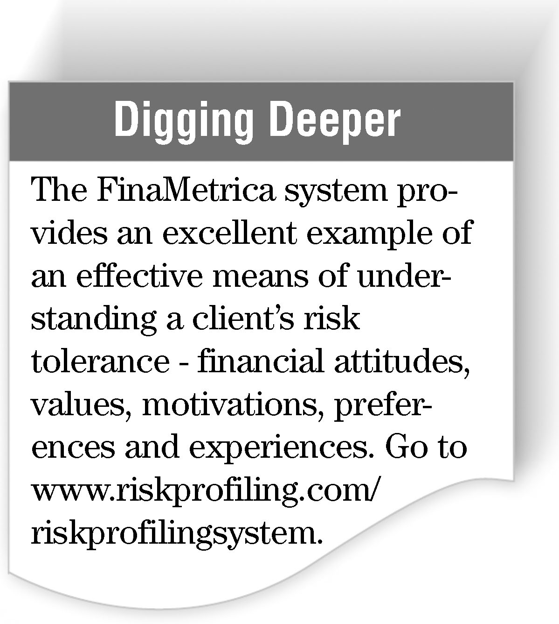
If the assessment process is objective, or quantitative, the planner uses a questionnaire designed to provide a basis for applying a numerical score, or rating, to the individual investor’s level of risk tolerance. The questions in the typical risk tolerance questionnaire are intended to provide a systematic and standardized measure of the investor’s tolerance for risk. To be credible, the test must be both valid and reliable (i.e., it must accurately measure what it purports to measure, and it must render these results on a consistent basis). Unfortunately, most questionnaires used by financial planners have not been subject to rigorous testing based upon known standards (a science known as psychometrics, or the science of psychological test construction). Recognizing this
Balanced Financial Growth
limitation, most financial planners use questionnaires in order to “begin the discussion,” but then supplement the numerical scores produced by the questionnaire with a subjective analysis based upon discussions with the investor.
Nonetheless, some good tools have become available over the years for a psychometrically rigorous evaluation of risk tolerance.
The Investment Profile. The development of an appropriate investment strategy requires obtaining an estimate of the investor’s risk tolerance and designing a solution consistent with the investor's risk capacity. The sample personal investor profile on page 45 places the investor in one of five investor categories, conservative, moderately conservative, moderate, moderately aggressive, and aggressive, based on a combination of time horizon/risk capacity, and personal risk tolerance. While different measures of risk tolerance and risk capacity may produce slightly different results, the fundamental point is that investors who have either little risk capacity or little risk tolerance should take much risk, while the riskiest portfolios are reserved for those who have both a high tolerance and capacity for risk. Assigning a classification to an investor is an important part of developing an appropriate investment strategy.
Creating A Portfolio Appropriate To The Personal Investor Profile. Once the investor determines an overall profile based on risk tolerance and capacity, it’s still necessary to determine the mix of these assets in his or her portfolio. The pie charts on page 46 provide a useful example of matching the risk profile to appropriate investment assets classes in assembling a portfolio, although advisors may construct slightly different portfolios depending on their own perspective on the potential risk and return of various asset classes.
It must be remembered that effective portfolio selection requires much more than merely matching a risk tolerance score to a particular mix of potential investments. The process involves a careful evaluation of risk capacity as well, including factors such as age, time horizon, family situation, income level, liquidity needs, and tax status. In this regard, see the asset allocation discussion on page 22. Ultimately, the goal is to ensure that the investor receives a portfolio that is consistent with both the constraints of his/her risk tolerance and risk capacity; if the only portfolio that can achieve the client's goals exceeds risk tolerance, the correct response is to help the client adjust the goals, not to select a portfolio that the client cannot tolerate just because he/she has the capacity to withstand the losses.
Balanced Financial Growth
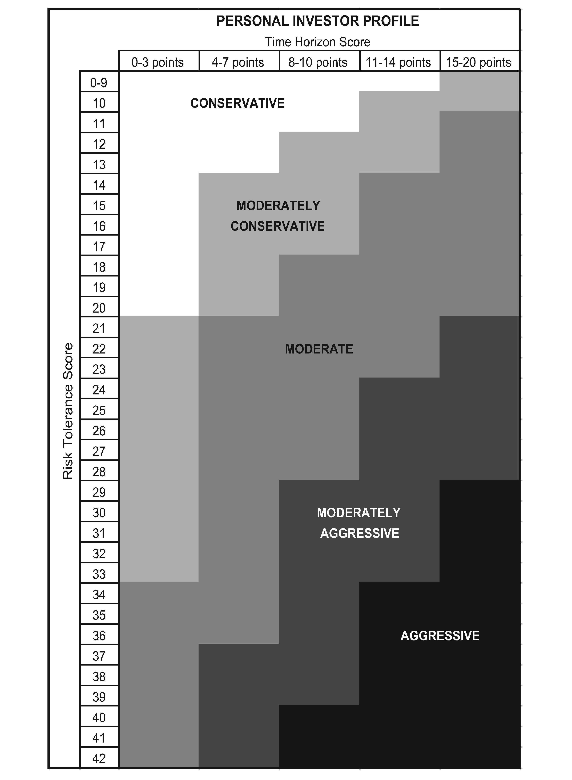
Balanced Financial Growth
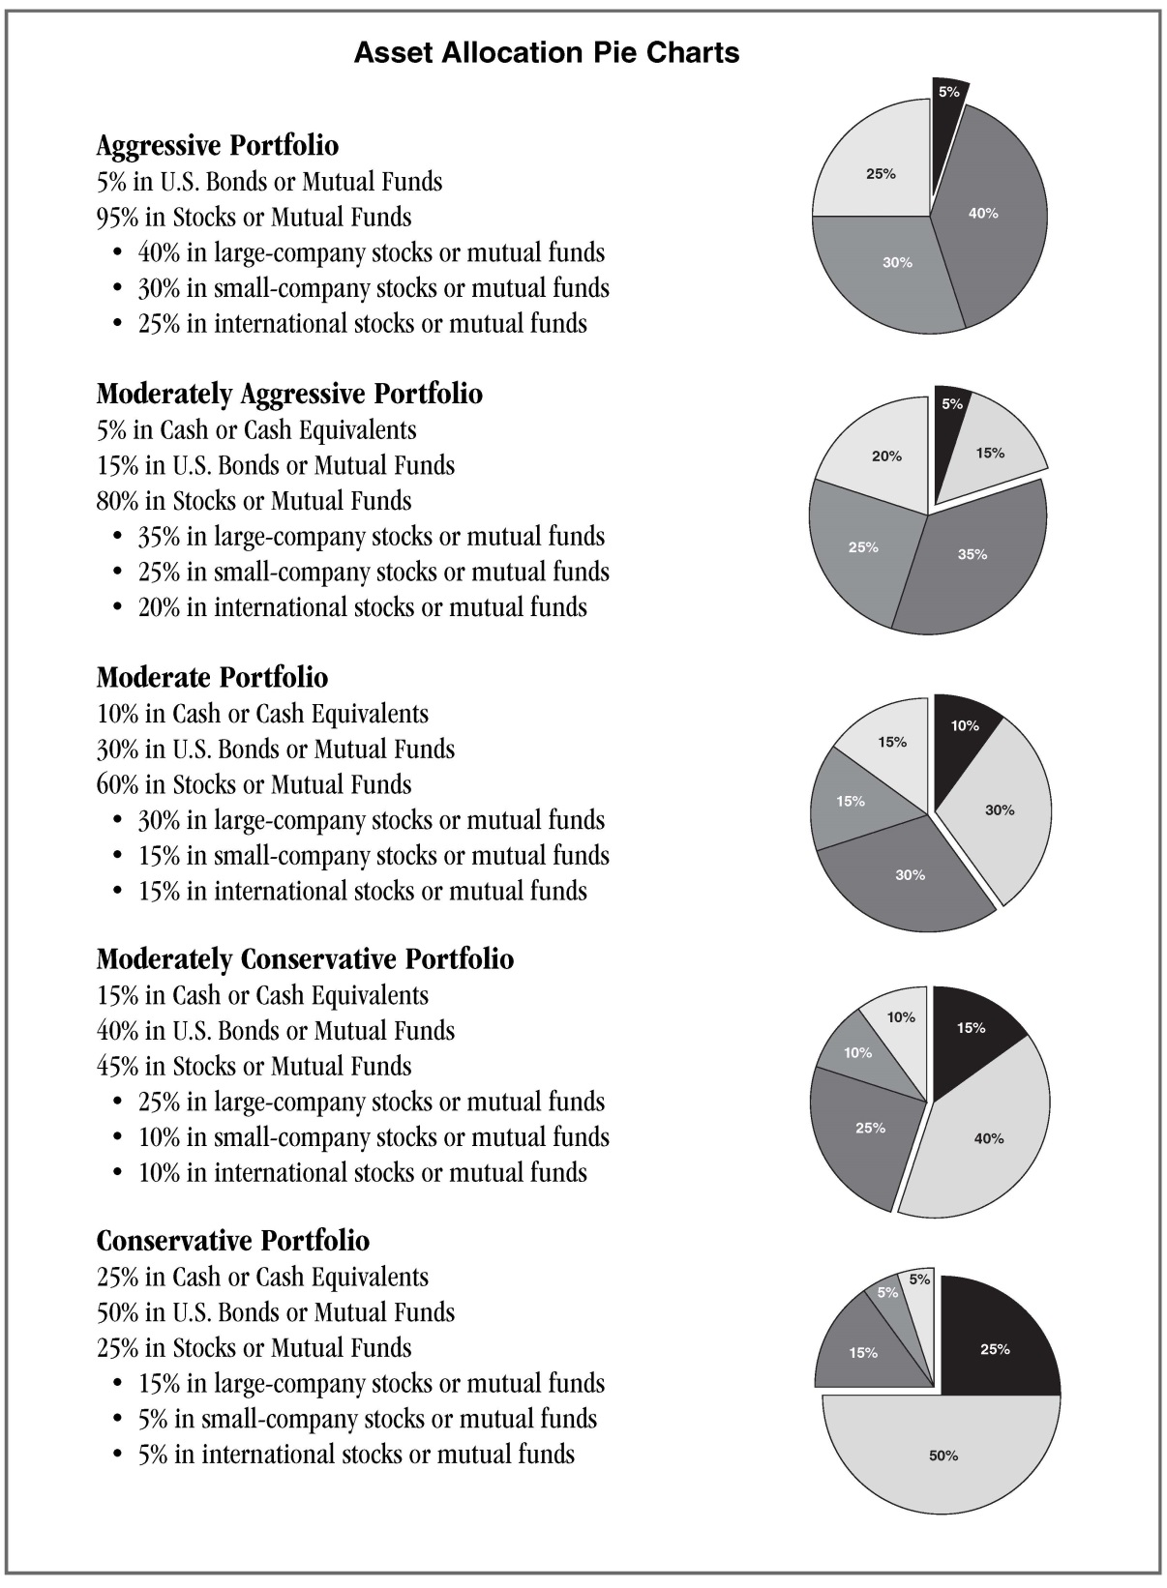
Balanced Financial Growth

Robert A. Esperti and Renno L. Peterson, 21st Century Wealth (Denver, Quantum Press, 2000), p. 5.
Sid Mittra and Jeffrey H. Rattiner, Practicing Financial Planning (Rochester Hills, Michigan: Mittra & Associates, 1998), p. 13-6.
G. Victor Hallman and Jerry S. Rosenbloom, Personal Financial Planning, 6th ed. (New York: McGraw-Hill, 2000), p. 255.
Press Release, The Social Investment Forum Foundation: US Sustainable and Responsible Investing (SRI) Assets Up 22 Percent in Two Years, November 14, 2012. This organization is a national membership association dedicated to advancing the concept, practice, and growth of socially and environmentally responsible investing (SRI).
For example, see Harry M. Markowitz, Portfolio Selection, 2nd ed. (Malden, Massachusetts: Blackwell Publishers, 2002); Gary Brinson, Randolph Hood, and Gilbert Beebower, “Determinants of Portfolio Performance,” Financial Analysis Journal (July/August, 1986: May/Jun, 1991).
For an expanded discussion of the correlation/covariance concept, see Stephan R. Leimberg et al., The Tools and Techniques Of Investment Planning, 3rd ed. (Cincinnati: The National Underwriter Company, 2013), pp. 286-288.
Interest rates are hypothetical.
This description was obtained from www.stockcharts.com. Used with permission.
Ibid.
Parts of this description were obtained from www.stockcharts.com. Used with permission.
Mean is another term for average. The mean is arrived at by dividing a total by the number of its components. For example, if five items cost $50, $80, $120, $300, and $500 respectively, the mean is $210 (($50 + $80 + $120 + $300 + $500)/5 = $210). In comparison, the median is the middle value that exceeds half of the values in a sample and is exceeded by the other half of the values. For example, if five items cost $50, $80, $120, $300, and $500 respectively, the median value is $120.
For an excellent survey of the many and varied indicators used in sentiment analysis, see George A. Fontanils and Tom Gentile, The Stock Market Course (New York: John Wiley & Sons, 2001).
CBOE stands for Chicago Board Options Exchange.

