Disability Income Plan
When a disabled employee is faced with increasing expenses and decreasing income, often many corporations will informally continue his salary for an extended period of time. Such an approach can be unwise when the disabled employee is a stockholder. To illustrate, assume that a corporation’s income is $150,000 before paying a $50,000 salary to its employee-stockholder.
NO PLAN. If this employee-stockholder becomes disabled without a pre-existing plan, continued salary payments of $50,000 will likely be treated by the IRS as nondeductible dividends, which must come from after-tax profits. Taxable income would then be $150,000, upon which $41,750 of taxes must be paid, with $58,250 remaining after-tax and after payment to the disabled stockholder-employee.
PLAN. A pre-existing disability income plan would enable the corporation to preserve the tax-deductibility of these continued salary payments to the disabled employee-stockholder. This would place the corporation in the same position as existed prior to the employee-stockholder’s disability.
To establish a plan, three things are required: (1) a corporate resolution must be adopted; (2) a plan document must be prepared; and (3) notification of the plan’s existence must be given to the covered employee. By doing this, the corporation could deduct continued salary payments and retain $77,750 after paying taxes of $22,250. Compared to “no plan,” this represents a saving of $19,500 per year. Such plans may be highly selective, and a class may consist of just one employee, provided it is a “reasonable” classification. If stockholders are covered, it must be in their capacity as employees.
Disability Income Plan
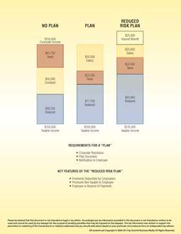
REDUCED RISK PLAN. Under the reduced risk plan, the corporation shifts a part of its liability to an insurance company. With an individual disability income contract, an insured benefit of $25,000 per year could be paid directly to the disabled employee-stockholder. The corporation would deduct a continued salary payment of $25,000, with $125,000 of taxable income remaining with the corporation. After paying taxes of $32,000, the corporation then retains $93,000. When compared to “no plan,” this represents a saving of $34,750 per year.
With a reduced risk plan the premium is deductible by the corporation, yet not taxable to the employee, who is assured of receiving disability payments if the corporation should fail.

